6CS005 Learning Journal - Semester 1 2018/19
Ashish Shrestha, 1828427

Table of Contents
1 POSIX Threads 2
1.1 Password Cracking 2
1.2 Image Processing 10
1.3 Linear Regression 21
2 CUDA 30
2.1 Password Cracking 30
2.2 Image Processing 34
2.3 Linear Regression 44
3 MPI 45
3.1 Password Cracking 45
3.2 Image Processing 49
3.3 Linear Regression 60
4 Verbose Repository Log 61

1 POSIX Threads

All of the running time of a program are in appendix (screenshots).

1.1 Password Cracking
a. Insert a table of 10 running times and the mean running time.

Calculating running times for the original program.
 | Time for original program.
1st | 852.086086160 Sec
2nd | 852.851117573 Sec
3rd | 866.621660790 Sec
4th | 841.839096854 Sec
5th | 870.891680057 Sec
6th | 825.242112556 Sec
7th | 864.673123279 Sec
8th | 877.859196113 Sec
9th | 871.069347481 Sec
10th | 854.746969314 Sec
Total time: | 8577.88039018 Sec
Mean Time in sec: | 857.788039018 Sec
Mean Time in Min : | 14.296467317 Min

From above table, we know that the average time taken to crack password is 14.296467317 minute.

b. Insert a paragraph that hypothesis's how long it would take to run if the number of initials were to be increased to 3. Include your calculations.

3-initials-2digits Password Cracking Program.
#include <stdio.h>
#include <string.h>
#include <stdlib.h>
#include <time.h>
#include <crypt.h>

/***********************************************************************
*******
Demonstrates how to crack an encrypted password using a simple
"brute force" algorithm. Works on passwords that consist only of 2
uppercase
letters and a 2 digit integer. Your personalized data set is included
in the
code.

Compile with:
cc -o CrackAZ99-With-3initials CrackAZ99-With-3initials.c -lcrypt

If you want to analyse the results then use the redirection operator
to send
output to a file that you can view using an editor or the less
utility:

./CrackAZ99-With-3initials > results.txt

Dr Kevan Buckley, University of Wolverhampton, 2018
************************************************************************
******/
int n_passwords = 4;

char *encrypted_passwords[] = {

"$6$KB$.OnsM0.pEomFoalYh1Tz0da3BPcVeBs6fn3fn6Aq8XMjLMc5aImRqL9hBnjFpCVLigSq9dYwAelFBufipopxY1",

"$6$KB$a3I0PZzxK72KmUEF9BwCDgavNTcKF7qMyisIX92DAGRCeiU4eAngEL7TSC/v.vAix7d0j1jFV3stlwZUohpEo0",

"$6$KB$hn2ozvmpb8pvNu.G7pewcZb6xu.iQBuE9MywKWKPgsALV.gpJnzo8NQqJBs7yvs13jPV2dficoIfumz04V5uH/",

"$6$KB$o1ZCfk2QE6ENjSr9AViCaiPy6Ln1.pkNEorytYnS5gEAAk4dYSTUomM5YGbXSs6Zg1ObJ3HiraiyI0ONH1oAb0"
};

/**
Required by lack of standard function in C.
*/

void substr(char *dest, char *src, int start, int length){
memcpy(dest, src + start, length);
*(dest + length) = '\0';
}

/**
This function can crack the kind of password explained above. All
combinations
that are tried are displayed and when the password is found, #, is put
at the
start of the line. Note that one of the most time consuming operations
that
it performs is the output of intermediate results, so performance
experiments
for this kind of program should not include this. i.e. comment out the
printfs.
*/

void crack(char *salt_and_encrypted){
int w, x, y, z; // Loop counters
char salt[7]; // String used in hashing the password. Need space
char plain[7]; // The combination of letters currently being checked
char *enc; // Pointer to the encrypted password
int count = 0; // The number of combinations explored so far

substr(salt, salt_and_encrypted, 0, 6);

for(w='A'; w<='Z'; w++){
for(x='A'; x<='Z'; x++){
for(y='A'; y<='Z'; y++){
for(z=0; z<=99; z++){
sprintf(plain, "%c%c%c%02d", w, x, y, z);
enc = (char *) crypt(plain, salt);
count++;
if(strcmp(salt_and_encrypted, enc) == 0){
printf("#%-8d%s %s\n", count, plain, enc);
} else {
printf(" %-8d%s %s\n", count, plain, enc);
}
}
}
}
}
printf("%d solutions explored\n", count);
}

// Calculate the difference between two times. Returns zero on
// success and the time difference through an argument. It will
// be unsuccessful if the start time is after the end time.

int time_difference(struct timespec *start,
struct timespec *finish,
long long int *difference) {
long long int ds = finish->tv_sec - start->tv_sec;
long long int dn = finish->tv_nsec - start->tv_nsec;

if(dn < 0 ) {
ds--;
dn += 1000000000;
}
*difference = ds * 1000000000 + dn;
return !(*difference > 0);
}

int main(int argc, char *argv[]){
int i;
struct timespec start, finish;
long long int time_elapsed;

clock_gettime(CLOCK_MONOTONIC, &start);

for(i=0;i<n_passwords;i<i++) {
crack(encrypted_passwords[i]);
}

clock_gettime(CLOCK_MONOTONIC, &finish);
time_difference(&start, &finish, &time_elapsed);
printf("Time elapsed was %lldns or %0.9lfs or %0.9lfmin\n", time_elapsed,
(time_elapsed/1.0e9),((time_elapsed/1.0e9)/60));

return 0;
}

/******************************************************************************/

Ans:
From 2 initial number program we know that, it took approximately 14.296 minute time to run program. So, if we increase the number of initials to 3, which means (A-Z) = 26 character, then the time should increase by 26 * 14.296 = 371.696 min = 6.1949 hours.

c. Explain your results of running your 3 initial password cracker with relation to your earlier hypothesis.

Ans:
From above (question number b) estimation it was found that it should take 6.1949 hours to run 3 initial password cracking program but actually it took 337.457580566 min = 5.624293009 hours ≈ 6 hours.

Multi-thread Password Cracking Program.

#include <stdlib.h>
#include <stdio.h>
#include <ctype.h>
#include <sys/stat.h>
#include <string.h>
#include <time.h>
#include <pthread.h>
#include <crypt.h>
/***********************************************************************
*******
Demonstrates how to crack an encrypted password using a simple
"brute force" algorithm. Works on passwords that consist only of 2
uppercase
letters and a 2 digit integer. Your personalised data set is included
in the
code.

Compile with:
cc -o CrackAZ99-With-Data-multi-threads CrackAZ99-With-Data-multi-threads.c -lcrypt -pthread

If you want to analyse the results then use the redirection operator
to send
output to a file that you can view using an editor or the less
utility:

./CrackAZ99-With-Data-multi-threads > results.txt

Dr Kevan Buckley, University of Wolverhampton, 2018
************************************************************************
******/

int n_passwords = 4;

char *encrypted_passwords[] = {

"$6$KB$6SsUGf4Cq7/Oooym9WWQN3VKeo2lynKV9gXVyEG4HvYy1UFRx.XAye89TLp/OTcW7cGpf9UlU0F.cK/S9CfZn1",

"$6$KB$1vCJQRsKAizZvuTjEqLE./zeAqZ7AdqzTdx5Tob.bQDRGlXOEVkNhuqMorBSvCp4fP0eoNm2wULs3DRABbrLQ/",

"$6$KB$VKxGV/w3/XgUswkstexjD72Q5jKKSTyxSfIQlkwtApaQlnYvPfZA4O38d1fc4QvWxDc93T4HzfF/ksMKgfzFM/",

"$6$KB$xJHmCu7jpWBZlq2AAXZUB5ZF8NcJgZkydHbCyfPwy3nE.djIlSmUxHDLAZdnwz8ys5L8L9.61NMdYXsyN32r11"
};

/**
Required by lack of standard function in C.
*/

void substr(char *dest, char *src, int start, int length){
memcpy(dest, src + start, length);
*(dest + length) = '\0';
}

/**
This function can crack the kind of password explained above. All
combinations
that are tried are displayed and when the password is found, #, is put
at the
start of the line. Note that one of the most time consuming operations
that
it performs is the output of intermediate results, so performance
experiments
for this kind of program should not include this. i.e. comment out the
printfs.
*/

void crack_block() {
int i;
pthread_t thread_1, thread_2;

void *kernel_function_1();
void *kernel_function_2();

for(i=0;i<n_passwords;i<i++) {
pthread_create(&thread_1, NULL, kernel_function_1, encrypted_passwords[i] );
pthread_create(&thread_2, NULL, kernel_function_2, encrypted_passwords[i]);

pthread_join(thread_1, NULL);
pthread_join(thread_2, NULL);
}
}

void *kernel_function_1(char *salt_and_encrypted){
int x, y, z; // Loop counters
char salt[7]; // String used in hashing the password. Need space
char plain[7]; // The combination of letters currently being checked
char *enc; // Pointer to the encrypted password
int count = 0; // The number of combinations explored so far

substr(salt, salt_and_encrypted, 0, 6);

for(x='A'; x<='M'; x++){
for(y='A'; y<='Z'; y++){
for(z=0; z<=99; z++){
sprintf(plain, "%c%c%02d", x, y, z);
enc = (char *) crypt(plain, salt);
count++;
if(strcmp(salt_and_encrypted, enc) == 0){
printf("#%-8d%s %s\n", count, plain, enc);
} else {
printf(" %-8d%s %s\n", count, plain, enc);
}
}
}
}
}

void *kernel_function_2(char *salt_and_encrypted){
int x, y, z; // Loop counters
char salt[7]; // String used in hashing the password. Need space
char plain[7]; // The combination of letters currently being checked
char *enc; // Pointer to the encrypted password
int count = 0; // The number of combinations explored so far

substr(salt, salt_and_encrypted, 0, 6);

for(x='N'; x<='Z'; x++){
for(y='A'; y<='Z'; y++){
for(z=0; z<=99; z++){
sprintf(plain, "%c%c%02d", x, y, z);
enc = (char *) crypt(plain, salt);
count++;
if(strcmp(salt_and_encrypted, enc) == 0){
printf("#%-8d%s %s\n", count, plain, enc);
} else {
printf(" %-8d%s %s\n", count, plain, enc);
}
}
}
}
printf("%d solutions explored\n", count);
}

int time_difference(struct timespec *start, struct timespec *finish,
long long int *difference) {
long long int ds = finish->tv_sec - start->tv_sec;
long long int dn = finish->tv_nsec - start->tv_nsec;

if(dn < 0 ) {
ds--;
dn += 1000000000;
}
*difference = ds * 1000000000 + dn;
return !(*difference > 0);
}

int main(int argc, char *argv[]) {
struct timespec start, finish;
long long int time_elapsed;

clock_gettime(CLOCK_MONOTONIC, &start);

crack_block();

clock_gettime(CLOCK_MONOTONIC, &finish);
time_difference(&start, &finish, &time_elapsed);
printf("Time elapsed was %lldns or %0.9lfs or %0.9lfmin\n", time_elapsed,
(time_elapsed/1.0e9),((time_elapsed/1.0e9)/60));

return 0;
}
/******************************************************************************/
d. Write a paragraph that compares the original results with those of your multi-thread password cracker.

Calculating running times for the original program and for multi-thread version.
 | Time for original program. | Time for multi-thread program.
1st | 852.086086160 Sec | 424.101145135 Sec
2nd | 852.851117573 Sec | 428.928177644 Sec
3rd | 866.621660790 Sec | 428.028800344 Sec
4th | 841.839096854 Sec | 426.398617337 Sec
5th | 870.891680057 Sec | 432.247245291 Sec
6th | 825.242112556 Sec | 430.344344965 Sec
7th | 864.673123279 Sec | 430.50855403 Sec
8th | 877.859196113 Sec | 431.871656769 Sec
9th | 871.069347481 Sec | 433.916258052 Sec
10th | 854.746969314 Sec | 475.311364531 Sec
Total time: | 8577.88039018 Sec | 4341.656164098 Sec
Mean Time in sec: | 857.788039018 Sec | 434.1656164098 Sec
Mean Time in Min : | 14.296467317 Min | 7.23609360683 Min

From above table, we know that the average time taken to crack password by using multi-threading is 7.2360 minute. So, we can say that by using multi-thread in password cracking can reduce time by half or more according to the processor of laptop or desktop.

These password was found from Password Cracking.
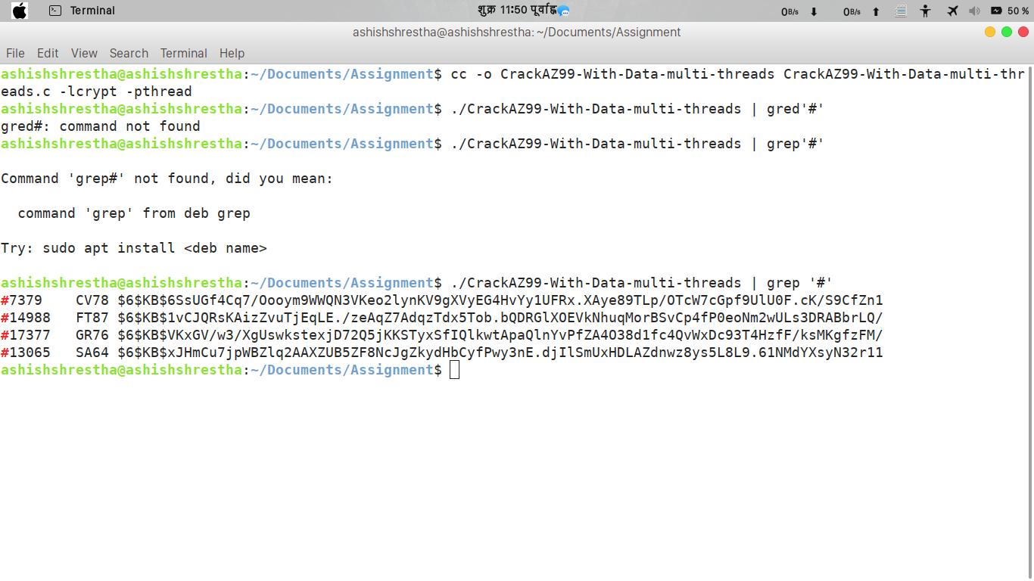

1.2 Image Processing
a. Insert the image displayed by your program
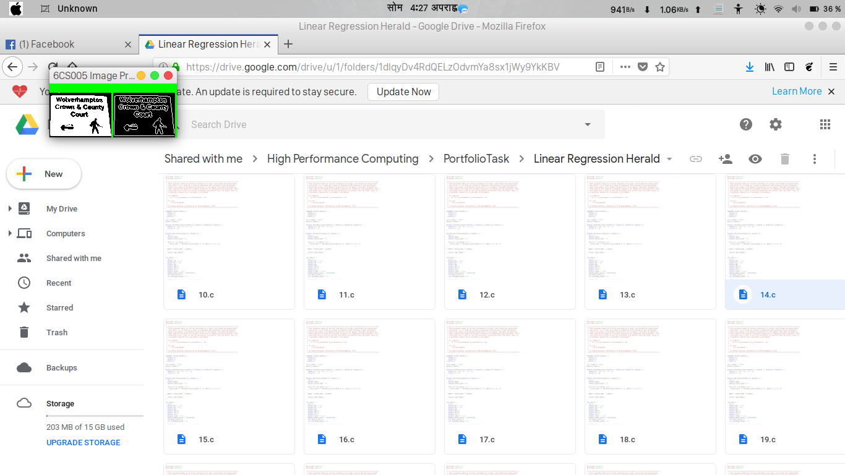

Image Processing program using multi-threaded edge detector.

#include <stdio.h>
#include <stdlib.h>
#include <time.h>
#include <GL/glut.h>
#include <GL/gl.h>
#include <malloc.h>
#include <signal.h>
#include <pthread.h>
/******************************************************************************
Displays two grey scale images. On the left is an image that has come from an
image processing pipeline, just after colour thresholding. On the right is
the result of applying an edge detection convolution operator to the left
image. This program performs that convolution.

Things to note:
- A single unsigned char stores a pixel intensity value. 0 is black, 256 is
white.
- The colour mode used is GL_LUMINANCE. This uses a single number to
represent a pixel's intensity. In this case we want 256 shades of grey,
which is best stored in eight bits, so GL_UNSIGNED_BYTE is specified as
the pixel data type.

To compile adapt the code below wo match your filenames:
cc -o ip_coursework_multi_thread_014 ip_coursework_multi_thread_014.c -lglut -lGL -lm -pthread
To run this program:
./ip_coursework_multi_thread_014

Dr Kevan Buckley, University of Wolverhampton, 2018
******************************************************************************/
#define width 100
#define height 72

unsigned char image[], results[width * height];
typedef struct arguments_t {
int start;
int stride;
unsigned char *input;
unsigned char *output;
} arguments_t;

void edge_detect(unsigned char *image,unsigned char *results) {
pthread_t th1, th2, th3, th4;

arguments_t t1_arguments;
t1_arguments.start = 0;
t1_arguments.stride = 4;
t1_arguments.input=image;
t1_arguments.output=results;

arguments_t t2_arguments;
t2_arguments.start = 1;
t2_arguments.stride = 4;
t2_arguments.input=image;
t2_arguments.output=results;

arguments_t t3_arguments;
t3_arguments.start = 2;
t3_arguments.stride = 4;
t3_arguments.input=image;
t3_arguments.output=results;

arguments_t t4_arguments;
t4_arguments.start = 3;
t4_arguments.stride = 4;
t4_arguments.input=image;
t4_arguments.output=results;

void *detect_image_edges();

pthread_create(&th1, NULL, detect_image_edges, &t1_arguments);
pthread_create(&th2, NULL, detect_image_edges, &t2_arguments);
pthread_create(&th3, NULL, detect_image_edges, &t3_arguments);
pthread_create(&th4, NULL, detect_image_edges, &t4_arguments);

pthread_join(th1, NULL);
pthread_join(th2, NULL);
pthread_join(th3, NULL);
pthread_join(th4, NULL);
}

void *detect_image_edges(arguments_t *args) {
int i;
int n_pixels = width * height;
unsigned char *in=args->input;
unsigned char *out=args->output;

for(i=args->start;i<n_pixels;i+=args->stride){
int x, y; // the pixel of interest
int b, d, f, h; // the pixels adjacent to x,y used for the calculation
int r; // the result of calculate

y = i / width;
x = i - (width * y);

if (x == 0 || y == 0 || x == width - 1 || y == height - 1) {
results[i] = 0;
} else {
b = i + width;
d = i - 1;
f = i + 1;
h = i - width;

r = (in[i] * 4) + (in[b] * -1) + (in[d] * -1) + (in[f] * -1)
+ (in[h] * -1);

if (r > 0) { // if the result is positive this is an edge pixel
out[i] = 255;
} else {
out[i] = 0;
}
}
}
}

void tidy_and_exit() {
exit(0);
}

void sigint_callback(int signal_number){
printf("\nInterrupt from keyboard\n");
tidy_and_exit();
}

static void display() {
glClear(GL_COLOR_BUFFER_BIT);
glRasterPos4i(-1, -1, 0, 1);
glDrawPixels(width, height, GL_LUMINANCE, GL_UNSIGNED_BYTE, image);
glRasterPos4i(0, -1, 0, 1);
glDrawPixels(width, height, GL_LUMINANCE, GL_UNSIGNED_BYTE, results);
glFlush();
}

static void key_pressed(unsigned char key, int x, int y) {
switch(key){
case 27: // escape
tidy_and_exit();
break;
default:
printf("\nPress escape to exit\n");
break;
}
}

int time_difference(struct timespec *start, struct timespec *finish,
long long int *difference) {
long long int ds = finish->tv_sec - start->tv_sec;
long long int dn = finish->tv_nsec - start->tv_nsec;

if(dn < 0 ) {
ds--;
dn += 1000000000;
}
*difference = ds * 1000000000 + dn;
return !(*difference > 0);
}

int main(int argc, char **argv) {
signal(SIGINT, sigint_callback);

printf("image dimensions %dx%d\n", width, height);
//detect_edges(image, results);

struct timespec start, finish;
long long int time_elapsed;

clock_gettime(CLOCK_MONOTONIC, &start);

edge_detect(image, results);

clock_gettime(CLOCK_MONOTONIC, &finish);
time_difference(&start, &finish, &time_elapsed);
printf("Time elapsed was %lldns or %0.9lfs\n", time_elapsed,
(time_elapsed/1.0e9));

glutInit(&argc, argv);
glutInitWindowSize(width * 2,height);
glutInitDisplayMode(GLUT_SINGLE | GLUT_LUMINANCE);

glutCreateWindow("6CS005 Image Progessing Courework");
glutDisplayFunc(display);
glutKeyboardFunc(key_pressed);
glClearColor(0.0, 1.0, 0.0, 1.0);

glutMainLoop();

tidy_and_exit();

return 0;
}

unsigned char image[] = {0,0,0,0,0,0,0,0,0,0,0,0,0,0,0,0,0,0,
0,0,0,0,0,0,0,0,0,0,0,0,0,0,0,0,0,0,0,
0,0,0,0,0,0,0,0,0,0,0,0,0,0,0,0,0,0,0,
0,0,0,0,0,0,0,0,0,0,0,0,0,0,0,0,0,0,0,
0,0,0,0,0,0,0,0,0,0,0,0,0,0,0,0,0,0,0,
0,0,0,0,0,0,0,0,0,0,0,0,0,0,0,0,0,0,0,
0,0,0,0,0,0,0,0,0,0,0,0,0,0,0,0,0,0,0,
0,0,0,0,0,0,0,0,0,0,0,0,0,0,0,0,0,0,0,
0,0,0,0,0,0,0,0,0,0,0,0,0,0,0,0,0,0,0,
0,0,0,0,0,0,0,0,0,0,0,0,0,0,0,0,0,0,0,
0,0,0,0,0,0,0,0,0,0,0,0,0,255,255,255,255,255,255,
255,255,255,255,255,255,255,255,255,255,255,255,255,255,255,255,255,255,255,
255,255,255,255,255,255,255,255,255,255,255,255,255,255,255,255,255,255,255,
255,255,255,255,255,255,255,255,255,255,255,255,255,255,255,255,255,255,255,
255,255,255,255,255,255,255,255,255,255,255,255,255,255,255,255,255,255,255,
255,255,255,255,255,255,255,255,255,255,255,255,255,255,255,255,0,255,255,
255,255,255,255,255,255,255,255,255,255,255,255,255,255,255,255,255,255,255,
255,255,255,255,255,255,255,255,255,255,255,255,255,255,255,255,255,255,255,
255,255,255,255,255,255,255,255,255,255,255,255,255,255,255,255,255,255,255,
255,255,255,255,255,255,255,255,255,255,255,255,255,255,255,255,255,255,255,
255,255,255,255,255,255,255,255,255,255,255,255,255,255,255,255,255,255,255,
255,255,0,255,255,255,255,255,255,255,255,255,255,255,255,255,255,255,255,
255,255,255,255,255,255,255,255,255,255,255,255,255,255,255,255,255,255,255,
255,255,255,255,255,255,255,255,255,255,255,255,255,255,255,255,255,255,255,
255,255,255,255,255,255,255,255,255,255,255,255,255,255,255,255,255,255,255,
255,255,255,255,255,255,255,255,255,255,255,255,255,255,255,255,255,255,255,
255,255,255,255,255,255,255,0,255,255,255,255,255,255,255,255,255,255,255,
255,255,255,255,255,255,255,255,255,255,255,255,255,255,255,255,255,255,255,
255,255,255,255,255,255,255,255,255,255,255,255,255,255,255,255,255,255,255,
255,255,255,255,255,255,255,255,255,255,255,255,255,255,255,255,255,255,255,
255,255,255,255,255,255,255,255,255,255,255,255,255,255,255,255,255,255,255,
255,255,255,255,255,255,255,255,255,255,255,255,0,255,255,255,255,255,255,
255,255,255,255,255,255,255,255,255,255,255,255,255,255,255,255,255,255,255,
255,255,255,255,255,255,255,255,255,255,255,255,255,255,255,255,255,255,255,
255,255,255,255,255,255,255,255,255,255,255,255,255,255,255,255,255,255,255,
255,255,255,255,255,0,0,255,255,255,255,255,255,0,0,0,255,255,255,
255,255,255,255,255,255,255,255,255,255,255,255,255,255,255,255,0,0,255,
255,255,255,255,255,255,255,255,255,255,255,255,255,255,255,255,255,255,255,
255,255,255,255,255,255,255,255,255,255,255,255,255,255,255,255,255,255,255,
255,255,255,255,255,255,255,255,255,255,255,255,255,255,255,255,255,255,255,
255,255,255,255,255,255,255,255,255,255,0,0,255,255,255,255,255,255,0,
0,0,255,255,255,255,255,255,255,255,255,255,255,255,255,255,255,255,255,
255,255,0,0,255,255,255,255,255,255,255,255,255,255,255,255,255,255,255,
255,255,255,255,255,255,255,255,255,255,255,255,255,255,255,255,255,255,255,
255,255,255,255,255,255,255,255,255,255,255,255,255,255,255,255,255,255,255,
255,255,255,255,255,255,255,255,255,255,255,255,255,255,255,0,0,255,255,
255,255,255,255,0,0,255,255,255,255,255,255,255,255,255,255,255,255,255,
255,255,255,255,255,255,255,0,0,255,255,255,255,255,255,255,255,255,255,
255,255,255,255,255,255,255,255,255,255,255,255,255,255,255,255,255,255,255,
255,255,255,255,255,255,255,255,255,255,255,255,255,255,255,255,255,255,255,
255,255,255,255,255,255,255,255,255,255,255,255,255,255,255,255,255,255,255,
255,0,0,0,255,255,255,255,0,0,0,255,255,255,255,255,255,255,255,
255,255,255,255,255,255,255,255,255,255,255,255,0,0,255,255,255,255,255,
255,255,255,255,255,255,255,255,255,255,255,255,255,255,255,255,255,255,255,
255,255,255,255,255,255,255,255,255,255,255,255,255,255,255,255,255,255,255,
255,255,255,255,255,255,255,255,255,255,255,255,255,255,255,255,255,255,255,
255,255,255,255,255,255,0,0,0,255,255,255,255,0,0,0,255,255,255,
255,255,255,255,255,255,255,255,255,255,255,255,255,255,255,255,255,0,0,
255,255,255,255,255,255,255,255,255,255,255,255,255,255,255,255,255,255,255,
255,0,0,0,0,255,255,255,255,255,255,255,255,255,255,255,255,255,255,
255,255,255,255,255,255,255,255,255,255,255,255,255,255,255,255,255,255,255,
255,255,255,255,255,255,255,255,255,255,255,0,0,0,255,255,255,0,0,
0,0,255,255,255,255,255,255,255,255,255,255,255,255,255,255,255,255,255,
255,255,255,0,0,255,255,255,255,255,255,255,255,255,255,255,255,255,255,
255,255,255,255,255,0,0,0,0,255,255,255,255,255,255,255,255,255,255,
255,255,255,255,255,255,255,255,255,255,255,255,255,255,255,255,255,255,255,
255,255,255,255,255,255,255,255,255,255,255,255,255,255,255,255,0,0,0,
0,255,255,0,0,0,255,255,255,255,255,255,255,255,255,255,255,255,255,
255,255,255,255,255,255,255,255,0,0,255,255,255,255,255,255,255,255,255,
255,255,255,255,255,255,255,255,255,0,0,0,0,0,255,255,255,255,255,
255,0,0,0,0,0,0,0,0,255,255,255,255,255,255,255,255,255,255,
255,255,255,255,255,255,255,255,255,255,255,255,255,255,255,255,255,255,255,
255,255,0,0,0,0,255,0,0,0,0,255,255,255,255,255,255,255,255,
255,255,255,255,255,255,255,255,255,255,255,255,255,0,0,255,255,255,255,
255,255,255,255,255,255,255,255,255,255,255,255,255,255,0,0,0,0,0,
0,0,0,0,0,0,0,0,0,0,0,0,0,0,0,255,255,255,255,
255,255,255,255,255,255,255,255,255,255,255,255,255,255,255,255,255,255,255,
255,255,255,255,255,255,255,255,0,0,0,0,0,0,0,255,255,255,255,
255,255,255,255,255,255,255,255,255,255,255,255,255,255,255,255,255,0,0,
0,255,255,255,255,255,255,255,255,255,255,255,255,255,255,255,255,255,0,
0,0,0,0,0,0,0,0,0,0,0,0,0,0,0,0,0,0,0,
0,255,255,255,255,255,255,255,255,255,255,255,255,255,255,255,255,255,255,
255,255,255,255,255,255,255,255,255,255,255,255,255,0,0,0,0,0,0,
0,255,255,255,255,255,255,255,255,255,255,255,255,255,255,255,255,255,255,
255,255,255,0,0,0,255,255,255,255,255,255,255,255,255,255,255,255,255,
255,255,255,255,0,0,0,0,0,0,0,0,0,0,0,0,0,0,0,
0,0,0,0,0,0,255,255,255,255,255,255,255,255,255,255,255,255,255,
255,255,255,255,255,255,255,255,255,255,255,255,255,255,255,255,255,255,0,
0,0,0,0,0,255,255,255,255,255,255,255,255,255,0,255,255,255,255,
255,255,255,255,255,255,255,255,0,0,0,255,255,255,255,255,255,255,255,
255,255,255,255,255,255,255,255,255,255,0,0,0,0,0,0,0,255,255,
255,255,255,255,255,255,255,255,255,255,255,255,255,255,255,255,255,255,255,
255,255,255,255,255,255,255,255,255,255,255,255,255,255,255,255,255,255,255,
255,0,0,255,0,0,0,0,0,255,255,255,0,255,255,0,0,255,0,
255,255,255,255,255,255,255,255,255,255,255,255,255,0,0,0,255,255,255,
255,255,255,255,255,255,255,255,255,255,255,255,255,255,255,255,0,0,0,
0,255,255,255,0,255,255,255,255,255,255,255,255,0,0,255,255,255,255,
255,255,255,255,255,255,255,255,255,255,255,255,255,255,255,255,255,255,255,
255,255,255,255,0,0,0,0,255,0,0,0,0,0,255,255,0,255,0,
0,255,255,255,255,255,255,255,255,255,255,255,255,255,255,255,255,255,0,
0,0,255,255,255,255,255,255,255,255,255,255,255,255,255,255,255,255,255,
255,255,255,0,0,0,0,255,255,255,255,0,255,255,255,255,255,0,0,
0,255,255,255,255,255,255,255,255,255,255,255,255,255,255,255,255,255,255,
255,255,255,255,255,255,255,255,255,0,0,0,0,0,0,0,0,0,0,
255,255,0,0,0,0,255,255,255,255,255,255,255,255,255,255,255,255,255,
255,255,255,255,0,0,0,255,255,255,255,255,255,255,255,255,255,255,255,
255,255,255,255,255,255,255,255,255,255,255,255,255,255,255,255,255,255,0,
0,255,255,0,0,255,255,255,255,255,255,255,255,255,255,255,255,255,255,
255,255,255,255,255,255,255,255,255,255,255,255,255,255,0,0,0,0,0,
0,0,0,0,0,255,0,0,0,0,255,255,255,255,255,255,255,255,255,
255,255,255,255,255,255,255,255,255,0,0,0,255,255,255,255,255,255,255,
255,255,255,255,255,255,255,255,255,255,255,255,255,255,255,255,255,255,255,
255,255,255,255,255,255,255,255,255,255,255,255,255,255,255,255,255,255,255,
255,255,255,255,255,255,255,255,255,255,255,255,255,255,255,255,255,255,255,
255,255,0,0,0,0,0,0,0,0,0,0,0,0,255,255,255,255,255,
255,255,255,255,255,255,255,255,255,255,255,255,255,0,0,0,0,255,255,
255,255,255,255,255,255,255,255,255,255,255,255,255,255,255,255,255,255,255,
255,255,255,255,255,255,255,255,255,255,255,255,255,255,255,255,255,255,255,
255,255,255,255,255,255,255,255,255,255,255,255,255,255,255,255,255,255,255,
255,255,255,255,255,255,255,0,0,0,0,0,0,0,0,0,0,255,255,
255,255,255,255,255,255,255,255,255,255,255,255,255,255,255,255,255,255,0,
0,0,0,255,255,255,255,255,255,255,255,255,255,255,255,255,255,255,255,
255,255,255,255,255,255,255,255,255,255,255,255,255,255,255,255,255,255,255,
255,255,255,255,255,255,255,255,255,255,255,255,255,255,255,255,255,255,255,
255,255,255,255,255,255,255,255,255,255,255,255,0,0,0,0,0,0,0,
0,0,0,255,255,255,255,255,255,255,255,255,255,255,255,255,255,255,255,
255,255,255,255,0,0,0,0,255,255,255,255,255,255,255,255,255,255,255,
255,255,255,255,255,255,255,255,255,255,255,255,255,255,255,255,255,255,255,
255,255,255,255,255,255,255,255,255,255,255,255,255,255,255,255,255,255,255,
255,255,255,255,255,255,255,255,255,255,255,255,255,255,255,255,255,255,0,
0,0,0,0,0,0,0,255,255,255,255,255,255,255,255,255,255,255,255,
255,255,255,255,255,255,255,255,255,0,0,0,0,255,255,255,255,255,255,
255,255,255,255,255,255,255,255,255,255,255,255,255,255,255,255,255,255,255,
255,255,255,255,255,255,255,255,255,255,255,255,255,255,255,255,255,255,255,
255,255,255,255,255,255,255,255,255,255,255,255,255,255,255,255,255,255,255,
255,255,255,255,255,0,0,0,0,0,0,0,255,255,255,255,255,255,255,
255,255,255,255,255,255,255,255,255,255,255,255,255,255,0,0,0,0,255,
255,255,255,255,255,255,255,255,255,255,255,255,255,255,255,255,255,255,255,
255,255,255,255,255,255,255,255,255,255,255,255,255,255,255,255,255,255,255,
255,255,255,255,255,255,255,255,255,255,255,255,255,255,255,255,255,255,255,
255,255,255,255,255,255,255,255,255,255,255,255,0,0,0,0,255,255,255,
255,255,255,255,255,255,255,255,255,255,255,255,255,255,255,255,255,255,255,
0,0,0,0,0,255,255,255,255,255,255,255,255,255,255,255,255,255,255,
255,255,255,255,255,255,255,255,255,255,255,255,255,255,255,255,255,255,255,
255,255,255,255,255,255,255,255,255,255,255,255,255,255,255,255,255,255,255,
255,255,255,255,255,255,255,255,255,255,255,255,255,255,255,255,255,255,255,
0,0,0,255,255,255,255,255,255,255,255,255,255,255,255,255,255,255,255,
255,255,255,255,255,0,0,0,0,0,255,255,255,255,255,255,255,255,255,
255,255,255,255,255,255,255,255,255,255,255,255,255,255,255,255,255,255,255,
255,255,255,255,255,255,255,255,255,255,255,255,255,255,255,255,255,255,255,
255,255,255,255,255,255,255,255,255,255,255,255,255,255,255,255,255,255,255,
255,255,255,255,255,0,0,0,0,255,255,255,255,255,255,255,255,255,255,
255,255,255,255,255,255,255,255,255,255,0,0,0,0,0,255,255,255,255,
255,255,255,255,255,255,255,255,255,255,255,255,255,255,255,255,255,255,255,
255,255,255,255,255,255,255,255,255,255,255,255,255,255,255,255,255,255,255,
255,255,255,255,255,255,255,255,255,255,255,255,255,255,255,255,255,255,255,
255,255,255,255,255,255,255,255,255,255,0,0,0,255,255,255,255,255,255,
255,255,255,255,255,255,255,255,255,255,255,255,255,255,255,0,0,0,0,
0,255,255,255,255,255,255,255,255,255,255,255,255,255,255,255,255,255,255,
255,255,255,255,255,255,255,255,255,255,255,255,255,255,255,255,255,255,255,
255,255,255,255,255,255,255,255,255,255,255,255,255,255,255,255,255,255,255,
255,255,255,255,255,255,255,255,255,255,255,255,255,255,255,255,0,0,255,
255,255,255,255,255,255,255,255,255,255,255,255,255,255,255,255,255,255,255,
255,0,0,0,0,0,255,255,255,255,255,255,255,255,255,255,255,255,255,
255,255,255,255,255,255,255,255,255,255,255,255,255,255,255,255,255,255,255,
255,255,255,255,255,255,255,255,255,255,255,255,255,255,255,255,255,255,255,
255,255,255,255,255,255,255,255,255,255,255,255,255,255,255,255,255,255,255,
255,255,255,255,255,255,255,255,255,255,255,255,255,255,255,255,255,255,255,
255,255,255,255,255,255,0,0,0,0,0,255,255,255,255,255,255,255,255,
255,255,255,255,255,255,255,255,255,255,255,255,255,255,255,255,255,255,255,
255,255,255,255,255,255,255,255,255,255,255,255,255,255,255,255,255,255,255,
255,255,255,255,255,255,255,255,255,255,255,255,255,255,255,255,255,255,255,
255,255,255,255,255,255,255,255,255,255,255,255,255,255,255,255,255,255,255,
255,255,255,255,255,255,255,255,255,255,0,0,0,0,0,0,255,255,255,
255,255,255,255,255,255,255,255,255,255,255,255,255,255,255,255,255,255,255,
255,255,255,255,255,255,255,255,255,255,255,255,255,0,0,0,255,255,255,
255,0,0,0,255,255,255,0,0,0,0,255,0,0,255,255,255,0,0,
255,255,255,255,255,255,255,255,255,255,255,255,255,255,255,255,255,255,255,
255,255,255,255,255,255,255,255,255,255,255,255,255,255,255,0,0,0,0,
0,0,255,255,255,255,255,255,255,255,255,255,255,255,255,255,255,255,255,
255,255,255,255,255,255,255,255,255,255,255,255,255,255,255,255,255,0,0,
0,0,0,255,255,0,0,0,0,0,255,0,0,0,0,0,0,0,0,
255,255,0,0,0,0,255,255,255,255,255,255,255,255,255,255,255,255,255,
255,255,255,255,255,255,255,255,255,255,255,255,255,255,255,255,255,255,255,
255,0,0,0,0,0,0,255,255,255,255,255,255,255,255,255,255,255,255,
255,255,255,255,255,255,255,255,255,255,255,255,255,255,255,255,255,255,255,
255,255,0,0,0,255,0,0,0,0,0,0,255,0,0,0,0,0,255,
0,0,0,0,0,255,255,0,0,255,255,255,255,255,255,255,255,255,255,
255,255,255,255,255,255,255,255,255,255,255,255,255,255,255,255,255,255,255,
255,255,255,255,255,255,0,0,0,0,0,0,255,255,255,255,255,255,255,
255,255,255,255,255,255,255,255,255,255,255,255,255,255,255,255,255,255,255,
255,255,255,255,255,255,0,0,0,255,255,255,255,255,0,0,255,255,0,
0,0,0,0,255,0,0,0,0,0,255,255,0,0,255,255,255,255,255,
255,255,255,255,255,255,255,255,255,255,255,255,255,255,255,255,255,255,255,
255,255,255,255,255,255,255,255,255,255,255,0,0,0,0,0,0,255,255,
255,255,255,255,255,255,255,255,255,255,255,255,255,255,255,255,255,255,255,
255,255,255,255,255,255,255,255,255,255,255,0,0,0,255,255,255,255,255,
0,0,0,0,0,0,0,0,0,255,0,0,0,0,0,0,0,0,0,
0,255,255,255,255,255,255,255,255,255,255,255,255,255,255,255,255,255,255,
255,255,255,255,255,255,255,255,255,255,255,255,255,255,255,255,0,0,0,
0,0,0,255,255,255,255,255,255,255,255,255,255,255,255,255,255,255,255,
255,255,255,255,255,255,255,255,255,255,255,255,255,255,255,255,0,0,0,
255,255,255,0,255,255,0,0,0,0,255,0,0,255,255,0,0,0,0,
0,0,0,0,0,0,255,255,255,255,255,255,255,255,255,255,255,255,255,
255,255,255,255,255,255,255,255,255,255,255,255,255,255,255,255,255,255,255,
255,255,0,0,0,0,0,0,255,255,255,255,255,255,255,255,255,255,255,
255,255,255,255,255,255,255,255,255,255,255,255,255,255,255,255,255,255,255,
255,255,255,0,0,0,0,0,0,0,255,255,255,255,255,255,255,255,255,
255,255,255,255,255,255,255,0,0,0,255,255,255,255,255,255,255,255,255,
255,255,255,255,255,255,255,255,255,255,255,255,255,255,255,255,255,255,255,
255,255,255,255,255,255,255,0,0,0,0,0,0,255,255,255,255,255,255,
255,255,255,255,255,255,255,255,255,255,255,255,255,255,255,255,255,255,255,
255,255,255,255,255,255,255,255,0,0,0,0,0,0,255,255,255,255,255,
255,255,255,255,255,255,255,255,255,255,255,255,255,0,0,255,255,255,255,
255,255,255,255,255,255,255,255,255,255,255,255,255,255,255,255,255,255,255,
255,255,255,255,255,255,255,255,255,255,255,0,0,0,0,0,0,0,255,
255,255,255,255,255,255,255,255,255,255,255,255,255,255,255,255,255,255,255,
255,255,255,255,255,255,255,255,255,255,255,255,255,255,255,0,0,255,255,
255,255,255,255,255,255,255,255,255,255,255,255,255,255,255,255,255,255,255,
255,255,255,255,255,255,255,255,255,255,255,255,255,255,255,255,255,255,255,
255,255,255,255,255,255,255,255,255,255,255,255,255,255,255,255,0,0,0,
0,0,0,0,255,255,255,255,255,255,255,255,255,255,255,255,255,255,255,
255,255,255,255,255,255,255,255,255,255,255,255,255,255,255,255,255,255,255,
255,255,255,255,255,255,255,255,255,255,255,255,255,255,255,255,255,255,255,
255,255,255,255,255,255,255,255,255,255,255,255,255,255,255,255,255,255,255,
255,255,255,255,255,255,255,255,255,255,255,255,255,255,255,255,255,255,255,
255,255,0,0,0,0,0,0,0,255,255,255,255,255,255,255,255,255,255,
255,255,255,255,255,255,255,255,255,255,255,255,255,255,255,255,255,255,255,
255,255,255,255,255,255,255,255,255,255,255,255,255,255,255,255,255,255,255,
255,255,255,255,255,255,255,255,255,255,255,255,255,255,255,255,255,255,255,
255,255,255,255,255,255,255,255,255,255,255,255,255,255,255,0,0,0,255,
255,255,255,255,255,255,255,0,0,0,0,0,0,0,255,255,255,255,255,
255,255,255,255,255,255,255,255,255,255,255,255,255,255,255,255,255,255,255,
255,255,255,255,255,255,255,255,255,255,255,255,255,255,255,255,255,255,255,
255,255,255,255,255,255,255,255,255,255,255,255,255,255,255,255,255,255,255,
255,255,255,255,255,255,255,255,255,255,255,255,255,255,255,255,255,255,255,
255,0,0,0,255,255,255,255,255,255,255,255,0,0,0,0,0,0,0,
255,255,255,255,255,255,255,255,255,255,255,255,255,255,255,255,255,255,255,
255,255,255,255,255,255,255,255,255,255,255,255,255,255,0,255,255,255,0,
255,255,255,255,255,255,0,0,0,0,0,255,255,255,255,255,255,0,0,
0,255,255,255,0,0,0,0,255,255,0,0,0,0,0,0,0,255,255,
0,255,255,0,0,0,255,0,0,255,255,255,255,255,255,255,255,0,0,
0,0,0,0,0,255,255,255,255,255,255,255,255,0,0,0,0,0,255,
255,0,0,255,255,0,0,0,0,0,255,255,0,0,255,0,0,0,255,
0,0,255,0,0,0,255,255,255,255,0,0,0,0,0,0,255,255,255,
255,0,0,0,0,0,0,255,0,0,0,0,0,255,0,0,0,0,0,
0,0,0,255,0,0,255,0,0,0,255,255,0,0,0,255,255,255,255,
255,255,255,0,0,0,0,0,0,0,255,255,255,255,255,255,255,255,0,
0,255,255,0,0,255,0,0,255,255,0,0,255,0,0,255,0,0,0,
0,0,0,0,0,0,0,255,0,0,255,255,255,255,0,0,255,0,0,
0,0,255,255,255,255,0,0,255,255,0,0,0,0,0,0,0,0,0,
0,0,255,0,0,0,0,0,255,0,0,255,0,0,255,255,0,0,0,
0,255,255,255,255,255,255,255,0,0,0,0,0,0,0,255,255,255,255,
255,255,255,0,0,255,255,255,255,255,255,0,0,255,255,0,0,255,0,
0,255,0,0,0,0,0,0,0,0,0,0,255,0,0,255,255,255,255,
0,0,0,0,0,0,0,255,255,255,0,0,0,255,255,255,255,255,0,
0,0,0,0,0,0,0,255,0,0,0,0,0,255,0,0,255,0,0,
255,255,0,0,0,0,255,255,255,255,255,255,0,0,0,0,0,0,0,
0,255,255,255,255,255,255,255,0,0,255,255,255,255,255,255,0,0,255,
0,0,0,255,0,0,0,0,0,0,0,0,0,0,0,0,0,255,0,
0,255,255,255,255,255,0,0,0,255,255,255,255,255,255,0,0,0,255,
255,255,255,255,0,0,0,0,0,255,0,0,255,0,0,0,0,0,0,
0,0,0,0,0,0,0,0,255,0,0,255,255,255,255,255,255,0,0,
0,0,0,0,0,0,255,255,255,255,255,255,255,0,0,255,255,255,255,
255,255,0,0,0,0,0,0,0,0,0,0,0,255,0,0,0,255,0,
0,0,0,0,0,0,255,255,255,255,255,0,0,0,0,255,255,255,255,
255,0,0,0,255,255,0,0,255,255,0,0,0,0,255,0,0,255,0,
0,255,0,0,0,0,255,0,0,0,0,0,0,255,255,0,255,255,255,
255,255,255,0,0,0,0,0,0,0,0,255,255,255,255,255,255,255,255,
0,0,255,255,0,0,255,255,255,255,255,255,0,0,255,255,255,255,255,
255,255,255,255,255,255,255,255,255,255,255,255,255,255,255,255,0,0,0,
0,255,255,255,255,255,255,0,0,0,0,0,0,255,255,255,255,255,255,
255,255,255,255,255,255,255,255,255,255,255,255,255,0,0,255,255,255,255,
255,255,255,255,255,255,255,255,0,0,0,0,0,0,0,0,255,255,255,
255,255,255,255,255,255,0,0,0,0,255,255,255,255,255,255,255,255,255,
255,255,255,255,255,255,255,255,255,255,255,255,255,255,255,255,255,255,255,
255,255,0,0,0,0,255,255,255,255,255,255,255,0,0,0,0,255,255,
255,255,255,255,255,255,255,255,255,255,255,255,255,255,255,255,255,255,255,
255,255,255,255,255,255,255,255,255,255,255,255,255,0,0,0,0,0,0,
0,0,255,255,255,255,255,255,255,255,255,255,255,255,255,255,255,255,255,
255,255,255,255,255,255,255,255,255,255,255,255,255,255,255,255,255,255,255,
255,255,255,255,255,255,255,255,255,255,255,255,255,255,255,255,255,255,255,
255,255,255,255,255,255,255,255,255,255,255,255,255,255,255,255,255,255,255,
255,255,255,255,255,255,255,255,255,255,255,255,255,255,255,255,255,255,0,
0,0,0,0,0,0,0,255,255,255,255,255,255,255,255,255,255,255,255,
255,255,255,255,255,255,255,255,255,255,255,255,255,255,255,255,255,255,255,
255,255,255,255,255,255,255,255,255,255,255,255,255,255,255,255,255,255,255,
255,255,255,255,255,255,255,255,255,255,255,255,255,255,255,255,255,255,255,
255,255,255,255,255,255,255,255,255,255,255,255,255,255,255,255,255,255,255,
255,255,255,255,0,0,0,0,0,0,0,0,255,255,255,255,255,255,255,
255,255,255,255,255,255,255,255,255,255,255,255,255,255,255,255,255,255,255,
255,255,255,255,255,255,255,255,255,255,255,255,255,255,255,255,255,255,255,
255,255,255,255,255,255,255,255,255,255,255,255,255,255,255,255,255,255,255,
0,255,255,255,255,255,255,255,255,255,255,255,255,255,255,255,255,255,255,
255,255,255,255,255,255,255,255,0,0,0,0,0,0,0,0,0,255,255,
255,255,255,255,255,255,255,255,255,255,255,255,255,255,255,255,255,255,255,
255,255,255,255,255,255,255,255,255,255,255,255,255,255,255,255,255,255,255,
255,255,255,255,255,255,255,255,255,255,255,255,255,255,255,255,255,255,255,
255,255,255,255,0,0,255,255,255,255,255,255,255,255,255,255,255,255,255,
255,255,255,255,0,255,255,255,255,255,255,255,255,0,0,0,0,0,0,
0,0,0,255,255,255,255,255,255,255,255,255,255,255,255,255,255,255,255,
255,255,255,255,0,0,255,255,255,0,0,255,255,0,0,255,255,255,0,
0,0,255,255,0,255,255,255,0,255,255,0,0,255,0,0,0,0,0,
0,0,255,0,0,255,0,0,255,0,0,0,0,0,255,255,0,0,0,
255,0,0,0,0,255,0,0,255,0,0,255,255,255,255,255,255,255,0,
0,0,0,0,0,0,0,0,255,255,255,255,255,255,255,255,255,255,0,
0,0,255,0,0,0,255,255,0,0,0,0,255,0,0,0,255,0,0,
0,255,255,0,0,0,0,255,255,0,0,255,0,0,0,255,0,0,0,
0,0,0,0,255,0,0,255,0,0,255,0,0,255,0,0,0,0,0,
255,0,0,0,255,0,0,0,0,0,255,0,0,255,0,0,255,255,255,
255,255,255,255,0,0,0,0,0,0,0,0,0,255,255,255,255,255,255,
255,255,255,255,0,0,0,255,0,0,0,255,0,0,255,0,0,0,0,
0,255,255,0,0,0,0,255,0,0,255,0,255,255,0,0,255,0,0,
255,255,0,0,0,0,0,0,0,255,0,0,255,0,0,255,0,0,255,
0,0,255,255,0,0,0,0,255,255,0,0,255,0,0,255,0,255,0,
0,255,255,255,255,255,255,255,255,0,0,0,0,0,0,0,0,0,255,
255,255,255,255,255,255,255,255,255,0,0,0,255,0,0,0,255,0,0,
255,255,0,0,0,0,255,255,0,0,0,0,255,0,0,0,0,0,255,
0,0,255,0,0,255,255,0,0,255,0,0,0,0,255,0,0,255,0,
0,255,0,0,255,0,0,255,0,0,255,0,0,255,255,0,0,255,0,
0,0,0,0,0,0,255,255,255,255,255,255,255,255,0,0,0,0,0,
0,0,0,0,255,255,255,255,255,255,255,255,255,0,0,0,0,0,0,
255,0,255,0,0,0,0,0,255,0,0,255,0,0,255,0,0,255,0,
0,0,0,0,0,0,0,0,0,0,0,0,0,255,0,0,0,0,0,
255,0,0,0,0,0,0,0,0,255,0,0,0,0,0,0,0,0,0,
255,0,0,0,0,255,0,0,0,0,0,255,255,255,255,255,255,255,255,
0,0,0,0,0,0,0,0,0,255,255,255,255,255,255,255,255,255,0,
0,255,0,0,0,255,0,0,255,0,0,0,0,255,0,0,255,0,0,
255,255,0,255,0,0,0,0,255,255,0,0,0,0,0,0,0,0,255,
255,0,0,0,255,255,0,0,0,0,0,0,0,255,255,0,0,0,0,
255,255,0,0,255,255,255,0,0,255,255,255,255,255,255,255,255,255,255,
255,255,255,255,255,0,0,0,0,0,0,0,0,0,255,255,255,255,255,
255,255,255,255,0,0,255,0,0,0,255,0,0,255,255,255,255,255,255,
0,0,255,255,255,255,255,255,255,255,255,255,255,255,255,255,255,255,0,
0,255,255,255,255,255,255,255,255,255,255,255,255,255,255,255,255,255,255,
255,255,255,255,255,255,255,0,0,255,255,255,255,255,255,255,255,255,255,
255,255,255,255,255,255,255,255,255,255,0,0,0,0,0,0,0,0,0,
255,255,255,255,255,255,255,255,255,0,255,255,255,0,255,255,0,0,255,
255,255,255,255,255,0,0,255,255,255,255,255,255,255,255,255,255,255,255,
255,255,255,255,0,0,255,255,255,255,255,255,255,255,255,255,255,255,255,
255,255,255,255,255,255,255,255,255,255,255,255,255,255,255,255,255,255,255,
255,255,255,255,255,255,255,255,255,255,255,255,255,255,255,0,0,0,0,
0,0,0,0,0,255,255,255,255,255,255,255,255,255,255,255,255,255,255,
255,255,255,255,255,255,255,255,255,255,255,255,255,255,255,255,255,255,255,
255,255,255,255,255,255,255,255,255,255,255,255,255,255,255,255,255,255,255,
255,255,255,255,255,255,255,255,255,255,255,255,255,255,255,255,255,255,255,
255,255,255,255,255,255,255,255,255,255,255,255,255,255,255,255,255,255,255,
0,0,0,0,0,0,0,0,0,0,255,255,255,255,255,255,255,255,255,
255,255,255,255,255,255,255,255,255,255,255,255,255,255,255,255,255,255,255,
255,255,255,255,255,255,255,255,255,255,255,255,255,255,255,255,255,255,255,
255,255,255,255,255,255,255,255,255,255,255,255,255,255,255,255,255,255,255,
255,255,255,255,255,255,255,255,255,255,255,255,255,255,255,255,255,255,255,
255,0,0,0,0,0,0,0,0,0,0,0,0,0,0,0,0,255,255,
255,255,255,255,255,255,255,255,255,255,255,255,255,255,255,255,255,255,255,
255,255,255,255,255,255,255,255,255,255,255,255,255,255,255,255,255,255,255,
255,255,255,255,255,255,255,255,255,255,255,255,255,255,255,255,255,255,255,
255,255,255,255,255,255,255,255,255,255,0,0,0,0,0,0,0,0,0,
0,0,0,0,0,0,0,0,0,0,0,0,0,0,0,0,0,0,0,
0,0,0,0,0,0,0,0,0,0,0,0,0,0,0,0,0,0,0,
0,0,0,0,0,0,0,0,0,0,0,0,0,0,0,0,0,0,0,
0,0,0,0,0,0,0,0,0,0,0,0,0,0,0,0,0,0,0,
0,0,0,0,0,0,0,0,0,0,0,0,0,0,0,0,0,0,0,
0,0,0,0,0,0,0,0,0,0,0,0,0,0,0,0,0,0,0,
0,0,0,0,0,0,0,0,0,0,0,0,0,0,0,0,0,0,0,
0,0,0,0,0,0,0,0,0,0,0,0,0,0,0,0,0,0,0,
0,0,0,0,0,0,0,0,0,0,0,0,0,0,0,0,0,0,0,
0,0,0,0,0,0,0,0,0,0,0,0,0,0,0,0,0,0,0,
0,0,0,0,0,0,0,0,0,0,0,0,0,0,0,0,0,0,0,
0,0,0,0,0,0,0,0,0,0,0,0,0,0,0,0,0,0,0,
0,0,0,0,0,0,0,0,0,0,0,0,0,0,0,0,0,0,0,
0,0,0,0,0,0,0,0,0,0,0,0,0,0,0,0,0,0,0,
0,0,0,0,0,0,0,0,0,0,0,0,0,0,0,0,0,0,0,
0,0,0,0,0,0,0,0,0,0,0,0,0,0,0,0,0,0,0,
0,0,0,0,0,0,0,0,0,0,0,0,0,0,0,0,0,0,0,
0,0,0,0,0,0,0,0,0,0,255,0,0,0,0,0,0,0,0,
0,0,0,0,0,0,0,0,0,0,0,0,0,0,0,0,0,0,0,
0,0,0,0,0,0,0,0,0,0,0,0,0,0,0,0,0,0,0,
0,0,0,0,0,0,0,0,0,0,0,0,0,0,0,0,0,0,0,
0,0,0,0,0,0,0,0,0,0,0,0,0,0,0,0,0,0,0
};

/******************************************************************************/

b. Insert a table that has columns containing running times for the original program and your multi-thread version. Mean running times should be included at the bottom of the columns.

Calculating running times for the original program and for multi-thread version.
 | Time for original program in second. | Time for multi-thread program in second.
1st | 0.000244189 | 0.000276838
2nd | 0.000158769 | 0.000386129
3rd | 0.000134126 | 0.000563675
4th | 0.000124196 | 0.000390902
5th | 0.000320527 | 0.000624942
6th | 0.000182322 | 0.00058715
7th | 0.000297749 | 0.000371939
8th | 0.000330665 | 0.000629257
9th | 0.000338829 | 0.000600857
10th | 0.000286728 | 0.000544998
Total time: | 0.0024181 | 0.004976687
Mean Time: | 0.00024181 | 0.0004976687

c. Insert an explanation of the results presented in the above table.
Ans:

From above table the mean time to run an original program is 0.00024181 sec and for multi-thread program mean time is 0.0004976687 sec. Which shows that the multi-thread program took more time to execute compared to original program because in multi-thread program there are four pixels in parallel which processes each thread. So, it took more time.

1.3 Linear Regression
a. Insert a scatter plot of your data.
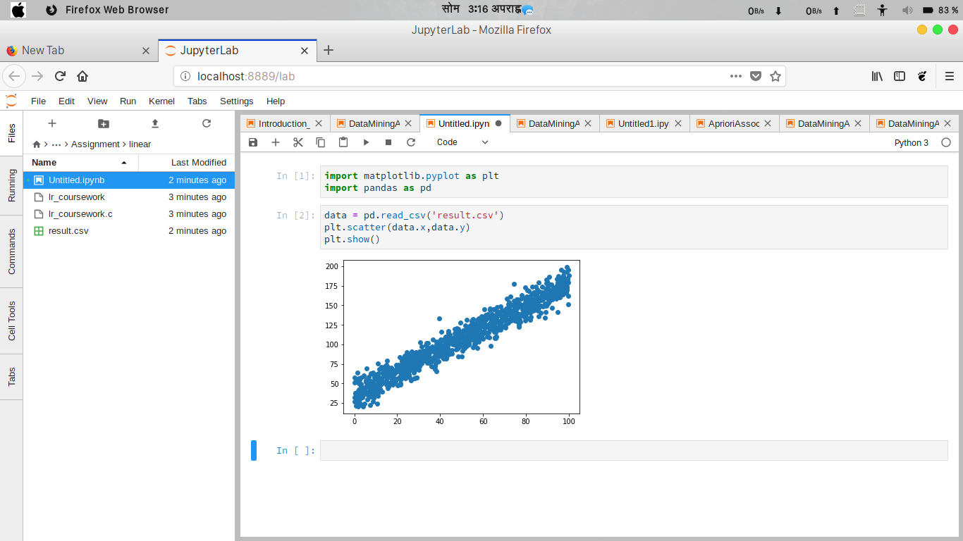

b. Have 3 guesses at the optimum values for m and c and present them in a graph that overlays your data.

The three initial guesses are:
1. m = 1.2 , c = 35
2. m = 1.75 , c = 40
3. m = 1.5 , c = 40
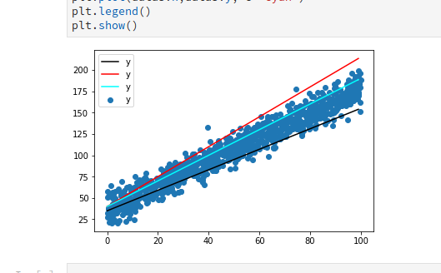

c. Insert a graph that presents your data with the solution overlaid.
My data,
m = 1.42 , c = 36.18
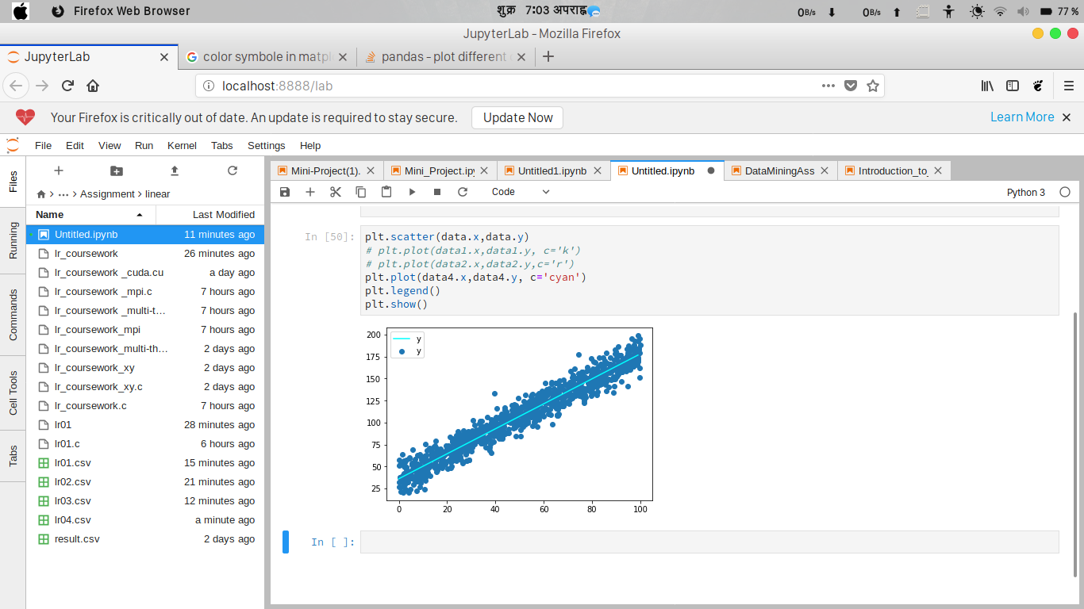

d. Insert a comment that compares your guesses with the solution found.

Linear regression multi-thread program.

#include <stdio.h>
#include <math.h>
#include <pthread.h>

/******************************************************************************
* This program takes an initial estimate of m and c and finds the associated
* rms error. It is then as a base to generate and evaluate 8 new estimates,
* which are steps in different directions in m-c space. The best estimate is
* then used as the base for another iteration of "generate and evaluate". This
* continues until none of the new estimates are better than the base. This is
* a gradient search for a minimum in mc-space by using thread.
*
* To compile:
* cc -o lr_coursework_multi-thread 'lr_coursework _multi-thread.c' -lm -pthread
*
* To run:
* ./lr_coursework_multi-thread
*
* Dr Kevan Buckley, University of Wolverhampton, 2018
*****************************************************************************/

typedef struct point_t {
double x;
double y;
} point_t;

int n_data = 1000;
point_t data[];

double residual_error(double x, double y, double m, double c) {
double e = (m * x) + c - y;
return e * e;
}

double bm = 1.3;
double bc = 10;
double be;
double dm[8];
double dc[8];
double e[8];
double step = 0.01;
double best_error = 999999999;
int best_error_i;
int minimum_found = 0;

double om[] = {0,1,1, 1, 0,-1,-1,-1};
double oc[] = {1,1,0,-1,-1,-1, 0, 1};

double rms_error(double m, double c) {
int i;
double mean;
double error_sum = 0;

for(i=0; i<n_data; i++) {
error_sum += residual_error(data[i].x, data[i].y, m, c);
}

mean = error_sum / n_data;

return sqrt(mean);
}

void *kernel_threads_function(void *args){
int *arg = args;
int i = *arg;
dm[i] = bm + (om[i] * step);
dc[i] = bc + (oc[i] * step);

e[i] = rms_error(dm[i], dc[i]);

if(e[i] < best_error) {
best_error = e[i];
best_error_i = i;
pthread_exit(NULL);
}
}

int time_difference(struct timespec *start,
struct timespec *finish,
long long int *difference) {
long long int ds = finish->tv_sec - start->tv_sec;
long long int dn = finish->tv_nsec - start->tv_nsec;

if(dn < 0 ) {
ds--;
dn += 1000000000;
}
*difference = ds * 1000000000 + dn;
return !(*difference > 0);
}

int main() {
int i;
pthread_t th[8];

be = rms_error(bm, bc);

struct timespec start, finish;
long long int time_elapsed;

clock_gettime(CLOCK_MONOTONIC, &start);

while(!minimum_found) {
for(i=0;i<8;i++) {
pthread_create(&th[i], NULL,(void*)kernel_threads_function , &i);
pthread_join(th[i],NULL);
}

/*printf("best m,c is %lf,%lf with error %lf in direction %d\n",
dm[best_error_i], dc[best_error_i], best_error, best_error_i);*/
if(best_error < be) {
be = best_error;
bm = dm[best_error_i];
bc = dc[best_error_i];
} else {
minimum_found = 1;
}
}

printf("minimum m,c is %lf,%lf with error %lf\n", bm, bc, be);

clock_gettime(CLOCK_MONOTONIC, &finish);
time_difference(&start, &finish, &time_elapsed);
printf("Time elapsed was %lldns or %0.9lfs\n", time_elapsed,
(time_elapsed/1.0e9));

return 0;
}

point_t data[] = {
{77.23,150.76},{79.80,130.99},{72.07,129.56},{68.54,135.57},
{83.81,149.30},{85.64,146.39},{76.45,131.33},{84.98,160.16},
{65.01,144.98},{78.23,138.68},{80.13,138.82},{14.69,60.34},
{15.27,56.88},{42.63,99.46},{49.53,108.22},{46.79,114.60},
{74.02,138.49},{68.93,143.70},{29.07,78.24},{22.66,57.23},
{13.55,60.50},{24.42,89.84},{69.63,141.88},{68.20,121.97},
{13.52,67.63},{98.18,171.90},{96.84,167.57},{15.31,79.26},
{81.15,155.58},{ 7.24,42.23},{92.34,171.28},{ 7.59,35.72},
{86.80,140.15},{94.64,164.89},{55.48,117.90},{94.96,162.89},
{27.86,70.22},{58.08,132.89},{66.77,128.47},{74.02,138.16},
{ 0.44,37.42},{24.84,61.83},{36.74,93.20},{ 6.16,36.15},
{ 8.67,46.12},{62.84,120.85},{91.14,160.36},{38.19,92.96},
{38.61,86.03},{ 4.54,41.42},{ 7.66,45.15},{90.28,151.89},
{66.28,136.36},{14.97,53.68},{99.09,181.15},{ 4.32,37.34},
{28.45,70.87},{51.71,106.37},{72.04,154.43},{92.30,157.78},
{43.08,107.99},{68.79,133.45},{21.91,66.64},{ 0.87,21.60},
{37.19,90.34},{34.04,84.70},{31.02,84.13},{44.61,88.35},
{14.38,51.01},{65.07,131.80},{25.28,83.50},{57.93,103.46},
{63.70,133.50},{61.95,135.18},{25.10,71.75},{ 7.30,35.50},
{27.96,56.29},{56.46,101.30},{64.09,138.41},{84.80,156.70},
{82.47,148.81},{65.74,115.48},{ 2.20,50.31},{79.73,146.57},
{99.84,195.89},{75.87,157.39},{99.03,169.23},{ 1.04,37.54},
{90.77,169.12},{44.44,112.84},{53.09,117.78},{29.20,74.15},
{ 8.14,48.53},{75.40,151.29},{ 0.36,51.74},{44.53,109.50},
{17.21,69.95},{82.10,153.97},{10.85,75.38},{11.03,37.76},
{43.62,95.03},{ 4.17,37.63},{42.83,86.76},{94.99,162.04},
{38.27,103.19},{ 8.92,31.66},{ 5.91,47.62},{72.11,147.98},
{21.67,50.12},{73.32,150.38},{89.72,162.56},{21.43,63.83},
{38.87,87.30},{57.55,108.29},{95.32,160.39},{50.51,102.08},
{40.26,105.93},{ 1.42,64.12},{88.47,165.02},{60.40,117.44},
{23.16,61.15},{31.47,97.11},{24.66,65.60},{15.71,66.86},
{53.25,100.04},{25.62,75.47},{65.53,127.89},{20.46,68.16},
{17.91,67.45},{58.56,110.59},{72.98,137.58},{41.63,81.83},
{52.35,131.31},{42.70,81.87},{18.82,63.87},{82.37,135.43},
{50.63,118.03},{26.69,86.74},{38.28,96.89},{79.50,149.35},
{91.93,176.52},{27.69,87.12},{27.88,71.18},{ 7.50,33.40},
{53.18,106.68},{42.09,92.69},{12.12,47.44},{55.74,126.06},
{12.73,71.40},{47.39,102.06},{66.37,128.93},{11.89,56.14},
{25.50,61.42},{60.54,145.01},{25.38,80.41},{51.70,119.33},
{78.77,138.83},{54.80,113.53},{67.44,128.89},{21.41,55.06},
{87.89,161.48},{30.29,84.74},{ 4.13,39.77},{73.32,136.32},
{30.56,102.27},{13.64,66.47},{46.86,119.54},{43.94,113.97},
{84.97,148.64},{32.25,79.23},{51.04,117.43},{ 7.29,40.56},
{65.26,144.83},{17.88,52.10},{23.29,75.11},{10.81,24.38},
{ 2.63,24.55},{80.69,147.49},{51.33,107.01},{87.47,164.31},
{55.04,131.68},{88.24,149.22},{55.56,108.54},{99.68,179.53},
{94.33,175.50},{32.96,85.35},{60.91,134.47},{22.09,82.19},
{25.30,78.38},{96.33,195.65},{77.88,138.48},{ 8.50,39.79},
{78.23,148.86},{69.41,135.14},{30.54,77.78},{46.23,102.68},
{89.37,178.40},{29.83,79.88},{71.53,129.01},{94.35,171.86},
{45.41,88.06},{51.08,106.12},{39.44,133.07},{82.63,164.06},
{22.72,64.40},{34.75,89.84},{23.32,63.71},{59.84,129.53},
{21.32,73.28},{95.18,170.16},{ 2.38,31.84},{96.41,173.78},
{31.43,83.49},{99.53,151.57},{73.88,138.10},{80.01,155.21},
{79.83,159.75},{ 2.96,57.46},{25.73,66.61},{79.91,157.52},
{55.94,118.26},{73.29,141.97},{80.19,151.77},{94.29,173.05},
{51.57,109.38},{49.58,128.08},{24.75,58.95},{ 7.00,33.41},
{70.50,130.74},{17.67,55.34},{37.63,68.25},{26.82,91.27},
{79.86,146.65},{10.04,56.42},{71.33,128.72},{64.98,121.51},
{32.35,87.64},{64.04,122.89},{45.95,103.56},{94.60,141.55},
{98.90,177.75},{40.96,86.52},{73.50,142.09},{25.03,62.52},
{52.53,98.14},{48.42,120.10},{87.03,156.45},{36.30,95.35},
{79.61,138.84},{20.66,67.92},{62.61,125.21},{ 2.90,23.00},
{98.68,165.89},{ 6.96,50.75},{39.79,104.21},{79.05,137.55},
{52.58,111.78},{80.68,141.45},{59.72,108.11},{16.10,67.64},
{34.04,88.73},{34.17,101.36},{19.48,64.44},{75.91,151.92},
{11.10,33.79},{77.63,158.42},{36.73,92.59},{75.41,146.27},
{23.88,69.67},{52.25,103.51},{85.09,149.96},{87.95,157.52},
{92.24,157.91},{43.90,87.27},{ 1.94,37.20},{43.01,83.71},
{65.13,116.23},{ 3.01,46.90},{22.24,68.17},{29.85,79.88},
{16.25,63.22},{43.43,99.49},{52.04,104.99},{ 2.45,29.99},
{52.39,110.43},{56.02,122.25},{96.73,169.43},{80.39,161.18},
{75.89,140.06},{83.85,143.76},{85.20,166.70},{ 7.88,35.14},
{80.19,134.04},{85.45,166.57},{39.31,102.76},{46.99,106.95},
{ 8.61,26.49},{75.77,151.27},{ 9.79,41.97},{58.14,121.89},
{95.44,180.82},{88.45,160.82},{55.43,109.57},{33.69,88.65},
{ 6.82,58.64},{10.68,62.46},{76.72,148.78},{61.42,131.59},
{74.44,177.54},{65.51,108.40},{64.69,119.39},{52.46,104.86},
{67.71,125.61},{96.16,182.97},{25.98,75.56},{69.79,122.21},
{80.36,153.17},{46.84,109.51},{75.33,144.70},{27.97,83.34},
{79.32,149.37},{89.43,183.03},{63.62,123.51},{64.08,125.41},
{31.31,75.90},{47.85,107.86},{31.41,87.37},{90.41,157.01},
{19.09,66.83},{85.48,147.29},{ 9.35,45.51},{78.32,145.47},
{40.27,92.98},{54.85,113.99},{36.07,77.94},{76.15,157.52},
{49.07,102.81},{38.90,95.01},{70.96,140.87},{39.03,87.93},
{33.72,84.07},{66.39,128.59},{44.04,108.08},{33.14,82.42},
{ 2.73,37.89},{26.45,77.66},{37.03,91.89},{54.00,124.50},
{63.59,134.17},{16.03,62.07},{ 0.31,32.38},{25.76,72.06},
{98.95,193.05},{78.40,150.31},{40.62,98.71},{64.81,137.01},
{97.67,169.77},{25.90,85.88},{ 2.96,41.00},{22.47,69.35},
{92.01,169.06},{95.45,164.77},{48.19,105.23},{ 7.76,52.64},
{ 7.21,40.27},{61.00,116.59},{ 2.23,40.79},{ 5.47,52.55},
{71.36,131.37},{68.30,118.58},{65.41,109.22},{45.47,100.67},
{41.21,87.43},{43.77,89.17},{91.86,166.20},{21.43,48.32},
{10.75,36.04},{70.80,139.92},{87.62,173.81},{37.35,95.39},
{75.73,137.61},{89.33,141.27},{15.56,70.91},{37.29,96.21},
{22.13,62.15},{89.49,149.91},{50.07,97.91},{65.22,122.88},
{63.93,130.94},{94.46,168.37},{38.82,88.52},{74.84,154.31},
{54.08,106.91},{62.50,133.84},{77.25,128.70},{16.46,67.64},
{73.45,139.73},{70.40,139.76},{94.44,163.56},{97.97,175.20},
{33.23,89.79},{81.72,146.38},{ 4.70,36.62},{74.68,148.95},
{72.68,140.81},{ 8.87,39.55},{94.28,183.46},{27.16,68.99},
{43.16,92.09},{53.48,101.44},{51.57,124.00},{75.99,156.88},
{94.41,174.23},{72.17,144.36},{71.46,131.88},{42.40,84.41},
{40.17,92.91},{27.88,88.57},{49.06,97.55},{14.86,48.97},
{73.36,140.86},{57.78,108.11},{84.53,158.66},{38.27,100.15},
{12.74,55.85},{14.22,61.66},{65.98,122.01},{63.38,143.72},
{37.68,71.66},{76.78,122.46},{75.28,133.60},{69.72,143.09},
{ 5.52,52.41},{74.35,139.08},{59.99,125.76},{65.64,133.87},
{60.07,107.21},{34.70,85.96},{ 4.61,24.00},{71.23,140.57},
{57.74,121.04},{ 4.23,21.04},{ 5.29,54.13},{25.21,81.66},
{56.30,124.65},{57.39,116.99},{85.46,154.23},{85.10,170.56},
{85.89,146.44},{11.25,63.44},{ 8.29,40.05},{79.22,135.00},
{59.96,123.38},{97.19,163.58},{59.92,116.15},{ 7.36,53.16},
{85.64,143.10},{10.47,41.00},{70.35,125.13},{ 6.02,50.75},
{73.95,139.07},{81.88,144.64},{42.93,104.10},{34.71,76.10},
{ 5.69,52.52},{48.59,84.24},{48.10,94.76},{30.71,88.16},
{68.56,136.98},{22.53,77.31},{16.95,63.73},{27.59,64.07},
{65.14,118.01},{75.78,146.28},{33.86,91.29},{98.93,171.89},
{83.61,167.09},{93.15,164.61},{35.08,95.68},{83.79,149.46},
{52.03,119.04},{23.64,85.42},{18.22,57.37},{74.06,138.99},
{50.25,84.46},{21.37,66.09},{61.15,137.81},{99.61,162.24},
{96.95,173.40},{43.05,95.67},{89.28,163.68},{79.99,158.47},
{59.69,130.55},{ 0.52,38.07},{49.77,111.52},{89.25,164.41},
{25.92,57.36},{81.92,152.67},{61.39,125.63},{29.09,57.77},
{23.31,81.37},{56.87,120.86},{74.59,142.88},{11.80,42.65},
{33.64,101.80},{99.49,184.80},{ 1.85,33.70},{88.99,152.68},
{90.98,186.45},{59.23,136.17},{47.73,120.71},{85.64,158.30},
{30.41,72.27},{20.02,67.23},{68.23,148.39},{15.82,45.42},
{80.29,149.38},{59.94,123.61},{92.82,159.34},{59.14,128.74},
{25.35,77.45},{71.64,145.51},{19.97,70.58},{89.04,171.14},
{53.43,99.51},{67.84,129.83},{54.76,107.18},{15.45,44.48},
{41.74,97.86},{30.68,89.22},{68.71,129.61},{76.58,125.21},
{64.96,129.77},{47.73,102.10},{92.55,169.95},{81.52,161.02},
{51.35,105.53},{56.53,123.58},{51.51,95.62},{59.01,124.59},
{16.29,63.29},{52.83,120.16},{97.68,184.76},{46.83,106.76},
{ 0.02,51.18},{26.76,80.54},{ 2.94,32.88},{87.10,157.17},
{36.90,71.20},{62.84,108.89},{16.87,66.87},{ 5.03,40.84},
{43.45,108.16},{38.04,75.39},{76.77,150.88},{74.60,139.64},
{40.12,91.15},{49.06,100.84},{94.95,184.68},{74.31,134.38},
{54.58,129.65},{86.95,160.05},{55.69,120.67},{22.24,56.35},
{39.13,90.38},{60.57,131.42},{18.30,53.91},{38.32,95.23},
{55.98,122.71},{13.06,52.26},{38.17,90.53},{95.59,168.64},
{18.62,61.91},{91.96,176.78},{21.70,63.04},{81.25,152.90},
{42.63,81.69},{70.76,137.17},{11.34,51.74},{13.05,39.96},
{48.79,110.92},{86.88,157.80},{27.50,76.94},{88.77,149.45},
{64.06,118.59},{85.27,147.23},{81.98,143.52},{84.58,156.89},
{98.89,174.03},{34.99,82.30},{92.73,172.82},{ 0.75,35.91},
{ 8.61,52.25},{19.10,53.49},{41.42,106.22},{47.89,106.29},
{83.85,148.92},{23.87,57.76},{88.54,165.40},{94.60,173.80},
{19.56,68.73},{54.48,120.93},{67.85,119.02},{24.27,74.92},
{78.18,159.68},{51.03,109.92},{33.42,98.61},{77.69,136.60},
{40.97,84.93},{ 4.75,39.85},{25.01,87.53},{11.52,68.65},
{34.40,78.01},{13.79,65.82},{ 6.27,56.21},{44.00,103.71},
{83.26,143.34},{49.88,101.41},{73.05,140.87},{52.12,104.77},
{66.38,121.93},{87.42,166.29},{ 3.08,43.40},{97.34,169.74},
{31.67,81.37},{66.59,140.38},{45.21,102.87},{41.90,88.79},
{76.28,138.48},{ 1.57,39.23},{42.25,103.21},{43.90,116.91},
{ 3.74,32.26},{ 5.85,46.20},{12.12,51.00},{96.69,164.76},
{10.84,38.65},{63.15,121.09},{62.55,115.31},{42.63,87.47},
{28.87,77.89},{40.33,103.79},{54.09,121.41},{18.21,65.54},
{ 5.68,69.26},{85.82,136.13},{17.38,62.76},{81.55,154.58},
{77.85,163.45},{84.33,163.20},{20.70,57.52},{84.73,173.72},
{86.17,167.83},{10.73,46.04},{71.83,151.69},{29.03,85.40},
{66.88,141.73},{98.13,177.38},{30.52,76.72},{75.67,134.21},
{34.35,77.06},{89.94,181.44},{95.53,176.57},{25.20,76.67},
{40.27,99.43},{33.58,84.87},{63.60,128.21},{90.24,173.53},
{70.81,145.77},{65.90,122.10},{ 5.06,37.13},{72.71,132.60},
{14.98,74.10},{25.67,80.69},{32.04,92.28},{37.97,87.84},
{47.47,93.50},{90.41,154.15},{ 7.68,45.93},{65.44,123.28},
{33.96,76.14},{79.75,154.15},{72.74,161.05},{69.83,135.64},
{29.13,74.88},{81.07,152.23},{ 9.39,57.45},{54.28,115.35},
{58.15,119.42},{47.87,95.57},{29.20,71.41},{23.84,56.54},
{69.13,132.86},{ 9.92,57.01},{84.33,146.61},{69.75,134.84},
{63.33,127.11},{50.30,101.96},{ 7.43,22.18},{21.08,58.29},
{63.42,98.06},{ 6.04,51.75},{88.80,134.59},{10.57,48.82},
{14.86,59.58},{38.78,89.65},{ 8.60,63.72},{ 3.05,49.55},
{79.64,140.40},{61.74,114.00},{47.51,110.09},{37.02,83.39},
{22.32,78.38},{10.91,53.39},{97.40,188.44},{97.81,192.36},
{46.23,100.00},{84.68,160.74},{56.35,103.47},{87.88,148.54},
{11.47,48.34},{74.44,155.79},{24.04,77.24},{85.92,156.32},
{95.47,166.23},{50.51,99.85},{79.61,150.41},{56.65,126.88},
{10.18,46.83},{94.11,165.73},{16.84,68.82},{ 1.32,53.18},
{35.24,82.85},{76.50,133.97},{49.70,115.78},{84.58,154.89},
{ 2.58,54.96},{28.05,56.88},{39.27,84.67},{ 1.26,26.79},
{37.45,81.33},{26.01,83.07},{72.33,139.74},{ 8.92,61.33},
{95.21,187.73},{12.96,57.68},{47.92,99.43},{20.09,47.75},
{74.33,144.70},{36.15,79.94},{83.59,153.50},{ 5.37,46.07},
{98.97,198.88},{85.91,179.15},{95.38,169.13},{85.64,160.16},
{56.06,100.60},{96.89,176.63},{83.93,150.17},{48.80,111.06},
{22.27,79.22},{95.58,173.58},{56.49,124.20},{92.03,146.39},
{66.49,131.04},{39.22,90.96},{17.98,48.44},{ 1.00,33.27},
{80.50,169.11},{82.88,173.50},{57.92,111.58},{68.90,130.96},
{38.65,87.82},{20.49,73.50},{58.10,106.58},{38.99,88.07},
{41.65,91.96},{82.00,140.65},{33.81,91.57},{23.62,78.38},
{75.76,151.93},{40.42,116.08},{30.84,84.99},{76.73,148.69},
{ 7.81,62.57},{66.31,134.40},{70.76,143.33},{16.91,60.19},
{ 8.16,44.28},{72.52,138.18},{28.13,66.46},{70.97,126.90},
{54.46,112.39},{61.94,110.06},{45.47,92.99},{90.78,156.57},
{66.08,109.59},{12.35,56.66},{17.23,52.58},{71.21,158.27},
{61.22,122.83},{50.62,117.43},{26.52,54.24},{57.46,126.25},
{28.74,90.15},{10.49,48.72},{62.11,138.78},{79.20,140.57},
{73.06,141.61},{19.01,52.29},{15.35,51.63},{98.03,174.79},
{19.43,73.68},{57.18,95.12},{28.71,84.43},{56.17,114.52},
{12.66,50.03},{35.83,78.66},{73.95,137.25},{96.68,169.26},
{13.12,70.59},{72.84,142.80},{80.36,150.96},{29.96,67.92},
{41.51,98.54},{51.54,102.60},{81.96,131.69},{74.14,138.07},
{10.89,57.54},{68.18,127.68},{ 2.46,49.79},{51.99,119.32},
{11.65,55.78},{75.74,132.46},{80.32,146.13},{96.60,165.24},
{66.52,147.54},{18.28,66.38},{66.88,138.55},{66.37,141.96},
{94.67,179.38},{56.35,108.03},{74.57,130.64},{59.22,113.97},
{52.15,104.28},{46.60,107.63},{60.24,126.30},{75.58,129.28},
{47.49,100.09},{96.21,162.75},{20.45,68.77},{39.10,94.83},
{29.27,76.85},{ 8.94,36.23},{97.54,167.51},{13.40,64.23},
{26.77,72.87},{85.95,157.69},{11.91,43.38},{65.80,107.86},
{41.47,89.57},{77.07,131.29},{ 2.25,41.23},{21.29,83.85},
{97.15,164.38},{33.93,89.39},{90.07,158.68},{ 1.90,32.41},
{59.48,126.95},{18.54,62.78},{36.23,97.52},{86.61,160.14},
{28.96,57.15},{15.98,67.67},{58.71,127.68},{45.96,105.75},
{90.77,155.07},{72.45,143.70},{40.83,85.07},{40.26,94.81},
{ 7.74,52.45},{42.50,102.66},{ 6.20,30.04},{40.97,97.68},
{57.38,131.11},{81.44,168.91},{ 2.14,42.62},{47.76,106.77},
{82.71,158.27},{97.74,181.81},{57.87,122.41},{99.50,182.94},
{77.02,151.94},{39.36,86.25},{ 2.21,56.76},{55.28,132.20},
{74.87,132.06},{42.57,109.85},{10.54,46.27},{68.74,123.83},
{99.98,188.43},{35.14,89.08},{79.73,145.31},{95.77,160.03},
{81.03,147.97},{26.37,71.29},{97.06,185.07},{90.27,164.86},
{84.43,162.64},{77.12,138.46},{78.68,141.56},{60.29,129.14},
{11.58,45.54},{47.52,115.01},{50.02,113.78},{95.50,184.29},
{43.90,87.31},{50.31,92.19},{57.40,110.42},{41.27,95.48},
{52.73,122.70},{97.37,181.72},{87.18,156.97},{ 0.27,27.24},
{32.53,78.79},{94.39,163.45},{29.47,74.81},{20.24,73.08},
{ 4.56,59.03},{38.65,90.42},{63.17,145.59},{12.77,49.40},
{14.36,72.37},{71.92,127.46},{35.96,72.29},{54.82,105.88},
{30.31,90.56},{70.58,121.99},{46.53,104.57},{83.62,164.66},
{10.50,43.60},{27.90,68.17},{46.54,100.24},{48.49,115.46},
{53.57,109.34},{19.56,55.62},{81.20,152.35},{55.46,96.62},
{94.19,158.45},{56.27,124.61},{80.51,146.14},{67.37,141.02},
{31.71,89.49},{93.04,161.28},{42.11,91.72},{33.56,93.79},
{ 4.44,60.08},{ 8.21,47.86},{90.51,177.18},{27.26,73.60},
{29.63,85.02},{52.43,112.75},{73.07,130.27},{ 1.79,20.71},
{28.08,81.49},{51.24,117.62},{47.53,109.75},{79.66,172.71},
{15.43,51.60},{39.10,78.55},{48.00,114.36},{ 2.19,39.04},
{16.43,49.62},{47.88,102.29},{24.64,68.34},{57.88,127.64},
{34.97,95.54},{ 4.03,42.88},{10.94,60.98},{36.51,105.88},
{74.16,142.76},{25.29,69.47},{59.63,112.76},{ 2.42,39.41},
{61.17,115.63},{ 0.02,57.34},{82.24,158.82},{84.95,156.06},
{38.16,65.51},{29.66,89.43},{84.26,144.66},{37.30,90.54},
{47.88,108.10},{99.07,171.56},{ 5.35,46.07},{91.88,159.90},
{66.92,118.74},{51.63,104.98},{86.92,149.65},{91.78,168.41}
};

/******************************************************************************/

e. Insert a table that shows running times for the original and multi-thread versions.

Calculating running times for the original program and for multi-thread version.
 | Time for original program in second. | Time for multi-thread program in second.
1st | 0.153255700 | 0.729684644
2nd | 0.154264022 | 0.730370932
3rd | 0.153620850 | 0.729603310
4th | 0.155420145 | 0.739406606
5th | 0.152466764 | 0.720501911
6th | 0.150451341 | 0.730797864
7th | 0.155607034 | 0.731083206
8th | 0.151813714 | 0.712123609
9th | 0.153453562 | 0.744400154
10th | 0.153750012 | 0.707047138
Total time: | 1.534103144 | 7.275019374
Mean Time: | 0.1534103144 | 0.7275019374

From above table the mean time to run an original program is 0.1534103144 sec and for multi-thread program mean time is 0.7275019374 sec. Which shows that the multi-thread program took more time to execute compared to original program because in multi-thread program each of the evaluations i.e. eights values for m and c, performs on a different thread. So, it took more time than the original one.

2 CUDA

2.1 Password Cracking

CUDA based Password Cracking program.

#include <cuda_runtime_api.h>
#include <stdlib.h>
#include <stdio.h>
#include <string.h>
#include <time.h>

/***********************************************************************
**

Compile with:
nvcc -o CrackAZ99-With-Data-cuda CrackAZ99-With-Data-cuda.cu

To run program:
./CrackAZ99-With-Data-cuda

Dr Kevan Buckley, University of Wolverhampton, 2018
************************************************************************
******/

/****************************************************************************
This function returns 1 if the attempt at cracking the password is
identical to the plain text password string stored in the program.
Otherwise,it returns 0.
*****************************************************************************/

__device__ int is_a_match(char *attempt) {
char plain_pwd[] = "ML4249";
char plain_pwd1[] = "PE3462";
char plain_pwd2[] = "UM4598";
char plain_pwd3[] = "GT9859";

char *a = attempt;
char *p = plain_pwd;
char *q = plain_pwd1;
char *r = plain_pwd2;
char *s = plain_pwd3;

while(*a == *p) {
if(*a == '\0') {
return 1;
}
a++;
p++;

}

while(*a == *q) {
if(*a == '\0') {
return 1;
}
a++;
q++;

}

while(*a == *r) {
if(*a == '\0') {
return 1;
}
a++;
r++;

}

while(*a == *s) {
if(*a == '\0') {
return 1;
}
a++;
s++;

}

return 0;
}

/****************************************************************************
The kernel function run in 675 threads uses
nested loops to generate all possible passwords and test whether they match
the hidden password.
*****************************************************************************/

__global__ void crack() {
char alpha[26]= {'A','B','C','D','E','F','G','H','I','J','K','L','M','N','O','P','Q','R','S','T','U','V','W','X','Y','Z'};

char num[10] = {'0','1','2','3','4','5','6','7','8','9'};

char result[7];
result[6] = '\0';
int e, f, g, h;
for(e=0;e<=9;e++) {
for(f=0; f<=9; f++) {
for(g=0; g<=9; g++) {
for(h=0; h<=9; h++) {
result[0] = alpha[blockIdx.x];
result[1] = alpha[threadIdx.x];
result[2] = num[e];
result[3] = num[f];
result[4] = num[g];
result[5] = num[h];
if(is_a_match(result)) {
printf("password found: %s\n", result);
} else {
//printf("tried: %s\n", result);
}
}
}
}
}
}

int time_difference(struct timespec *start, struct timespec *finish,
long long int *difference) {
long long int ds = finish->tv_sec - start->tv_sec;
long long int dn = finish->tv_nsec - start->tv_nsec;

if(dn < 0 ) {
ds--;
dn += 1000000000;
}
*difference = ds * 1000000000 + dn;
return !(*difference > 0);
}

int main(int argc, char *argv[]) {
struct timespec start, finish
;
long long int time_elapsed;

clock_gettime(CLOCK_MONOTONIC, &start);

crack <<<26, 26>>>();
cudaThreadSynchronize();

clock_gettime(CLOCK_MONOTONIC, &finish);
time_difference(&start, &finish, &time_elapsed);
printf("Time elapsed was %lldns or %0.9lfs\n", time_elapsed,
(time_elapsed/1.0e9));

return 0;
}

/*****************************************************************************/

a. Insert a table that shows running times for the original, multi-thread and CUDA versions.

Calculating running times for the original program, multi-thread version and CUDA version.
S.NO. | Time for original program. | Time for multi-thread program. | Time for CUDA program.
1st | 852.086086160 Sec | 424.101145135 Sec | 0.109940907 Sec
2nd | 852.851117573 Sec | 428.928177644 Sec | 0.103769861 Sec
3rd | 866.621660790 Sec | 428.028800344 Sec | 0.103947175 Sec
4th | 841.839096854 Sec | 426.398617337 Sec | 0.106515338 Sec
5th | 870.891680057 Sec | 432.247245291 Sec | 0.111379871 Sec
6th | 825.242112556 Sec | 430.344344965 Sec | 0.107143562 Sec
7th | 864.673123279 Sec | 430.50855403 Sec | 0.111375666 Sec
8th | 877.859196113 Sec | 431.871656769 Sec | 0.110901209 Sec
9th | 871.069347481 Sec | 433.916258052 Sec | 0.109263462 Sec
10th | 854.746969314 Sec | 475.311364531 Sec | 0.115912735 Sec
Total time: | 8577.88039018 Sec | 4341.656164098 Sec | 1.090149786 Sec
Mean Time in sec: | 857.788039018 Sec | 434.1656164098 Sec | 0.1090149786 Sec
Mean Time in Min : | 14.296467317 Min | 7.23609360683 Min | 0.00181691631 Min

b. Write a short analysis of the results
Ans:
From above table the mean time to run an original program is 14.296467317 Min and for multi-thread program mean time is 7.23609360683 Min and for CUDA program mean time is 0.1090149786 Sec or 0.00181691631 Min. CUDA version crack password faster than other two program because in CUDA password cracking program runs parallel over 675 threads. So, it is fastest among other two program.

2.2 Image Processing

CUDA based image processing program.

#include <stdio.h>
#include <stdlib.h>
#include <time.h>
#include <GL/glut.h>
#include <GL/gl.h>
#include <malloc.h>
#include <signal.h>
#include <cuda_runtime_api.h>
/******************************************************************************
Displays two grey scale images. On the left is an image that has come from an
image processing pipeline, just after colour thresholding. On the right is
the result of applying an edge detection convolution operator to the left
image. This program performs that convolution.

Things to note:
- A single unsigned char stores a pixel intensity value. 0 is black, 256 is
white.
- The colour mode used is GL_LUMINANCE. This uses a single number to
represent a pixel's intensity. In this case we want 256 shades of grey,
which is best stored in eight bits, so GL_UNSIGNED_BYTE is specified as
the pixel data type.

To compile adapt the code below wo match your filenames:
nvcc -o ip_coursework_014_CUDA 'ip_coursework_014 .cu' -lglut -lGL -lm

To run the program:

./ip_coursework_014_CUDA

Dr Kevan Buckley, University of Wolverhampton, 2018
******************************************************************************/
#define width 100
#define height 72

unsigned char data[width * height];

unsigned char image[] = {0,0,0,0,0,0,0,0,0,0,0,0,0,0,0,0,0,0,
0,0,0,0,0,0,0,0,0,0,0,0,0,0,0,0,0,0,0,
0,0,0,0,0,0,0,0,0,0,0,0,0,0,0,0,0,0,0,
0,0,0,0,0,0,0,0,0,0,0,0,0,0,0,0,0,0,0,
0,0,0,0,0,0,0,0,0,0,0,0,0,0,0,0,0,0,0,
0,0,0,0,0,0,0,0,0,0,0,0,0,0,0,0,0,0,0,
0,0,0,0,0,0,0,0,0,0,0,0,0,0,0,0,0,0,0,
0,0,0,0,0,0,0,0,0,0,0,0,0,0,0,0,0,0,0,
0,0,0,0,0,0,0,0,0,0,0,0,0,0,0,0,0,0,0,
0,0,0,0,0,0,0,0,0,0,0,0,0,0,0,0,0,0,0,
0,0,0,0,0,0,0,0,0,0,0,0,0,255,255,255,255,255,255,
255,255,255,255,255,255,255,255,255,255,255,255,255,255,255,255,255,255,255,
255,255,255,255,255,255,255,255,255,255,255,255,255,255,255,255,255,255,255,
255,255,255,255,255,255,255,255,255,255,255,255,255,255,255,255,255,255,255,
255,255,255,255,255,255,255,255,255,255,255,255,255,255,255,255,255,255,255,
255,255,255,255,255,255,255,255,255,255,255,255,255,255,255,255,0,255,255,
255,255,255,255,255,255,255,255,255,255,255,255,255,255,255,255,255,255,255,
255,255,255,255,255,255,255,255,255,255,255,255,255,255,255,255,255,255,255,
255,255,255,255,255,255,255,255,255,255,255,255,255,255,255,255,255,255,255,
255,255,255,255,255,255,255,255,255,255,255,255,255,255,255,255,255,255,255,
255,255,255,255,255,255,255,255,255,255,255,255,255,255,255,255,255,255,255,
255,255,0,255,255,255,255,255,255,255,255,255,255,255,255,255,255,255,255,
255,255,255,255,255,255,255,255,255,255,255,255,255,255,255,255,255,255,255,
255,255,255,255,255,255,255,255,255,255,255,255,255,255,255,255,255,255,255,
255,255,255,255,255,255,255,255,255,255,255,255,255,255,255,255,255,255,255,
255,255,255,255,255,255,255,255,255,255,255,255,255,255,255,255,255,255,255,
255,255,255,255,255,255,255,0,255,255,255,255,255,255,255,255,255,255,255,
255,255,255,255,255,255,255,255,255,255,255,255,255,255,255,255,255,255,255,
255,255,255,255,255,255,255,255,255,255,255,255,255,255,255,255,255,255,255,
255,255,255,255,255,255,255,255,255,255,255,255,255,255,255,255,255,255,255,
255,255,255,255,255,255,255,255,255,255,255,255,255,255,255,255,255,255,255,
255,255,255,255,255,255,255,255,255,255,255,255,0,255,255,255,255,255,255,
255,255,255,255,255,255,255,255,255,255,255,255,255,255,255,255,255,255,255,
255,255,255,255,255,255,255,255,255,255,255,255,255,255,255,255,255,255,255,
255,255,255,255,255,255,255,255,255,255,255,255,255,255,255,255,255,255,255,
255,255,255,255,255,0,0,255,255,255,255,255,255,0,0,0,255,255,255,
255,255,255,255,255,255,255,255,255,255,255,255,255,255,255,255,0,0,255,
255,255,255,255,255,255,255,255,255,255,255,255,255,255,255,255,255,255,255,
255,255,255,255,255,255,255,255,255,255,255,255,255,255,255,255,255,255,255,
255,255,255,255,255,255,255,255,255,255,255,255,255,255,255,255,255,255,255,
255,255,255,255,255,255,255,255,255,255,0,0,255,255,255,255,255,255,0,
0,0,255,255,255,255,255,255,255,255,255,255,255,255,255,255,255,255,255,
255,255,0,0,255,255,255,255,255,255,255,255,255,255,255,255,255,255,255,
255,255,255,255,255,255,255,255,255,255,255,255,255,255,255,255,255,255,255,
255,255,255,255,255,255,255,255,255,255,255,255,255,255,255,255,255,255,255,
255,255,255,255,255,255,255,255,255,255,255,255,255,255,255,0,0,255,255,
255,255,255,255,0,0,255,255,255,255,255,255,255,255,255,255,255,255,255,
255,255,255,255,255,255,255,0,0,255,255,255,255,255,255,255,255,255,255,
255,255,255,255,255,255,255,255,255,255,255,255,255,255,255,255,255,255,255,
255,255,255,255,255,255,255,255,255,255,255,255,255,255,255,255,255,255,255,
255,255,255,255,255,255,255,255,255,255,255,255,255,255,255,255,255,255,255,
255,0,0,0,255,255,255,255,0,0,0,255,255,255,255,255,255,255,255,
255,255,255,255,255,255,255,255,255,255,255,255,0,0,255,255,255,255,255,
255,255,255,255,255,255,255,255,255,255,255,255,255,255,255,255,255,255,255,
255,255,255,255,255,255,255,255,255,255,255,255,255,255,255,255,255,255,255,
255,255,255,255,255,255,255,255,255,255,255,255,255,255,255,255,255,255,255,
255,255,255,255,255,255,0,0,0,255,255,255,255,0,0,0,255,255,255,
255,255,255,255,255,255,255,255,255,255,255,255,255,255,255,255,255,0,0,
255,255,255,255,255,255,255,255,255,255,255,255,255,255,255,255,255,255,255,
255,0,0,0,0,255,255,255,255,255,255,255,255,255,255,255,255,255,255,
255,255,255,255,255,255,255,255,255,255,255,255,255,255,255,255,255,255,255,
255,255,255,255,255,255,255,255,255,255,255,0,0,0,255,255,255,0,0,
0,0,255,255,255,255,255,255,255,255,255,255,255,255,255,255,255,255,255,
255,255,255,0,0,255,255,255,255,255,255,255,255,255,255,255,255,255,255,
255,255,255,255,255,0,0,0,0,255,255,255,255,255,255,255,255,255,255,
255,255,255,255,255,255,255,255,255,255,255,255,255,255,255,255,255,255,255,
255,255,255,255,255,255,255,255,255,255,255,255,255,255,255,255,0,0,0,
0,255,255,0,0,0,255,255,255,255,255,255,255,255,255,255,255,255,255,
255,255,255,255,255,255,255,255,0,0,255,255,255,255,255,255,255,255,255,
255,255,255,255,255,255,255,255,255,0,0,0,0,0,255,255,255,255,255,
255,0,0,0,0,0,0,0,0,255,255,255,255,255,255,255,255,255,255,
255,255,255,255,255,255,255,255,255,255,255,255,255,255,255,255,255,255,255,
255,255,0,0,0,0,255,0,0,0,0,255,255,255,255,255,255,255,255,
255,255,255,255,255,255,255,255,255,255,255,255,255,0,0,255,255,255,255,
255,255,255,255,255,255,255,255,255,255,255,255,255,255,0,0,0,0,0,
0,0,0,0,0,0,0,0,0,0,0,0,0,0,0,255,255,255,255,
255,255,255,255,255,255,255,255,255,255,255,255,255,255,255,255,255,255,255,
255,255,255,255,255,255,255,255,0,0,0,0,0,0,0,255,255,255,255,
255,255,255,255,255,255,255,255,255,255,255,255,255,255,255,255,255,0,0,
0,255,255,255,255,255,255,255,255,255,255,255,255,255,255,255,255,255,0,
0,0,0,0,0,0,0,0,0,0,0,0,0,0,0,0,0,0,0,
0,255,255,255,255,255,255,255,255,255,255,255,255,255,255,255,255,255,255,
255,255,255,255,255,255,255,255,255,255,255,255,255,0,0,0,0,0,0,
0,255,255,255,255,255,255,255,255,255,255,255,255,255,255,255,255,255,255,
255,255,255,0,0,0,255,255,255,255,255,255,255,255,255,255,255,255,255,
255,255,255,255,0,0,0,0,0,0,0,0,0,0,0,0,0,0,0,
0,0,0,0,0,0,255,255,255,255,255,255,255,255,255,255,255,255,255,
255,255,255,255,255,255,255,255,255,255,255,255,255,255,255,255,255,255,0,
0,0,0,0,0,255,255,255,255,255,255,255,255,255,0,255,255,255,255,
255,255,255,255,255,255,255,255,0,0,0,255,255,255,255,255,255,255,255,
255,255,255,255,255,255,255,255,255,255,0,0,0,0,0,0,0,255,255,
255,255,255,255,255,255,255,255,255,255,255,255,255,255,255,255,255,255,255,
255,255,255,255,255,255,255,255,255,255,255,255,255,255,255,255,255,255,255,
255,0,0,255,0,0,0,0,0,255,255,255,0,255,255,0,0,255,0,
255,255,255,255,255,255,255,255,255,255,255,255,255,0,0,0,255,255,255,
255,255,255,255,255,255,255,255,255,255,255,255,255,255,255,255,0,0,0,
0,255,255,255,0,255,255,255,255,255,255,255,255,0,0,255,255,255,255,
255,255,255,255,255,255,255,255,255,255,255,255,255,255,255,255,255,255,255,
255,255,255,255,0,0,0,0,255,0,0,0,0,0,255,255,0,255,0,
0,255,255,255,255,255,255,255,255,255,255,255,255,255,255,255,255,255,0,
0,0,255,255,255,255,255,255,255,255,255,255,255,255,255,255,255,255,255,
255,255,255,0,0,0,0,255,255,255,255,0,255,255,255,255,255,0,0,
0,255,255,255,255,255,255,255,255,255,255,255,255,255,255,255,255,255,255,
255,255,255,255,255,255,255,255,255,0,0,0,0,0,0,0,0,0,0,
255,255,0,0,0,0,255,255,255,255,255,255,255,255,255,255,255,255,255,
255,255,255,255,0,0,0,255,255,255,255,255,255,255,255,255,255,255,255,
255,255,255,255,255,255,255,255,255,255,255,255,255,255,255,255,255,255,0,
0,255,255,0,0,255,255,255,255,255,255,255,255,255,255,255,255,255,255,
255,255,255,255,255,255,255,255,255,255,255,255,255,255,0,0,0,0,0,
0,0,0,0,0,255,0,0,0,0,255,255,255,255,255,255,255,255,255,
255,255,255,255,255,255,255,255,255,0,0,0,255,255,255,255,255,255,255,
255,255,255,255,255,255,255,255,255,255,255,255,255,255,255,255,255,255,255,
255,255,255,255,255,255,255,255,255,255,255,255,255,255,255,255,255,255,255,
255,255,255,255,255,255,255,255,255,255,255,255,255,255,255,255,255,255,255,
255,255,0,0,0,0,0,0,0,0,0,0,0,0,255,255,255,255,255,
255,255,255,255,255,255,255,255,255,255,255,255,255,0,0,0,0,255,255,
255,255,255,255,255,255,255,255,255,255,255,255,255,255,255,255,255,255,255,
255,255,255,255,255,255,255,255,255,255,255,255,255,255,255,255,255,255,255,
255,255,255,255,255,255,255,255,255,255,255,255,255,255,255,255,255,255,255,
255,255,255,255,255,255,255,0,0,0,0,0,0,0,0,0,0,255,255,
255,255,255,255,255,255,255,255,255,255,255,255,255,255,255,255,255,255,0,
0,0,0,255,255,255,255,255,255,255,255,255,255,255,255,255,255,255,255,
255,255,255,255,255,255,255,255,255,255,255,255,255,255,255,255,255,255,255,
255,255,255,255,255,255,255,255,255,255,255,255,255,255,255,255,255,255,255,
255,255,255,255,255,255,255,255,255,255,255,255,0,0,0,0,0,0,0,
0,0,0,255,255,255,255,255,255,255,255,255,255,255,255,255,255,255,255,
255,255,255,255,0,0,0,0,255,255,255,255,255,255,255,255,255,255,255,
255,255,255,255,255,255,255,255,255,255,255,255,255,255,255,255,255,255,255,
255,255,255,255,255,255,255,255,255,255,255,255,255,255,255,255,255,255,255,
255,255,255,255,255,255,255,255,255,255,255,255,255,255,255,255,255,255,0,
0,0,0,0,0,0,0,255,255,255,255,255,255,255,255,255,255,255,255,
255,255,255,255,255,255,255,255,255,0,0,0,0,255,255,255,255,255,255,
255,255,255,255,255,255,255,255,255,255,255,255,255,255,255,255,255,255,255,
255,255,255,255,255,255,255,255,255,255,255,255,255,255,255,255,255,255,255,
255,255,255,255,255,255,255,255,255,255,255,255,255,255,255,255,255,255,255,
255,255,255,255,255,0,0,0,0,0,0,0,255,255,255,255,255,255,255,
255,255,255,255,255,255,255,255,255,255,255,255,255,255,0,0,0,0,255,
255,255,255,255,255,255,255,255,255,255,255,255,255,255,255,255,255,255,255,
255,255,255,255,255,255,255,255,255,255,255,255,255,255,255,255,255,255,255,
255,255,255,255,255,255,255,255,255,255,255,255,255,255,255,255,255,255,255,
255,255,255,255,255,255,255,255,255,255,255,255,0,0,0,0,255,255,255,
255,255,255,255,255,255,255,255,255,255,255,255,255,255,255,255,255,255,255,
0,0,0,0,0,255,255,255,255,255,255,255,255,255,255,255,255,255,255,
255,255,255,255,255,255,255,255,255,255,255,255,255,255,255,255,255,255,255,
255,255,255,255,255,255,255,255,255,255,255,255,255,255,255,255,255,255,255,
255,255,255,255,255,255,255,255,255,255,255,255,255,255,255,255,255,255,255,
0,0,0,255,255,255,255,255,255,255,255,255,255,255,255,255,255,255,255,
255,255,255,255,255,0,0,0,0,0,255,255,255,255,255,255,255,255,255,
255,255,255,255,255,255,255,255,255,255,255,255,255,255,255,255,255,255,255,
255,255,255,255,255,255,255,255,255,255,255,255,255,255,255,255,255,255,255,
255,255,255,255,255,255,255,255,255,255,255,255,255,255,255,255,255,255,255,
255,255,255,255,255,0,0,0,0,255,255,255,255,255,255,255,255,255,255,
255,255,255,255,255,255,255,255,255,255,0,0,0,0,0,255,255,255,255,
255,255,255,255,255,255,255,255,255,255,255,255,255,255,255,255,255,255,255,
255,255,255,255,255,255,255,255,255,255,255,255,255,255,255,255,255,255,255,
255,255,255,255,255,255,255,255,255,255,255,255,255,255,255,255,255,255,255,
255,255,255,255,255,255,255,255,255,255,0,0,0,255,255,255,255,255,255,
255,255,255,255,255,255,255,255,255,255,255,255,255,255,255,0,0,0,0,
0,255,255,255,255,255,255,255,255,255,255,255,255,255,255,255,255,255,255,
255,255,255,255,255,255,255,255,255,255,255,255,255,255,255,255,255,255,255,
255,255,255,255,255,255,255,255,255,255,255,255,255,255,255,255,255,255,255,
255,255,255,255,255,255,255,255,255,255,255,255,255,255,255,255,0,0,255,
255,255,255,255,255,255,255,255,255,255,255,255,255,255,255,255,255,255,255,
255,0,0,0,0,0,255,255,255,255,255,255,255,255,255,255,255,255,255,
255,255,255,255,255,255,255,255,255,255,255,255,255,255,255,255,255,255,255,
255,255,255,255,255,255,255,255,255,255,255,255,255,255,255,255,255,255,255,
255,255,255,255,255,255,255,255,255,255,255,255,255,255,255,255,255,255,255,
255,255,255,255,255,255,255,255,255,255,255,255,255,255,255,255,255,255,255,
255,255,255,255,255,255,0,0,0,0,0,255,255,255,255,255,255,255,255,
255,255,255,255,255,255,255,255,255,255,255,255,255,255,255,255,255,255,255,
255,255,255,255,255,255,255,255,255,255,255,255,255,255,255,255,255,255,255,
255,255,255,255,255,255,255,255,255,255,255,255,255,255,255,255,255,255,255,
255,255,255,255,255,255,255,255,255,255,255,255,255,255,255,255,255,255,255,
255,255,255,255,255,255,255,255,255,255,0,0,0,0,0,0,255,255,255,
255,255,255,255,255,255,255,255,255,255,255,255,255,255,255,255,255,255,255,
255,255,255,255,255,255,255,255,255,255,255,255,255,0,0,0,255,255,255,
255,0,0,0,255,255,255,0,0,0,0,255,0,0,255,255,255,0,0,
255,255,255,255,255,255,255,255,255,255,255,255,255,255,255,255,255,255,255,
255,255,255,255,255,255,255,255,255,255,255,255,255,255,255,0,0,0,0,
0,0,255,255,255,255,255,255,255,255,255,255,255,255,255,255,255,255,255,
255,255,255,255,255,255,255,255,255,255,255,255,255,255,255,255,255,0,0,
0,0,0,255,255,0,0,0,0,0,255,0,0,0,0,0,0,0,0,
255,255,0,0,0,0,255,255,255,255,255,255,255,255,255,255,255,255,255,
255,255,255,255,255,255,255,255,255,255,255,255,255,255,255,255,255,255,255,
255,0,0,0,0,0,0,255,255,255,255,255,255,255,255,255,255,255,255,
255,255,255,255,255,255,255,255,255,255,255,255,255,255,255,255,255,255,255,
255,255,0,0,0,255,0,0,0,0,0,0,255,0,0,0,0,0,255,
0,0,0,0,0,255,255,0,0,255,255,255,255,255,255,255,255,255,255,
255,255,255,255,255,255,255,255,255,255,255,255,255,255,255,255,255,255,255,
255,255,255,255,255,255,0,0,0,0,0,0,255,255,255,255,255,255,255,
255,255,255,255,255,255,255,255,255,255,255,255,255,255,255,255,255,255,255,
255,255,255,255,255,255,0,0,0,255,255,255,255,255,0,0,255,255,0,
0,0,0,0,255,0,0,0,0,0,255,255,0,0,255,255,255,255,255,
255,255,255,255,255,255,255,255,255,255,255,255,255,255,255,255,255,255,255,
255,255,255,255,255,255,255,255,255,255,255,0,0,0,0,0,0,255,255,
255,255,255,255,255,255,255,255,255,255,255,255,255,255,255,255,255,255,255,
255,255,255,255,255,255,255,255,255,255,255,0,0,0,255,255,255,255,255,
0,0,0,0,0,0,0,0,0,255,0,0,0,0,0,0,0,0,0,
0,255,255,255,255,255,255,255,255,255,255,255,255,255,255,255,255,255,255,
255,255,255,255,255,255,255,255,255,255,255,255,255,255,255,255,0,0,0,
0,0,0,255,255,255,255,255,255,255,255,255,255,255,255,255,255,255,255,
255,255,255,255,255,255,255,255,255,255,255,255,255,255,255,255,0,0,0,
255,255,255,0,255,255,0,0,0,0,255,0,0,255,255,0,0,0,0,
0,0,0,0,0,0,255,255,255,255,255,255,255,255,255,255,255,255,255,
255,255,255,255,255,255,255,255,255,255,255,255,255,255,255,255,255,255,255,
255,255,0,0,0,0,0,0,255,255,255,255,255,255,255,255,255,255,255,
255,255,255,255,255,255,255,255,255,255,255,255,255,255,255,255,255,255,255,
255,255,255,0,0,0,0,0,0,0,255,255,255,255,255,255,255,255,255,
255,255,255,255,255,255,255,0,0,0,255,255,255,255,255,255,255,255,255,
255,255,255,255,255,255,255,255,255,255,255,255,255,255,255,255,255,255,255,
255,255,255,255,255,255,255,0,0,0,0,0,0,255,255,255,255,255,255,
255,255,255,255,255,255,255,255,255,255,255,255,255,255,255,255,255,255,255,
255,255,255,255,255,255,255,255,0,0,0,0,0,0,255,255,255,255,255,
255,255,255,255,255,255,255,255,255,255,255,255,255,0,0,255,255,255,255,
255,255,255,255,255,255,255,255,255,255,255,255,255,255,255,255,255,255,255,
255,255,255,255,255,255,255,255,255,255,255,0,0,0,0,0,0,0,255,
255,255,255,255,255,255,255,255,255,255,255,255,255,255,255,255,255,255,255,
255,255,255,255,255,255,255,255,255,255,255,255,255,255,255,0,0,255,255,
255,255,255,255,255,255,255,255,255,255,255,255,255,255,255,255,255,255,255,
255,255,255,255,255,255,255,255,255,255,255,255,255,255,255,255,255,255,255,
255,255,255,255,255,255,255,255,255,255,255,255,255,255,255,255,0,0,0,
0,0,0,0,255,255,255,255,255,255,255,255,255,255,255,255,255,255,255,
255,255,255,255,255,255,255,255,255,255,255,255,255,255,255,255,255,255,255,
255,255,255,255,255,255,255,255,255,255,255,255,255,255,255,255,255,255,255,
255,255,255,255,255,255,255,255,255,255,255,255,255,255,255,255,255,255,255,
255,255,255,255,255,255,255,255,255,255,255,255,255,255,255,255,255,255,255,
255,255,0,0,0,0,0,0,0,255,255,255,255,255,255,255,255,255,255,
255,255,255,255,255,255,255,255,255,255,255,255,255,255,255,255,255,255,255,
255,255,255,255,255,255,255,255,255,255,255,255,255,255,255,255,255,255,255,
255,255,255,255,255,255,255,255,255,255,255,255,255,255,255,255,255,255,255,
255,255,255,255,255,255,255,255,255,255,255,255,255,255,255,0,0,0,255,
255,255,255,255,255,255,255,0,0,0,0,0,0,0,255,255,255,255,255,
255,255,255,255,255,255,255,255,255,255,255,255,255,255,255,255,255,255,255,
255,255,255,255,255,255,255,255,255,255,255,255,255,255,255,255,255,255,255,
255,255,255,255,255,255,255,255,255,255,255,255,255,255,255,255,255,255,255,
255,255,255,255,255,255,255,255,255,255,255,255,255,255,255,255,255,255,255,
255,0,0,0,255,255,255,255,255,255,255,255,0,0,0,0,0,0,0,
255,255,255,255,255,255,255,255,255,255,255,255,255,255,255,255,255,255,255,
255,255,255,255,255,255,255,255,255,255,255,255,255,255,0,255,255,255,0,
255,255,255,255,255,255,0,0,0,0,0,255,255,255,255,255,255,0,0,
0,255,255,255,0,0,0,0,255,255,0,0,0,0,0,0,0,255,255,
0,255,255,0,0,0,255,0,0,255,255,255,255,255,255,255,255,0,0,
0,0,0,0,0,255,255,255,255,255,255,255,255,0,0,0,0,0,255,
255,0,0,255,255,0,0,0,0,0,255,255,0,0,255,0,0,0,255,
0,0,255,0,0,0,255,255,255,255,0,0,0,0,0,0,255,255,255,
255,0,0,0,0,0,0,255,0,0,0,0,0,255,0,0,0,0,0,
0,0,0,255,0,0,255,0,0,0,255,255,0,0,0,255,255,255,255,
255,255,255,0,0,0,0,0,0,0,255,255,255,255,255,255,255,255,0,
0,255,255,0,0,255,0,0,255,255,0,0,255,0,0,255,0,0,0,
0,0,0,0,0,0,0,255,0,0,255,255,255,255,0,0,255,0,0,
0,0,255,255,255,255,0,0,255,255,0,0,0,0,0,0,0,0,0,
0,0,255,0,0,0,0,0,255,0,0,255,0,0,255,255,0,0,0,
0,255,255,255,255,255,255,255,0,0,0,0,0,0,0,255,255,255,255,
255,255,255,0,0,255,255,255,255,255,255,0,0,255,255,0,0,255,0,
0,255,0,0,0,0,0,0,0,0,0,0,255,0,0,255,255,255,255,
0,0,0,0,0,0,0,255,255,255,0,0,0,255,255,255,255,255,0,
0,0,0,0,0,0,0,255,0,0,0,0,0,255,0,0,255,0,0,
255,255,0,0,0,0,255,255,255,255,255,255,0,0,0,0,0,0,0,
0,255,255,255,255,255,255,255,0,0,255,255,255,255,255,255,0,0,255,
0,0,0,255,0,0,0,0,0,0,0,0,0,0,0,0,0,255,0,
0,255,255,255,255,255,0,0,0,255,255,255,255,255,255,0,0,0,255,
255,255,255,255,0,0,0,0,0,255,0,0,255,0,0,0,0,0,0,
0,0,0,0,0,0,0,0,255,0,0,255,255,255,255,255,255,0,0,
0,0,0,0,0,0,255,255,255,255,255,255,255,0,0,255,255,255,255,
255,255,0,0,0,0,0,0,0,0,0,0,0,255,0,0,0,255,0,
0,0,0,0,0,0,255,255,255,255,255,0,0,0,0,255,255,255,255,
255,0,0,0,255,255,0,0,255,255,0,0,0,0,255,0,0,255,0,
0,255,0,0,0,0,255,0,0,0,0,0,0,255,255,0,255,255,255,
255,255,255,0,0,0,0,0,0,0,0,255,255,255,255,255,255,255,255,
0,0,255,255,0,0,255,255,255,255,255,255,0,0,255,255,255,255,255,
255,255,255,255,255,255,255,255,255,255,255,255,255,255,255,255,0,0,0,
0,255,255,255,255,255,255,0,0,0,0,0,0,255,255,255,255,255,255,
255,255,255,255,255,255,255,255,255,255,255,255,255,0,0,255,255,255,255,
255,255,255,255,255,255,255,255,0,0,0,0,0,0,0,0,255,255,255,
255,255,255,255,255,255,0,0,0,0,255,255,255,255,255,255,255,255,255,
255,255,255,255,255,255,255,255,255,255,255,255,255,255,255,255,255,255,255,
255,255,0,0,0,0,255,255,255,255,255,255,255,0,0,0,0,255,255,
255,255,255,255,255,255,255,255,255,255,255,255,255,255,255,255,255,255,255,
255,255,255,255,255,255,255,255,255,255,255,255,255,0,0,0,0,0,0,
0,0,255,255,255,255,255,255,255,255,255,255,255,255,255,255,255,255,255,
255,255,255,255,255,255,255,255,255,255,255,255,255,255,255,255,255,255,255,
255,255,255,255,255,255,255,255,255,255,255,255,255,255,255,255,255,255,255,
255,255,255,255,255,255,255,255,255,255,255,255,255,255,255,255,255,255,255,
255,255,255,255,255,255,255,255,255,255,255,255,255,255,255,255,255,255,0,
0,0,0,0,0,0,0,255,255,255,255,255,255,255,255,255,255,255,255,
255,255,255,255,255,255,255,255,255,255,255,255,255,255,255,255,255,255,255,
255,255,255,255,255,255,255,255,255,255,255,255,255,255,255,255,255,255,255,
255,255,255,255,255,255,255,255,255,255,255,255,255,255,255,255,255,255,255,
255,255,255,255,255,255,255,255,255,255,255,255,255,255,255,255,255,255,255,
255,255,255,255,0,0,0,0,0,0,0,0,255,255,255,255,255,255,255,
255,255,255,255,255,255,255,255,255,255,255,255,255,255,255,255,255,255,255,
255,255,255,255,255,255,255,255,255,255,255,255,255,255,255,255,255,255,255,
255,255,255,255,255,255,255,255,255,255,255,255,255,255,255,255,255,255,255,
0,255,255,255,255,255,255,255,255,255,255,255,255,255,255,255,255,255,255,
255,255,255,255,255,255,255,255,0,0,0,0,0,0,0,0,0,255,255,
255,255,255,255,255,255,255,255,255,255,255,255,255,255,255,255,255,255,255,
255,255,255,255,255,255,255,255,255,255,255,255,255,255,255,255,255,255,255,
255,255,255,255,255,255,255,255,255,255,255,255,255,255,255,255,255,255,255,
255,255,255,255,0,0,255,255,255,255,255,255,255,255,255,255,255,255,255,
255,255,255,255,0,255,255,255,255,255,255,255,255,0,0,0,0,0,0,
0,0,0,255,255,255,255,255,255,255,255,255,255,255,255,255,255,255,255,
255,255,255,255,0,0,255,255,255,0,0,255,255,0,0,255,255,255,0,
0,0,255,255,0,255,255,255,0,255,255,0,0,255,0,0,0,0,0,
0,0,255,0,0,255,0,0,255,0,0,0,0,0,255,255,0,0,0,
255,0,0,0,0,255,0,0,255,0,0,255,255,255,255,255,255,255,0,
0,0,0,0,0,0,0,0,255,255,255,255,255,255,255,255,255,255,0,
0,0,255,0,0,0,255,255,0,0,0,0,255,0,0,0,255,0,0,
0,255,255,0,0,0,0,255,255,0,0,255,0,0,0,255,0,0,0,
0,0,0,0,255,0,0,255,0,0,255,0,0,255,0,0,0,0,0,
255,0,0,0,255,0,0,0,0,0,255,0,0,255,0,0,255,255,255,
255,255,255,255,0,0,0,0,0,0,0,0,0,255,255,255,255,255,255,
255,255,255,255,0,0,0,255,0,0,0,255,0,0,255,0,0,0,0,
0,255,255,0,0,0,0,255,0,0,255,0,255,255,0,0,255,0,0,
255,255,0,0,0,0,0,0,0,255,0,0,255,0,0,255,0,0,255,
0,0,255,255,0,0,0,0,255,255,0,0,255,0,0,255,0,255,0,
0,255,255,255,255,255,255,255,255,0,0,0,0,0,0,0,0,0,255,
255,255,255,255,255,255,255,255,255,0,0,0,255,0,0,0,255,0,0,
255,255,0,0,0,0,255,255,0,0,0,0,255,0,0,0,0,0,255,
0,0,255,0,0,255,255,0,0,255,0,0,0,0,255,0,0,255,0,
0,255,0,0,255,0,0,255,0,0,255,0,0,255,255,0,0,255,0,
0,0,0,0,0,0,255,255,255,255,255,255,255,255,0,0,0,0,0,
0,0,0,0,255,255,255,255,255,255,255,255,255,0,0,0,0,0,0,
255,0,255,0,0,0,0,0,255,0,0,255,0,0,255,0,0,255,0,
0,0,0,0,0,0,0,0,0,0,0,0,0,255,0,0,0,0,0,
255,0,0,0,0,0,0,0,0,255,0,0,0,0,0,0,0,0,0,
255,0,0,0,0,255,0,0,0,0,0,255,255,255,255,255,255,255,255,
0,0,0,0,0,0,0,0,0,255,255,255,255,255,255,255,255,255,0,
0,255,0,0,0,255,0,0,255,0,0,0,0,255,0,0,255,0,0,
255,255,0,255,0,0,0,0,255,255,0,0,0,0,0,0,0,0,255,
255,0,0,0,255,255,0,0,0,0,0,0,0,255,255,0,0,0,0,
255,255,0,0,255,255,255,0,0,255,255,255,255,255,255,255,255,255,255,
255,255,255,255,255,0,0,0,0,0,0,0,0,0,255,255,255,255,255,
255,255,255,255,0,0,255,0,0,0,255,0,0,255,255,255,255,255,255,
0,0,255,255,255,255,255,255,255,255,255,255,255,255,255,255,255,255,0,
0,255,255,255,255,255,255,255,255,255,255,255,255,255,255,255,255,255,255,
255,255,255,255,255,255,255,0,0,255,255,255,255,255,255,255,255,255,255,
255,255,255,255,255,255,255,255,255,255,0,0,0,0,0,0,0,0,0,
255,255,255,255,255,255,255,255,255,0,255,255,255,0,255,255,0,0,255,
255,255,255,255,255,0,0,255,255,255,255,255,255,255,255,255,255,255,255,
255,255,255,255,0,0,255,255,255,255,255,255,255,255,255,255,255,255,255,
255,255,255,255,255,255,255,255,255,255,255,255,255,255,255,255,255,255,255,
255,255,255,255,255,255,255,255,255,255,255,255,255,255,255,0,0,0,0,
0,0,0,0,0,255,255,255,255,255,255,255,255,255,255,255,255,255,255,
255,255,255,255,255,255,255,255,255,255,255,255,255,255,255,255,255,255,255,
255,255,255,255,255,255,255,255,255,255,255,255,255,255,255,255,255,255,255,
255,255,255,255,255,255,255,255,255,255,255,255,255,255,255,255,255,255,255,
255,255,255,255,255,255,255,255,255,255,255,255,255,255,255,255,255,255,255,
0,0,0,0,0,0,0,0,0,0,255,255,255,255,255,255,255,255,255,
255,255,255,255,255,255,255,255,255,255,255,255,255,255,255,255,255,255,255,
255,255,255,255,255,255,255,255,255,255,255,255,255,255,255,255,255,255,255,
255,255,255,255,255,255,255,255,255,255,255,255,255,255,255,255,255,255,255,
255,255,255,255,255,255,255,255,255,255,255,255,255,255,255,255,255,255,255,
255,0,0,0,0,0,0,0,0,0,0,0,0,0,0,0,0,255,255,
255,255,255,255,255,255,255,255,255,255,255,255,255,255,255,255,255,255,255,
255,255,255,255,255,255,255,255,255,255,255,255,255,255,255,255,255,255,255,
255,255,255,255,255,255,255,255,255,255,255,255,255,255,255,255,255,255,255,
255,255,255,255,255,255,255,255,255,255,0,0,0,0,0,0,0,0,0,
0,0,0,0,0,0,0,0,0,0,0,0,0,0,0,0,0,0,0,
0,0,0,0,0,0,0,0,0,0,0,0,0,0,0,0,0,0,0,
0,0,0,0,0,0,0,0,0,0,0,0,0,0,0,0,0,0,0,
0,0,0,0,0,0,0,0,0,0,0,0,0,0,0,0,0,0,0,
0,0,0,0,0,0,0,0,0,0,0,0,0,0,0,0,0,0,0,
0,0,0,0,0,0,0,0,0,0,0,0,0,0,0,0,0,0,0,
0,0,0,0,0,0,0,0,0,0,0,0,0,0,0,0,0,0,0,
0,0,0,0,0,0,0,0,0,0,0,0,0,0,0,0,0,0,0,
0,0,0,0,0,0,0,0,0,0,0,0,0,0,0,0,0,0,0,
0,0,0,0,0,0,0,0,0,0,0,0,0,0,0,0,0,0,0,
0,0,0,0,0,0,0,0,0,0,0,0,0,0,0,0,0,0,0,
0,0,0,0,0,0,0,0,0,0,0,0,0,0,0,0,0,0,0,
0,0,0,0,0,0,0,0,0,0,0,0,0,0,0,0,0,0,0,
0,0,0,0,0,0,0,0,0,0,0,0,0,0,0,0,0,0,0,
0,0,0,0,0,0,0,0,0,0,0,0,0,0,0,0,0,0,0,
0,0,0,0,0,0,0,0,0,0,0,0,0,0,0,0,0,0,0,
0,0,0,0,0,0,0,0,0,0,0,0,0,0,0,0,0,0,0,
0,0,0,0,0,0,0,0,0,0,255,0,0,0,0,0,0,0,0,
0,0,0,0,0,0,0,0,0,0,0,0,0,0,0,0,0,0,0,
0,0,0,0,0,0,0,0,0,0,0,0,0,0,0,0,0,0,0,
0,0,0,0,0,0,0,0,0,0,0,0,0,0,0,0,0,0,0,
0,0,0,0,0,0,0,0,0,0,0,0,0,0,0,0,0,0,0
};
__global__ void detect_edges(unsigned char *in, unsigned char *out) {
unsigned int i = blockIdx.x ;

int x, y; // the pixel of interest
int b, d, f, h; // the pixels adjacent to x,y used for the calculation
int r; // the result of calculate

y = i / 100;
x = i - (100 * y);

if (x == 0 || y == 0 || x == width - 1 || y == height - 1) {
out[i] = 0;
} else {
b = i + width;
d = i - 1;
f = i + 1;
h = i - width;

r = (in[i] * 4) + (in[b] * -1) + (in[d] * -1) + (in[f] * -1)
+ (in[h] * -1);

if (r > 0) { // if the result is positive this is an edge pixel
out[i] = 255;
} else {
out[i] = 0;
}
}
}

void tidy_and_exit() {
exit(0);
}

void sigint_callback(int signal_number){
printf("\nInterrupt from keyboard\n");
tidy_and_exit();
}

static void display() {
glClear(GL_COLOR_BUFFER_BIT);
glRasterPos4i(-1, -1, 0, 1);
glDrawPixels(width, height, GL_LUMINANCE, GL_UNSIGNED_BYTE, image);
glRasterPos4i(0, -1, 0, 1);
glDrawPixels(width, height, GL_LUMINANCE, GL_UNSIGNED_BYTE, data);
glFlush();
}

static void key_pressed(unsigned char key, int x, int y) {
switch(key){
case 27: // escape
tidy_and_exit();
break;
default:
printf("\nPress escape to exit\n");
break;
}
}

int time_difference(struct timespec *start, struct timespec *finish,
long long int *difference) {
long long int ds = finish->tv_sec - start->tv_sec;
long long int dn = finish->tv_nsec - start->tv_nsec;

if(dn < 0 ) {
ds--;
dn += 1000000000;
}
*difference = ds * 1000000000 + dn;
return !(*difference > 0);
}

int main(int argc, char **argv) {
signal(SIGINT, sigint_callback);

printf("image dimensions %dx%d\n", width, height);
unsigned char *device_data;
unsigned char *device_image;

struct timespec start, finish;
long long int time_elapsed;

clock_gettime(CLOCK_MONOTONIC, &start);

cudaMalloc((void**)&device_data, sizeof(unsigned char) * (width * height));
cudaMalloc((void**)&device_image, sizeof(unsigned char) * (width * height) );
cudaMemcpy(device_image, &image, sizeof(unsigned char) * (width * height), cudaMemcpyHostToDevice);
cudaMemcpy(&device_data, &data, sizeof(unsigned char) * (width * height), cudaMemcpyHostToDevice);

detect_edges <<<7200, 1>>>(device_image, device_data);
cudaThreadSynchronize();

cudaMemcpy(&data, device_data, sizeof(unsigned char) * (width * height), cudaMemcpyDeviceToHost);
cudaMemcpy(&image, &device_image, sizeof(unsigned char) * (width * height), cudaMemcpyDeviceToHost);

cudaFree(&device_image);
cudaFree(&device_data);

clock_gettime(CLOCK_MONOTONIC, &finish);
time_difference(&start, &finish, &time_elapsed);
printf("Time elapsed was %lldns or %0.9lfs\n", time_elapsed,
(time_elapsed/1.0e9));

glutInit(&argc, argv);
glutInitWindowSize(width * 2,height);
glutInitDisplayMode(GLUT_SINGLE | GLUT_LUMINANCE);

glutCreateWindow("6CS005 Image Progessing Courework");
glutDisplayFunc(display);
glutKeyboardFunc(key_pressed);
glClearColor(0.0, 1.0, 0.0, 1.0);

glutMainLoop();

tidy_and_exit();

return 0;
}

/*****************************************************************************/

b. Insert a table that shows running times for the original, multi-thread and CUDA versions.

Calculating running times for the original program, multi-thread version and CUDA version.
 | Time for original program in second. | Time for multi-thread program in second. | Time for CUDA program in second.
1st | 0.000244189 | 0.000276838 | 0.075386513
2nd | 0.000158769 | 0.000386129 | 0.074686924
3rd | 0.000134126 | 0.000563675 | 0.076007492
4th | 0.000124196 | 0.000390902 | 0.074578661
5th | 0.000320527 | 0.000624942 | 0.072643177
6th | 0.000182322 | 0.00058715 | 0.080916637
7th | 0.000297749 | 0.000371939 | 0.078102321
8th | 0.000330665 | 0.000629257 | 0.078525085
9th | 0.000338829 | 0.000600857 | 0.078103622
10th | 0.000286728 | 0.000544998 | 0.080501337
Total time: | 0.0024181 | 0.004976687 | 0.769451769
Mean Time: | 0.00024181 | 0.0004976687 | 0.0769451769

Write a short analysis of the results

2.3 Linear Regression
a. CUDA version Linear Regression Program.

#include <stdio.h>
#include <math.h>
#include <time.h>
#include <cuda_runtime_api.h>
#include <errno.h>
#include<malloc.h>

/******************************************************************************
* This program takes an initial estimate of m and c and finds the associated
* rms error. It is then as a base to generate and evaluate 8 new estimates,
* which are steps in different directions in m-c space. The best estimate is
* then used as the base for another iteration of "generate and evaluate". This
* continues until none of the new estimates are better than the base. This is
* a gradient search for a minimum in mc-space.
*
* To compile:
* nvcc -o lr_coursework_cuda 'lr_coursework _cuda.cu' -lm
*
* To run:
* ./lr_coursework_cu
*
* Dr Kevan Buckley, University of Wolverhampton, 2018
*****************************************************************************/
typedef struct point_t {
double x;
double y;
} point_t;

point_t data[] = {
{77.23,150.76},{79.80,130.99},{72.07,129.56},{68.54,135.57},
{83.81,149.30},{85.64,146.39},{76.45,131.33},{84.98,160.16},
{65.01,144.98},{78.23,138.68},{80.13,138.82},{14.69,60.34},
{15.27,56.88},{42.63,99.46},{49.53,108.22},{46.79,114.60},
{74.02,138.49},{68.93,143.70},{29.07,78.24},{22.66,57.23},
{13.55,60.50},{24.42,89.84},{69.63,141.88},{68.20,121.97},
{13.52,67.63},{98.18,171.90},{96.84,167.57},{15.31,79.26},
{81.15,155.58},{ 7.24,42.23},{92.34,171.28},{ 7.59,35.72},
{86.80,140.15},{94.64,164.89},{55.48,117.90},{94.96,162.89},
{27.86,70.22},{58.08,132.89},{66.77,128.47},{74.02,138.16},
{ 0.44,37.42},{24.84,61.83},{36.74,93.20},{ 6.16,36.15},
{ 8.67,46.12},{62.84,120.85},{91.14,160.36},{38.19,92.96},
{38.61,86.03},{ 4.54,41.42},{ 7.66,45.15},{90.28,151.89},
{66.28,136.36},{14.97,53.68},{99.09,181.15},{ 4.32,37.34},
{28.45,70.87},{51.71,106.37},{72.04,154.43},{92.30,157.78},
{43.08,107.99},{68.79,133.45},{21.91,66.64},{ 0.87,21.60},
{37.19,90.34},{34.04,84.70},{31.02,84.13},{44.61,88.35},
{14.38,51.01},{65.07,131.80},{25.28,83.50},{57.93,103.46},
{63.70,133.50},{61.95,135.18},{25.10,71.75},{ 7.30,35.50},
{27.96,56.29},{56.46,101.30},{64.09,138.41},{84.80,156.70},
{82.47,148.81},{65.74,115.48},{ 2.20,50.31},{79.73,146.57},
{99.84,195.89},{75.87,157.39},{99.03,169.23},{ 1.04,37.54},
{90.77,169.12},{44.44,112.84},{53.09,117.78},{29.20,74.15},
{ 8.14,48.53},{75.40,151.29},{ 0.36,51.74},{44.53,109.50},
{17.21,69.95},{82.10,153.97},{10.85,75.38},{11.03,37.76},
{43.62,95.03},{ 4.17,37.63},{42.83,86.76},{94.99,162.04},
{38.27,103.19},{ 8.92,31.66},{ 5.91,47.62},{72.11,147.98},
{21.67,50.12},{73.32,150.38},{89.72,162.56},{21.43,63.83},
{38.87,87.30},{57.55,108.29},{95.32,160.39},{50.51,102.08},
{40.26,105.93},{ 1.42,64.12},{88.47,165.02},{60.40,117.44},
{23.16,61.15},{31.47,97.11},{24.66,65.60},{15.71,66.86},
{53.25,100.04},{25.62,75.47},{65.53,127.89},{20.46,68.16},
{17.91,67.45},{58.56,110.59},{72.98,137.58},{41.63,81.83},
{52.35,131.31},{42.70,81.87},{18.82,63.87},{82.37,135.43},
{50.63,118.03},{26.69,86.74},{38.28,96.89},{79.50,149.35},
{91.93,176.52},{27.69,87.12},{27.88,71.18},{ 7.50,33.40},
{53.18,106.68},{42.09,92.69},{12.12,47.44},{55.74,126.06},
{12.73,71.40},{47.39,102.06},{66.37,128.93},{11.89,56.14},
{25.50,61.42},{60.54,145.01},{25.38,80.41},{51.70,119.33},
{78.77,138.83},{54.80,113.53},{67.44,128.89},{21.41,55.06},
{87.89,161.48},{30.29,84.74},{ 4.13,39.77},{73.32,136.32},
{30.56,102.27},{13.64,66.47},{46.86,119.54},{43.94,113.97},
{84.97,148.64},{32.25,79.23},{51.04,117.43},{ 7.29,40.56},
{65.26,144.83},{17.88,52.10},{23.29,75.11},{10.81,24.38},
{ 2.63,24.55},{80.69,147.49},{51.33,107.01},{87.47,164.31},
{55.04,131.68},{88.24,149.22},{55.56,108.54},{99.68,179.53},
{94.33,175.50},{32.96,85.35},{60.91,134.47},{22.09,82.19},
{25.30,78.38},{96.33,195.65},{77.88,138.48},{ 8.50,39.79},
{78.23,148.86},{69.41,135.14},{30.54,77.78},{46.23,102.68},
{89.37,178.40},{29.83,79.88},{71.53,129.01},{94.35,171.86},
{45.41,88.06},{51.08,106.12},{39.44,133.07},{82.63,164.06},
{22.72,64.40},{34.75,89.84},{23.32,63.71},{59.84,129.53},
{21.32,73.28},{95.18,170.16},{ 2.38,31.84},{96.41,173.78},
{31.43,83.49},{99.53,151.57},{73.88,138.10},{80.01,155.21},
{79.83,159.75},{ 2.96,57.46},{25.73,66.61},{79.91,157.52},
{55.94,118.26},{73.29,141.97},{80.19,151.77},{94.29,173.05},
{51.57,109.38},{49.58,128.08},{24.75,58.95},{ 7.00,33.41},
{70.50,130.74},{17.67,55.34},{37.63,68.25},{26.82,91.27},
{79.86,146.65},{10.04,56.42},{71.33,128.72},{64.98,121.51},
{32.35,87.64},{64.04,122.89},{45.95,103.56},{94.60,141.55},
{98.90,177.75},{40.96,86.52},{73.50,142.09},{25.03,62.52},
{52.53,98.14},{48.42,120.10},{87.03,156.45},{36.30,95.35},
{79.61,138.84},{20.66,67.92},{62.61,125.21},{ 2.90,23.00},
{98.68,165.89},{ 6.96,50.75},{39.79,104.21},{79.05,137.55},
{52.58,111.78},{80.68,141.45},{59.72,108.11},{16.10,67.64},
{34.04,88.73},{34.17,101.36},{19.48,64.44},{75.91,151.92},
{11.10,33.79},{77.63,158.42},{36.73,92.59},{75.41,146.27},
{23.88,69.67},{52.25,103.51},{85.09,149.96},{87.95,157.52},
{92.24,157.91},{43.90,87.27},{ 1.94,37.20},{43.01,83.71},
{65.13,116.23},{ 3.01,46.90},{22.24,68.17},{29.85,79.88},
{16.25,63.22},{43.43,99.49},{52.04,104.99},{ 2.45,29.99},
{52.39,110.43},{56.02,122.25},{96.73,169.43},{80.39,161.18},
{75.89,140.06},{83.85,143.76},{85.20,166.70},{ 7.88,35.14},
{80.19,134.04},{85.45,166.57},{39.31,102.76},{46.99,106.95},
{ 8.61,26.49},{75.77,151.27},{ 9.79,41.97},{58.14,121.89},
{95.44,180.82},{88.45,160.82},{55.43,109.57},{33.69,88.65},
{ 6.82,58.64},{10.68,62.46},{76.72,148.78},{61.42,131.59},
{74.44,177.54},{65.51,108.40},{64.69,119.39},{52.46,104.86},
{67.71,125.61},{96.16,182.97},{25.98,75.56},{69.79,122.21},
{80.36,153.17},{46.84,109.51},{75.33,144.70},{27.97,83.34},
{79.32,149.37},{89.43,183.03},{63.62,123.51},{64.08,125.41},
{31.31,75.90},{47.85,107.86},{31.41,87.37},{90.41,157.01},
{19.09,66.83},{85.48,147.29},{ 9.35,45.51},{78.32,145.47},
{40.27,92.98},{54.85,113.99},{36.07,77.94},{76.15,157.52},
{49.07,102.81},{38.90,95.01},{70.96,140.87},{39.03,87.93},
{33.72,84.07},{66.39,128.59},{44.04,108.08},{33.14,82.42},
{ 2.73,37.89},{26.45,77.66},{37.03,91.89},{54.00,124.50},
{63.59,134.17},{16.03,62.07},{ 0.31,32.38},{25.76,72.06},
{98.95,193.05},{78.40,150.31},{40.62,98.71},{64.81,137.01},
{97.67,169.77},{25.90,85.88},{ 2.96,41.00},{22.47,69.35},
{92.01,169.06},{95.45,164.77},{48.19,105.23},{ 7.76,52.64},
{ 7.21,40.27},{61.00,116.59},{ 2.23,40.79},{ 5.47,52.55},
{71.36,131.37},{68.30,118.58},{65.41,109.22},{45.47,100.67},
{41.21,87.43},{43.77,89.17},{91.86,166.20},{21.43,48.32},
{10.75,36.04},{70.80,139.92},{87.62,173.81},{37.35,95.39},
{75.73,137.61},{89.33,141.27},{15.56,70.91},{37.29,96.21},
{22.13,62.15},{89.49,149.91},{50.07,97.91},{65.22,122.88},
{63.93,130.94},{94.46,168.37},{38.82,88.52},{74.84,154.31},
{54.08,106.91},{62.50,133.84},{77.25,128.70},{16.46,67.64},
{73.45,139.73},{70.40,139.76},{94.44,163.56},{97.97,175.20},
{33.23,89.79},{81.72,146.38},{ 4.70,36.62},{74.68,148.95},
{72.68,140.81},{ 8.87,39.55},{94.28,183.46},{27.16,68.99},
{43.16,92.09},{53.48,101.44},{51.57,124.00},{75.99,156.88},
{94.41,174.23},{72.17,144.36},{71.46,131.88},{42.40,84.41},
{40.17,92.91},{27.88,88.57},{49.06,97.55},{14.86,48.97},
{73.36,140.86},{57.78,108.11},{84.53,158.66},{38.27,100.15},
{12.74,55.85},{14.22,61.66},{65.98,122.01},{63.38,143.72},
{37.68,71.66},{76.78,122.46},{75.28,133.60},{69.72,143.09},
{ 5.52,52.41},{74.35,139.08},{59.99,125.76},{65.64,133.87},
{60.07,107.21},{34.70,85.96},{ 4.61,24.00},{71.23,140.57},
{57.74,121.04},{ 4.23,21.04},{ 5.29,54.13},{25.21,81.66},
{56.30,124.65},{57.39,116.99},{85.46,154.23},{85.10,170.56},
{85.89,146.44},{11.25,63.44},{ 8.29,40.05},{79.22,135.00},
{59.96,123.38},{97.19,163.58},{59.92,116.15},{ 7.36,53.16},
{85.64,143.10},{10.47,41.00},{70.35,125.13},{ 6.02,50.75},
{73.95,139.07},{81.88,144.64},{42.93,104.10},{34.71,76.10},
{ 5.69,52.52},{48.59,84.24},{48.10,94.76},{30.71,88.16},
{68.56,136.98},{22.53,77.31},{16.95,63.73},{27.59,64.07},
{65.14,118.01},{75.78,146.28},{33.86,91.29},{98.93,171.89},
{83.61,167.09},{93.15,164.61},{35.08,95.68},{83.79,149.46},
{52.03,119.04},{23.64,85.42},{18.22,57.37},{74.06,138.99},
{50.25,84.46},{21.37,66.09},{61.15,137.81},{99.61,162.24},
{96.95,173.40},{43.05,95.67},{89.28,163.68},{79.99,158.47},
{59.69,130.55},{ 0.52,38.07},{49.77,111.52},{89.25,164.41},
{25.92,57.36},{81.92,152.67},{61.39,125.63},{29.09,57.77},
{23.31,81.37},{56.87,120.86},{74.59,142.88},{11.80,42.65},
{33.64,101.80},{99.49,184.80},{ 1.85,33.70},{88.99,152.68},
{90.98,186.45},{59.23,136.17},{47.73,120.71},{85.64,158.30},
{30.41,72.27},{20.02,67.23},{68.23,148.39},{15.82,45.42},
{80.29,149.38},{59.94,123.61},{92.82,159.34},{59.14,128.74},
{25.35,77.45},{71.64,145.51},{19.97,70.58},{89.04,171.14},
{53.43,99.51},{67.84,129.83},{54.76,107.18},{15.45,44.48},
{41.74,97.86},{30.68,89.22},{68.71,129.61},{76.58,125.21},
{64.96,129.77},{47.73,102.10},{92.55,169.95},{81.52,161.02},
{51.35,105.53},{56.53,123.58},{51.51,95.62},{59.01,124.59},
{16.29,63.29},{52.83,120.16},{97.68,184.76},{46.83,106.76},
{ 0.02,51.18},{26.76,80.54},{ 2.94,32.88},{87.10,157.17},
{36.90,71.20},{62.84,108.89},{16.87,66.87},{ 5.03,40.84},
{43.45,108.16},{38.04,75.39},{76.77,150.88},{74.60,139.64},
{40.12,91.15},{49.06,100.84},{94.95,184.68},{74.31,134.38},
{54.58,129.65},{86.95,160.05},{55.69,120.67},{22.24,56.35},
{39.13,90.38},{60.57,131.42},{18.30,53.91},{38.32,95.23},
{55.98,122.71},{13.06,52.26},{38.17,90.53},{95.59,168.64},
{18.62,61.91},{91.96,176.78},{21.70,63.04},{81.25,152.90},
{42.63,81.69},{70.76,137.17},{11.34,51.74},{13.05,39.96},
{48.79,110.92},{86.88,157.80},{27.50,76.94},{88.77,149.45},
{64.06,118.59},{85.27,147.23},{81.98,143.52},{84.58,156.89},
{98.89,174.03},{34.99,82.30},{92.73,172.82},{ 0.75,35.91},
{ 8.61,52.25},{19.10,53.49},{41.42,106.22},{47.89,106.29},
{83.85,148.92},{23.87,57.76},{88.54,165.40},{94.60,173.80},
{19.56,68.73},{54.48,120.93},{67.85,119.02},{24.27,74.92},
{78.18,159.68},{51.03,109.92},{33.42,98.61},{77.69,136.60},
{40.97,84.93},{ 4.75,39.85},{25.01,87.53},{11.52,68.65},
{34.40,78.01},{13.79,65.82},{ 6.27,56.21},{44.00,103.71},
{83.26,143.34},{49.88,101.41},{73.05,140.87},{52.12,104.77},
{66.38,121.93},{87.42,166.29},{ 3.08,43.40},{97.34,169.74},
{31.67,81.37},{66.59,140.38},{45.21,102.87},{41.90,88.79},
{76.28,138.48},{ 1.57,39.23},{42.25,103.21},{43.90,116.91},
{ 3.74,32.26},{ 5.85,46.20},{12.12,51.00},{96.69,164.76},
{10.84,38.65},{63.15,121.09},{62.55,115.31},{42.63,87.47},
{28.87,77.89},{40.33,103.79},{54.09,121.41},{18.21,65.54},
{ 5.68,69.26},{85.82,136.13},{17.38,62.76},{81.55,154.58},
{77.85,163.45},{84.33,163.20},{20.70,57.52},{84.73,173.72},
{86.17,167.83},{10.73,46.04},{71.83,151.69},{29.03,85.40},
{66.88,141.73},{98.13,177.38},{30.52,76.72},{75.67,134.21},
{34.35,77.06},{89.94,181.44},{95.53,176.57},{25.20,76.67},
{40.27,99.43},{33.58,84.87},{63.60,128.21},{90.24,173.53},
{70.81,145.77},{65.90,122.10},{ 5.06,37.13},{72.71,132.60},
{14.98,74.10},{25.67,80.69},{32.04,92.28},{37.97,87.84},
{47.47,93.50},{90.41,154.15},{ 7.68,45.93},{65.44,123.28},
{33.96,76.14},{79.75,154.15},{72.74,161.05},{69.83,135.64},
{29.13,74.88},{81.07,152.23},{ 9.39,57.45},{54.28,115.35},
{58.15,119.42},{47.87,95.57},{29.20,71.41},{23.84,56.54},
{69.13,132.86},{ 9.92,57.01},{84.33,146.61},{69.75,134.84},
{63.33,127.11},{50.30,101.96},{ 7.43,22.18},{21.08,58.29},
{63.42,98.06},{ 6.04,51.75},{88.80,134.59},{10.57,48.82},
{14.86,59.58},{38.78,89.65},{ 8.60,63.72},{ 3.05,49.55},
{79.64,140.40},{61.74,114.00},{47.51,110.09},{37.02,83.39},
{22.32,78.38},{10.91,53.39},{97.40,188.44},{97.81,192.36},
{46.23,100.00},{84.68,160.74},{56.35,103.47},{87.88,148.54},
{11.47,48.34},{74.44,155.79},{24.04,77.24},{85.92,156.32},
{95.47,166.23},{50.51,99.85},{79.61,150.41},{56.65,126.88},
{10.18,46.83},{94.11,165.73},{16.84,68.82},{ 1.32,53.18},
{35.24,82.85},{76.50,133.97},{49.70,115.78},{84.58,154.89},
{ 2.58,54.96},{28.05,56.88},{39.27,84.67},{ 1.26,26.79},
{37.45,81.33},{26.01,83.07},{72.33,139.74},{ 8.92,61.33},
{95.21,187.73},{12.96,57.68},{47.92,99.43},{20.09,47.75},
{74.33,144.70},{36.15,79.94},{83.59,153.50},{ 5.37,46.07},
{98.97,198.88},{85.91,179.15},{95.38,169.13},{85.64,160.16},
{56.06,100.60},{96.89,176.63},{83.93,150.17},{48.80,111.06},
{22.27,79.22},{95.58,173.58},{56.49,124.20},{92.03,146.39},
{66.49,131.04},{39.22,90.96},{17.98,48.44},{ 1.00,33.27},
{80.50,169.11},{82.88,173.50},{57.92,111.58},{68.90,130.96},
{38.65,87.82},{20.49,73.50},{58.10,106.58},{38.99,88.07},
{41.65,91.96},{82.00,140.65},{33.81,91.57},{23.62,78.38},
{75.76,151.93},{40.42,116.08},{30.84,84.99},{76.73,148.69},
{ 7.81,62.57},{66.31,134.40},{70.76,143.33},{16.91,60.19},
{ 8.16,44.28},{72.52,138.18},{28.13,66.46},{70.97,126.90},
{54.46,112.39},{61.94,110.06},{45.47,92.99},{90.78,156.57},
{66.08,109.59},{12.35,56.66},{17.23,52.58},{71.21,158.27},
{61.22,122.83},{50.62,117.43},{26.52,54.24},{57.46,126.25},
{28.74,90.15},{10.49,48.72},{62.11,138.78},{79.20,140.57},
{73.06,141.61},{19.01,52.29},{15.35,51.63},{98.03,174.79},
{19.43,73.68},{57.18,95.12},{28.71,84.43},{56.17,114.52},
{12.66,50.03},{35.83,78.66},{73.95,137.25},{96.68,169.26},
{13.12,70.59},{72.84,142.80},{80.36,150.96},{29.96,67.92},
{41.51,98.54},{51.54,102.60},{81.96,131.69},{74.14,138.07},
{10.89,57.54},{68.18,127.68},{ 2.46,49.79},{51.99,119.32},
{11.65,55.78},{75.74,132.46},{80.32,146.13},{96.60,165.24},
{66.52,147.54},{18.28,66.38},{66.88,138.55},{66.37,141.96},
{94.67,179.38},{56.35,108.03},{74.57,130.64},{59.22,113.97},
{52.15,104.28},{46.60,107.63},{60.24,126.30},{75.58,129.28},
{47.49,100.09},{96.21,162.75},{20.45,68.77},{39.10,94.83},
{29.27,76.85},{ 8.94,36.23},{97.54,167.51},{13.40,64.23},
{26.77,72.87},{85.95,157.69},{11.91,43.38},{65.80,107.86},
{41.47,89.57},{77.07,131.29},{ 2.25,41.23},{21.29,83.85},
{97.15,164.38},{33.93,89.39},{90.07,158.68},{ 1.90,32.41},
{59.48,126.95},{18.54,62.78},{36.23,97.52},{86.61,160.14},
{28.96,57.15},{15.98,67.67},{58.71,127.68},{45.96,105.75},
{90.77,155.07},{72.45,143.70},{40.83,85.07},{40.26,94.81},
{ 7.74,52.45},{42.50,102.66},{ 6.20,30.04},{40.97,97.68},
{57.38,131.11},{81.44,168.91},{ 2.14,42.62},{47.76,106.77},
{82.71,158.27},{97.74,181.81},{57.87,122.41},{99.50,182.94},
{77.02,151.94},{39.36,86.25},{ 2.21,56.76},{55.28,132.20},
{74.87,132.06},{42.57,109.85},{10.54,46.27},{68.74,123.83},
{99.98,188.43},{35.14,89.08},{79.73,145.31},{95.77,160.03},
{81.03,147.97},{26.37,71.29},{97.06,185.07},{90.27,164.86},
{84.43,162.64},{77.12,138.46},{78.68,141.56},{60.29,129.14},
{11.58,45.54},{47.52,115.01},{50.02,113.78},{95.50,184.29},
{43.90,87.31},{50.31,92.19},{57.40,110.42},{41.27,95.48},
{52.73,122.70},{97.37,181.72},{87.18,156.97},{ 0.27,27.24},
{32.53,78.79},{94.39,163.45},{29.47,74.81},{20.24,73.08},
{ 4.56,59.03},{38.65,90.42},{63.17,145.59},{12.77,49.40},
{14.36,72.37},{71.92,127.46},{35.96,72.29},{54.82,105.88},
{30.31,90.56},{70.58,121.99},{46.53,104.57},{83.62,164.66},
{10.50,43.60},{27.90,68.17},{46.54,100.24},{48.49,115.46},
{53.57,109.34},{19.56,55.62},{81.20,152.35},{55.46,96.62},
{94.19,158.45},{56.27,124.61},{80.51,146.14},{67.37,141.02},
{31.71,89.49},{93.04,161.28},{42.11,91.72},{33.56,93.79},
{ 4.44,60.08},{ 8.21,47.86},{90.51,177.18},{27.26,73.60},
{29.63,85.02},{52.43,112.75},{73.07,130.27},{ 1.79,20.71},
{28.08,81.49},{51.24,117.62},{47.53,109.75},{79.66,172.71},
{15.43,51.60},{39.10,78.55},{48.00,114.36},{ 2.19,39.04},
{16.43,49.62},{47.88,102.29},{24.64,68.34},{57.88,127.64},
{34.97,95.54},{ 4.03,42.88},{10.94,60.98},{36.51,105.88},
{74.16,142.76},{25.29,69.47},{59.63,112.76},{ 2.42,39.41},
{61.17,115.63},{ 0.02,57.34},{82.24,158.82},{84.95,156.06},
{38.16,65.51},{29.66,89.43},{84.26,144.66},{37.30,90.54},
{47.88,108.10},{99.07,171.56},{ 5.35,46.07},{91.88,159.90},
{66.92,118.74},{51.63,104.98},{86.92,149.65},{91.78,168.41}
};

int n_data = 1000;

double residual_error(double x, double y, double m, double c) {
double e = (m * x) + c - y;
return e * e;
}

__device__ double device_residual_error(double x, double y, double m, double c) {
double e = (m * x) + c - y;
return e * e;
}
__global__ void device_rms_error(double *m, double *c, double *sum_error, point_t *data_d) {

int i = threadIdx.x + blockIdx.x * blockDim.x;

sum_error[i] = device_residual_error(data_d[i].x, data_d[i].y, *m, *c);
}

double rms_error(double m, double c) {
int i;
double mean;
double error_sum = 0;

for(i=0; i<n_data; i++) {
error_sum += residual_error(data[i].x, data[i].y, m, c);
}

mean = error_sum / n_data;

return sqrt(mean);
}

int time_difference(struct timespec *start,
struct timespec *finish,
long long int *difference) {
long long int ds = finish->tv_sec - start->tv_sec;
long long int dn = finish->tv_nsec - start->tv_nsec;

if(dn < 0 ) {
ds--;
dn += 1000000000;
}
*difference = ds * 1000000000 + dn;
return !(*difference > 0);
}

int main() {

struct timespec start, finish;
long long int time_elapsed;
clock_gettime(CLOCK_MONOTONIC, &start);

int i,l;
cudaError_t error;
double bm = 1.3;
double bc = 10;
double be;
double dm[8];
double dc[8];
double e[8];
double step = 0.01;
double best_error = 999999999;
int best_error_i;
int minimum_found = 0;

double om[] = {0,1,1, 1, 0,-1,-1,-1};
double oc[] = {1,1,0,-1,-1,-1, 0, 1};
be = rms_error(bm, bc);
double *data_dm;
double *data_dc;
double *data_sum_error;
point_t *data_d;

//Allocate memory for data_dm
error = cudaMalloc(&data_dm, (sizeof(double) * 8));
if(error){
fprintf(stderr, "cudaMalloc on data_dm returned %d %s\n", error,
cudaGetErrorString(error));
exit(1);
}

//Allocate memory for data_dc
error = cudaMalloc(&data_dc, (sizeof(double) * 8));
if(error){
fprintf(stderr, "cudaMalloc on data_dc returned %d %s\n", error,
cudaGetErrorString(error));
exit(1);
}

//Allocate memory for data_sum_error
error = cudaMalloc(&data_sum_error, (sizeof(double) * 1000));
if(error){
fprintf(stderr, "cudaMalloc on data_sum_error returned %d %s\n", error,
cudaGetErrorString(error));
exit(1);
}

//Allocate memory for data_d
error = cudaMalloc(&data_d, sizeof(data));
if(error){
fprintf(stderr, "cudaMalloc on data_d returned %d %s\n", error,
cudaGetErrorString(error));
exit(1);
}

while(!minimum_found) {
for(i=0;i<8;i++) {
dm[i] = bm + (om[i] * step);
dc[i] = bc + (oc[i] * step);
}

//Copy memory for dm to data_dm
error = cudaMemcpy(data_dm, dm, (sizeof(double) * 8), cudaMemcpyHostToDevice);
if(error){
fprintf(stderr, "cudaMemcpy to data_dm returned %d %s\n", error,
cudaGetErrorString(error));
}

//Copy memory for dc to data_dc
error = cudaMemcpy(data_dc, dc, (sizeof(double) * 8), cudaMemcpyHostToDevice);
if(error){
fprintf(stderr, "cudaMemcpy to data_dc returned %d %s\n", error,
cudaGetErrorString(error));
}

//Copy memory for data to data_d
error = cudaMemcpy(data_d, data, sizeof(data), cudaMemcpyHostToDevice);
if(error){
fprintf(stderr, "cudaMemcpy to data_d returned %d %s\n", error,
cudaGetErrorString(error));
}

for(i=0;i<8;i++) {

double Host_sum_error[1000];
double total_error_sum;
double mean_sum_error;
device_rms_error <<<10,100>>>(&data_dm[i], &data_dc[i], data_sum_error, data_d);
cudaThreadSynchronize();

//Copy memory for data_sum_error
error = cudaMemcpy(&Host_sum_error, data_sum_error, (sizeof(double) * 1000), cudaMemcpyDeviceToHost);
if(error){
fprintf(stderr, "cudaMemcpy to error_sum returned %d %s\n", error,
cudaGetErrorString(error));
}

//Loop for the error_sum returned from the kernel function
for( l=0; l<n_data; l++) {
//Add each error sum to the error sum total.
total_error_sum += Host_sum_error[l];
}

//Calculate the mean for the error sum.
mean_sum_error = total_error_sum / n_data;

//Calculate the square root for the error sum mean.
e[i] = sqrt(mean_sum_error);

if(e[i] < best_error) {
best_error = e[i];
best_error_i = i;
}

total_error_sum = 0;
}

/*printf("best m,c is %lf,%lf with error %lf in direction %d\n",
dm[best_error_i], dc[best_error_i], best_error, best_error_i);*/

if(best_error < be) {
be = best_error;
bm = dm[best_error_i];
bc = dc[best_error_i];
} else {
minimum_found = 1;
}
}

//Free memory for data_dm
error = cudaFree(data_dm);
if(error){
fprintf(stderr, "cudaFree on data_dm returned %d %s\n", error,
cudaGetErrorString(error));
exit(1);
}

//Free memory for data_dc
error = cudaFree(data_dc);
if(error){
fprintf(stderr, "cudaFree on data_dc returned %d %s\n", error,
cudaGetErrorString(error));
exit(1);
}

//Free memory for data_d
error = cudaFree(data_d);
if(error){
fprintf(stderr, "cudaFree on data_d returned %d %s\n", error,
cudaGetErrorString(error));
exit(1);
}

//Free memory for data_sum_error
error = cudaFree(data_sum_error);
if(error){
fprintf(stderr, "cudaFree on data_sum_error returned %d %s\n", error,
cudaGetErrorString(error));
exit(1);
}

printf("minimum m,c is %lf,%lf with error %lf\n", bm, bc, be);

clock_gettime(CLOCK_MONOTONIC, &finish);
time_difference(&start, &finish, &time_elapsed);
printf("Time elapsed was %lldns or %0.9lfs\n", time_elapsed,
(time_elapsed/1.0e9));

return 0;
}

b. Insert a table that shows running times for the original, multi-thread and CUDA versions.

Calculating running times for the original program, multi-thread and CUDA version.
 | Time for original program in second. | Time for multi-thread program in second. | Time for CUDA program in second.
1st | 0.153255700 | 0.729684644
2nd | 0.154264022 | 0.730370932
3rd | 0.153620850 | 0.729603310
4th | 0.155420145 | 0.739406606
5th | 0.152466764 | 0.720501911
6th | 0.150451341 | 0.730797864
7th | 0.155607034 | 0.731083206
8th | 0.151813714 | 0.712123609
9th | 0.153453562 | 0.744400154
10th | 0.153750012 | 0.707047138
Total time: | 1.534103144 | 7.275019374
Mean Time: | 0.1534103144 | 0.7275019374

Write a short analysis of the results

3 MPI

3.1 Password Cracking
a. MPI based Password Cracking.

#include <stdio.h>
#include <string.h>
#include <stdlib.h>
#include <crypt.h>
#include "time_diff.h"
#include <stdio.h>
#include <mpi.h>
#include <unistd.h>
/***********************************************************************
*******
Demonstrates how to crack an encrypted password using a simple
"brute force" algorithm. Works on passwords that consist only of 2
uppercase
letters and a 2 digit integer. Your personalised data set is included
in the
code.

Compile with:
mpicc -o CrackAZ99-With-Data-MPI CrackAZ99-With-Data-MPI.c time_diff.c -lcrypt

If you want to analyse the results then use the redirection operator
to send
output to a file that you can view using an editor or the less
utility:

mpiexec -n 3 ./CrackAZ99-With-Data-MPI

Dr Kevan Buckley, University of Wolverhampton, 2018
************************************************************************
******/
int n_passwords = 4;

char *encrypted_passwords[] = {

"$6$KB$6SsUGf4Cq7/Oooym9WWQN3VKeo2lynKV9gXVyEG4HvYy1UFRx.XAye89TLp/OTcW7cGpf9UlU0F.cK/S9CfZn1",

"$6$KB$1vCJQRsKAizZvuTjEqLE./zeAqZ7AdqzTdx5Tob.bQDRGlXOEVkNhuqMorBSvCp4fP0eoNm2wULs3DRABbrLQ/",

"$6$KB$VKxGV/w3/XgUswkstexjD72Q5jKKSTyxSfIQlkwtApaQlnYvPfZA4O38d1fc4QvWxDc93T4HzfF/ksMKgfzFM/",

"$6$KB$xJHmCu7jpWBZlq2AAXZUB5ZF8NcJgZkydHbCyfPwy3nE.djIlSmUxHDLAZdnwz8ys5L8L9.61NMdYXsyN32r11"
};

/**
Required by lack of standard function in C.
*/

void substr(char *dest, char *src, int start, int length){
memcpy(dest, src + start, length);
*(dest + length) = '\0';
}

/**
This function can crack the kind of password explained above. All
combinations
that are tried are displayed and when the password is found, #, is put
at the
start of the line. Note that one of the most time consuming operations
that
it performs is the output of intermediate results, so performance
experiments
for this kind of program should not include this. i.e. comment out the
printfs.
*/

void first_block_crack(char *salt_and_encrypted){
int x, y, z; // Loop counters
char salt[7]; // String used in hashing the password. Need space
char plain[7]; // The combination of letters currently being checked
char *enc; // Pointer to the encrypted password
int count = 0; // The number of combinations explored so far

substr(salt, salt_and_encrypted, 0, 6);

for(x='A'; x<='M'; x++){
for(y='A'; y<='Z'; y++){
for(z=0; z<=99; z++){
printf("Instance 1");
sprintf(plain, "%c%c%02d", x, y, z);
enc = (char *) crypt(plain, salt);
count++;
if(strcmp(salt_and_encrypted, enc) == 0){
printf("#%-8d%s %s\n", count, plain, enc);
} else {
printf(" %-8d%s %s\n", count, plain, enc);
}
}
}
}
printf("%d solutions explored\n", count);
}

void second_block_crack(char *salt_and_encrypted){
int x, y, z; // Loop counters
char salt[7]; // String used in hashing the password. Need space
char plain[7]; // The combination of letters currently being checked
char *enc; // Pointer to the encrypted password
int count = 0; // The number of combinations explored so far

substr(salt, salt_and_encrypted, 0, 6);

for(x='N'; x<='Z'; x++){
for(y='A'; y<='Z'; y++){
for(z=0; z<=99; z++){
printf("Instance 2");
sprintf(plain, "%c%c%02d", x, y, z);
enc = (char *) crypt(plain, salt);
count++;
if(strcmp(salt_and_encrypted, enc) == 0){
printf("#%-8d%s %s\n", count, plain, enc);
} else {
printf(" %-8d%s %s\n", count, plain, enc);
}
}
}
}
printf("%d solutions explored\n", count);
}

int main(int argc, char *argv[]){

struct timespec start, finish;
long long int time_elapsed;
int account = 0;
clock_gettime(CLOCK_MONOTONIC, &start);

int size, rank;

MPI_Init(NULL, NULL);
MPI_Comm_size(MPI_COMM_WORLD, &size);
MPI_Comm_rank(MPI_COMM_WORLD, &rank);
if(size != 3) {
if(rank == 0) {
printf("This program needs to run on exactly 3 processes\n");
}
} else {
if(rank ==0){
int x;
int y;
int i;
MPI_Send(&x, 1, MPI_INT, 1, 0, MPI_COMM_WORLD);
MPI_Send(&y, 1, MPI_INT, 2, 0, MPI_COMM_WORLD);

} else {
if(rank == 1){
int i;
int number = rank + 10;
MPI_Recv(&number, 1, MPI_INT, 0, 0, MPI_COMM_WORLD,MPI_STATUS_IGNORE);
for ( i = 0; i<n_passwords;i<i++){
first_block_crack(encrypted_passwords[i]);
}
}
else if(rank == 2){
int i;
int number = rank + 10;
MPI_Recv(&number, 1, MPI_INT, 0, 0, MPI_COMM_WORLD,MPI_STATUS_IGNORE);
for ( i = 0; i<n_passwords;i<i++){
second_block_crack(encrypted_passwords[i]);
}
}
}
}
MPI_Finalize();

clock_gettime(CLOCK_MONOTONIC, &finish);
time_difference(&start, &finish, &time_elapsed);

printf("Elapsed Time: %0.9lfs or %0.9lfmin\n", (time_elapsed/1.0e9),((time_elapsed/1.0e9)/60));

return 0;
}

/******************************************************************************/

b. Insert a table that shows running times for the original, multi-thread version, CUDA version and MPI versions.

Calculating running times for the original program, multi-thread version, CUDA version and MPI versions.
S.NO. | Time for original program. | Time for multi-thread program. | Time for CUDA program. | Time for MPI program.
1st | 852.086086160 Sec | 424.101145135 Sec | 0.109940907 Sec | 448.548901729 Sec
2nd | 852.851117573 Sec | 428.928177644 Sec | 0.103769861 Sec | 450.614477814 Sec
3rd | 866.621660790 Sec | 428.028800344 Sec | 0.103947175 Sec | 457.101931998 Sec
4th | 841.839096854 Sec | 426.398617337 Sec | 0.106515338 Sec | 452.628022154 Sec
5th | 870.891680057 Sec | 432.247245291 Sec | 0.111379871 Sec | 459.816985690 Sec
6th | 825.242112556 Sec | 430.344344965 Sec | 0.107143562 Sec | 450.138745586 Sec
7th | 864.673123279 Sec | 430.50855403 Sec | 0.111375666 Sec | 453.292350263 Sec
8th | 877.859196113 Sec | 431.871656769 Sec | 0.110901209 Sec | 458.325443892 Sec
9th | 871.069347481 Sec | 433.916258052 Sec | 0.109263462 Sec | 455.466813751 Sec
10th | 854.746969314 Sec | 475.311364531 Sec | 0.115912735 Sec | 457.408307580 Sec
Total time: | 8577.88039018 Sec | 4341.656164098 Sec | 1.090149786 Sec | 4543.341980457 Sec
Mean Time in sec: | 857.788039018 Sec | 434.1656164098 Sec | 0.1090149786 Sec | 454.3341980457 Sec
Mean Time in Min : | 14.296467317 Min | 7.23609360683 Min | 0.00181691631 Min | 7.572236634095 Min

c. Write a short analysis of the results

3.2 Image Processing

a. MPI based Image Processing Program.

#include <stdio.h>
#include <stdlib.h>
#include <time.h>
#include <GL/glut.h>
#include <GL/gl.h>
#include <malloc.h>
#include <signal.h>
#include <mpi.h>
/******************************************************************************
Displays two grey scale images. On the left is an image that has come from an
image processing pipeline, just after colour thresholding. On the right is
the result of applying an edge detection convolution operator to the left
image. This program performs that convolution.

Things to note:
- A single unsigned char stores a pixel intensity value. 0 is black, 256 is
white.
- The colour mode used is GL_LUMINANCE. This uses a single number to
represent a pixel's intensity. In this case we want 256 shades of grey,
which is best stored in eight bits, so GL_UNSIGNED_BYTE is specified as
the pixel data type.

To compile adapt the code below wo match your filenames:
mpicc -o ip_coursework_014_mpi 'ip_coursework_014 _mpi.c' -lglut -lGL -lm

To run the program:
mpiexec -n 5 ./ip_coursework_014_mpi

Dr Kevan Buckley, University of Wolverhampton, 2018
******************************************************************************/
#define width 100
#define height 72

unsigned char image[], data[width * height];
int start, end;
int time_difference(struct timespec *start, struct timespec *finish,
long long int *difference);
void detect_edges(unsigned char *in, unsigned char *out);
static void key_pressed(unsigned char key,int x, int y);
void sigint_callback(int signal_number);
static void display();
void tidy_and_exit();

void detect_edges(unsigned char *in, unsigned char *out) {
int i;
int n_pixels = width * height;

for(i=0;i<n_pixels;i++) {
int x, y; // the pixel of interest
int b, d, f, h; // the pixels adjacent to x,y used for the calculation
int r; // the result of calculate

y = i / width;
x = i - (width * y);

if (x == 0 || y == 0 || x == width - 1 || y == height - 1) {
data[i] = 0;
} else {
b = i + width;
d = i - 1;
f = i + 1;
h = i - width;

r = (in[i] * 4) + (in[b] * -1) + (in[d] * -1) + (in[f] * -1)
+ (in[h] * -1);

if (r > 0) { // if the result is positive this is an edge pixel
out[i] = 255;
} else {
out[i] = 0;
}
}
}
}

void tidy_and_exit() {
exit(0);
}

void sigint_callback(int signal_number){
printf("\nInterrupt from keyboard\n");
tidy_and_exit();
}

static void display() {
glClear(GL_COLOR_BUFFER_BIT);
glRasterPos4i(-1, -1, 0, 1);
glDrawPixels(width, height, GL_LUMINANCE, GL_UNSIGNED_BYTE, image);
glRasterPos4i(0, -1, 0, 1);
glDrawPixels(width, height, GL_LUMINANCE, GL_UNSIGNED_BYTE, data);
glFlush();
}

static void key_pressed(unsigned char key, int x, int y) {
switch(key){
case 27: // escape
tidy_and_exit();
break;
default:
printf("\nPress escape to exit\n");
break;
}
}

int time_difference(struct timespec *start, struct timespec *finish,
long long int *difference) {
long long int ds = finish->tv_sec - start->tv_sec;
long long int dn = finish->tv_nsec - start->tv_nsec;

if(dn < 0 ) {
ds--;
dn += 1000000000;
}
*difference = ds * 1000000000 + dn;
return !(*difference > 0);
}

int main(int argc, char **argv) {
signal(SIGINT, sigint_callback);

printf("image dimensions %dx%d\n", width, height);

int size,rank;
MPI_Init(NULL,NULL);
MPI_Comm_size(MPI_COMM_WORLD,&size);
MPI_Comm_rank(MPI_COMM_WORLD,&rank);

if (size !=5){
printf("This program needs exactly 5 instances.\n");
exit(-1);

}

if(rank == 0){

struct timespec start, finish;
long long int time_elapsed;

clock_gettime(CLOCK_MONOTONIC, &start);

detect_edges(image, data);

//data, receive
MPI_Recv(&data[0],1800, MPI_UNSIGNED_CHAR,1,0,MPI_COMM_WORLD,MPI_STATUS_IGNORE);
MPI_Recv(&data[1800],1800, MPI_UNSIGNED_CHAR,2,0,MPI_COMM_WORLD,MPI_STATUS_IGNORE);
MPI_Recv(&data[3600],1800, MPI_UNSIGNED_CHAR,3,0,MPI_COMM_WORLD,MPI_STATUS_IGNORE);
MPI_Recv(&data[5400],1800, MPI_UNSIGNED_CHAR,4,0,MPI_COMM_WORLD,MPI_STATUS_IGNORE);

clock_gettime(CLOCK_MONOTONIC, &finish);
time_difference(&start, &finish, &time_elapsed);
printf("Time elapsed was %lldns or %0.9lfs\n", time_elapsed,
(time_elapsed/1.0e9));

glutInit(&argc, argv);
glutInitWindowSize(width * 2,height);
glutInitDisplayMode(GLUT_SINGLE | GLUT_LUMINANCE);

glutCreateWindow("6CS005 Image Progessing Courework");
glutDisplayFunc(display);
glutKeyboardFunc(key_pressed);
glClearColor(0.0, 1.0, 0.0, 1.0);

glutMainLoop();

tidy_and_exit();

}else if(rank==1) {
start = 0;
end=1799;
detect_edges(image, data);
MPI_Send(&data[0], 1800, MPI_UNSIGNED_CHAR, 0, 0, MPI_COMM_WORLD);

}else if(rank==2) {
start = 1800;
end = 3599;
detect_edges(image, data);
MPI_Send(&data[1800], 1800, MPI_UNSIGNED_CHAR, 0, 0, MPI_COMM_WORLD);

}
else if(rank==3) {
start = 3600;
end = 5399;
detect_edges(image, data);
MPI_Send(&data[3600], 1800, MPI_UNSIGNED_CHAR, 0, 0, MPI_COMM_WORLD);

}
else if(rank==4) {
start = 5400;
end = 7199;
detect_edges(image, data);
MPI_Send(&data[5400], 1800, MPI_UNSIGNED_CHAR, 0, 0, MPI_COMM_WORLD);

}
MPI_Finalize();

return 0;
}

unsigned char image[] = {0,0,0,0,0,0,0,0,0,0,0,0,0,0,0,0,0,0,
0,0,0,0,0,0,0,0,0,0,0,0,0,0,0,0,0,0,0,
0,0,0,0,0,0,0,0,0,0,0,0,0,0,0,0,0,0,0,
0,0,0,0,0,0,0,0,0,0,0,0,0,0,0,0,0,0,0,
0,0,0,0,0,0,0,0,0,0,0,0,0,0,0,0,0,0,0,
0,0,0,0,0,0,0,0,0,0,0,0,0,0,0,0,0,0,0,
0,0,0,0,0,0,0,0,0,0,0,0,0,0,0,0,0,0,0,
0,0,0,0,0,0,0,0,0,0,0,0,0,0,0,0,0,0,0,
0,0,0,0,0,0,0,0,0,0,0,0,0,0,0,0,0,0,0,
0,0,0,0,0,0,0,0,0,0,0,0,0,0,0,0,0,0,0,
0,0,0,0,0,0,0,0,0,0,0,0,0,255,255,255,255,255,255,
255,255,255,255,255,255,255,255,255,255,255,255,255,255,255,255,255,255,255,
255,255,255,255,255,255,255,255,255,255,255,255,255,255,255,255,255,255,255,
255,255,255,255,255,255,255,255,255,255,255,255,255,255,255,255,255,255,255,
255,255,255,255,255,255,255,255,255,255,255,255,255,255,255,255,255,255,255,
255,255,255,255,255,255,255,255,255,255,255,255,255,255,255,255,0,255,255,
255,255,255,255,255,255,255,255,255,255,255,255,255,255,255,255,255,255,255,
255,255,255,255,255,255,255,255,255,255,255,255,255,255,255,255,255,255,255,
255,255,255,255,255,255,255,255,255,255,255,255,255,255,255,255,255,255,255,
255,255,255,255,255,255,255,255,255,255,255,255,255,255,255,255,255,255,255,
255,255,255,255,255,255,255,255,255,255,255,255,255,255,255,255,255,255,255,
255,255,0,255,255,255,255,255,255,255,255,255,255,255,255,255,255,255,255,
255,255,255,255,255,255,255,255,255,255,255,255,255,255,255,255,255,255,255,
255,255,255,255,255,255,255,255,255,255,255,255,255,255,255,255,255,255,255,
255,255,255,255,255,255,255,255,255,255,255,255,255,255,255,255,255,255,255,
255,255,255,255,255,255,255,255,255,255,255,255,255,255,255,255,255,255,255,
255,255,255,255,255,255,255,0,255,255,255,255,255,255,255,255,255,255,255,
255,255,255,255,255,255,255,255,255,255,255,255,255,255,255,255,255,255,255,
255,255,255,255,255,255,255,255,255,255,255,255,255,255,255,255,255,255,255,
255,255,255,255,255,255,255,255,255,255,255,255,255,255,255,255,255,255,255,
255,255,255,255,255,255,255,255,255,255,255,255,255,255,255,255,255,255,255,
255,255,255,255,255,255,255,255,255,255,255,255,0,255,255,255,255,255,255,
255,255,255,255,255,255,255,255,255,255,255,255,255,255,255,255,255,255,255,
255,255,255,255,255,255,255,255,255,255,255,255,255,255,255,255,255,255,255,
255,255,255,255,255,255,255,255,255,255,255,255,255,255,255,255,255,255,255,
255,255,255,255,255,0,0,255,255,255,255,255,255,0,0,0,255,255,255,
255,255,255,255,255,255,255,255,255,255,255,255,255,255,255,255,0,0,255,
255,255,255,255,255,255,255,255,255,255,255,255,255,255,255,255,255,255,255,
255,255,255,255,255,255,255,255,255,255,255,255,255,255,255,255,255,255,255,
255,255,255,255,255,255,255,255,255,255,255,255,255,255,255,255,255,255,255,
255,255,255,255,255,255,255,255,255,255,0,0,255,255,255,255,255,255,0,
0,0,255,255,255,255,255,255,255,255,255,255,255,255,255,255,255,255,255,
255,255,0,0,255,255,255,255,255,255,255,255,255,255,255,255,255,255,255,
255,255,255,255,255,255,255,255,255,255,255,255,255,255,255,255,255,255,255,
255,255,255,255,255,255,255,255,255,255,255,255,255,255,255,255,255,255,255,
255,255,255,255,255,255,255,255,255,255,255,255,255,255,255,0,0,255,255,
255,255,255,255,0,0,255,255,255,255,255,255,255,255,255,255,255,255,255,
255,255,255,255,255,255,255,0,0,255,255,255,255,255,255,255,255,255,255,
255,255,255,255,255,255,255,255,255,255,255,255,255,255,255,255,255,255,255,
255,255,255,255,255,255,255,255,255,255,255,255,255,255,255,255,255,255,255,
255,255,255,255,255,255,255,255,255,255,255,255,255,255,255,255,255,255,255,
255,0,0,0,255,255,255,255,0,0,0,255,255,255,255,255,255,255,255,
255,255,255,255,255,255,255,255,255,255,255,255,0,0,255,255,255,255,255,
255,255,255,255,255,255,255,255,255,255,255,255,255,255,255,255,255,255,255,
255,255,255,255,255,255,255,255,255,255,255,255,255,255,255,255,255,255,255,
255,255,255,255,255,255,255,255,255,255,255,255,255,255,255,255,255,255,255,
255,255,255,255,255,255,0,0,0,255,255,255,255,0,0,0,255,255,255,
255,255,255,255,255,255,255,255,255,255,255,255,255,255,255,255,255,0,0,
255,255,255,255,255,255,255,255,255,255,255,255,255,255,255,255,255,255,255,
255,0,0,0,0,255,255,255,255,255,255,255,255,255,255,255,255,255,255,
255,255,255,255,255,255,255,255,255,255,255,255,255,255,255,255,255,255,255,
255,255,255,255,255,255,255,255,255,255,255,0,0,0,255,255,255,0,0,
0,0,255,255,255,255,255,255,255,255,255,255,255,255,255,255,255,255,255,
255,255,255,0,0,255,255,255,255,255,255,255,255,255,255,255,255,255,255,
255,255,255,255,255,0,0,0,0,255,255,255,255,255,255,255,255,255,255,
255,255,255,255,255,255,255,255,255,255,255,255,255,255,255,255,255,255,255,
255,255,255,255,255,255,255,255,255,255,255,255,255,255,255,255,0,0,0,
0,255,255,0,0,0,255,255,255,255,255,255,255,255,255,255,255,255,255,
255,255,255,255,255,255,255,255,0,0,255,255,255,255,255,255,255,255,255,
255,255,255,255,255,255,255,255,255,0,0,0,0,0,255,255,255,255,255,
255,0,0,0,0,0,0,0,0,255,255,255,255,255,255,255,255,255,255,
255,255,255,255,255,255,255,255,255,255,255,255,255,255,255,255,255,255,255,
255,255,0,0,0,0,255,0,0,0,0,255,255,255,255,255,255,255,255,
255,255,255,255,255,255,255,255,255,255,255,255,255,0,0,255,255,255,255,
255,255,255,255,255,255,255,255,255,255,255,255,255,255,0,0,0,0,0,
0,0,0,0,0,0,0,0,0,0,0,0,0,0,0,255,255,255,255,
255,255,255,255,255,255,255,255,255,255,255,255,255,255,255,255,255,255,255,
255,255,255,255,255,255,255,255,0,0,0,0,0,0,0,255,255,255,255,
255,255,255,255,255,255,255,255,255,255,255,255,255,255,255,255,255,0,0,
0,255,255,255,255,255,255,255,255,255,255,255,255,255,255,255,255,255,0,
0,0,0,0,0,0,0,0,0,0,0,0,0,0,0,0,0,0,0,
0,255,255,255,255,255,255,255,255,255,255,255,255,255,255,255,255,255,255,
255,255,255,255,255,255,255,255,255,255,255,255,255,0,0,0,0,0,0,
0,255,255,255,255,255,255,255,255,255,255,255,255,255,255,255,255,255,255,
255,255,255,0,0,0,255,255,255,255,255,255,255,255,255,255,255,255,255,
255,255,255,255,0,0,0,0,0,0,0,0,0,0,0,0,0,0,0,
0,0,0,0,0,0,255,255,255,255,255,255,255,255,255,255,255,255,255,
255,255,255,255,255,255,255,255,255,255,255,255,255,255,255,255,255,255,0,
0,0,0,0,0,255,255,255,255,255,255,255,255,255,0,255,255,255,255,
255,255,255,255,255,255,255,255,0,0,0,255,255,255,255,255,255,255,255,
255,255,255,255,255,255,255,255,255,255,0,0,0,0,0,0,0,255,255,
255,255,255,255,255,255,255,255,255,255,255,255,255,255,255,255,255,255,255,
255,255,255,255,255,255,255,255,255,255,255,255,255,255,255,255,255,255,255,
255,0,0,255,0,0,0,0,0,255,255,255,0,255,255,0,0,255,0,
255,255,255,255,255,255,255,255,255,255,255,255,255,0,0,0,255,255,255,
255,255,255,255,255,255,255,255,255,255,255,255,255,255,255,255,0,0,0,
0,255,255,255,0,255,255,255,255,255,255,255,255,0,0,255,255,255,255,
255,255,255,255,255,255,255,255,255,255,255,255,255,255,255,255,255,255,255,
255,255,255,255,0,0,0,0,255,0,0,0,0,0,255,255,0,255,0,
0,255,255,255,255,255,255,255,255,255,255,255,255,255,255,255,255,255,0,
0,0,255,255,255,255,255,255,255,255,255,255,255,255,255,255,255,255,255,
255,255,255,0,0,0,0,255,255,255,255,0,255,255,255,255,255,0,0,
0,255,255,255,255,255,255,255,255,255,255,255,255,255,255,255,255,255,255,
255,255,255,255,255,255,255,255,255,0,0,0,0,0,0,0,0,0,0,
255,255,0,0,0,0,255,255,255,255,255,255,255,255,255,255,255,255,255,
255,255,255,255,0,0,0,255,255,255,255,255,255,255,255,255,255,255,255,
255,255,255,255,255,255,255,255,255,255,255,255,255,255,255,255,255,255,0,
0,255,255,0,0,255,255,255,255,255,255,255,255,255,255,255,255,255,255,
255,255,255,255,255,255,255,255,255,255,255,255,255,255,0,0,0,0,0,
0,0,0,0,0,255,0,0,0,0,255,255,255,255,255,255,255,255,255,
255,255,255,255,255,255,255,255,255,0,0,0,255,255,255,255,255,255,255,
255,255,255,255,255,255,255,255,255,255,255,255,255,255,255,255,255,255,255,
255,255,255,255,255,255,255,255,255,255,255,255,255,255,255,255,255,255,255,
255,255,255,255,255,255,255,255,255,255,255,255,255,255,255,255,255,255,255,
255,255,0,0,0,0,0,0,0,0,0,0,0,0,255,255,255,255,255,
255,255,255,255,255,255,255,255,255,255,255,255,255,0,0,0,0,255,255,
255,255,255,255,255,255,255,255,255,255,255,255,255,255,255,255,255,255,255,
255,255,255,255,255,255,255,255,255,255,255,255,255,255,255,255,255,255,255,
255,255,255,255,255,255,255,255,255,255,255,255,255,255,255,255,255,255,255,
255,255,255,255,255,255,255,0,0,0,0,0,0,0,0,0,0,255,255,
255,255,255,255,255,255,255,255,255,255,255,255,255,255,255,255,255,255,0,
0,0,0,255,255,255,255,255,255,255,255,255,255,255,255,255,255,255,255,
255,255,255,255,255,255,255,255,255,255,255,255,255,255,255,255,255,255,255,
255,255,255,255,255,255,255,255,255,255,255,255,255,255,255,255,255,255,255,
255,255,255,255,255,255,255,255,255,255,255,255,0,0,0,0,0,0,0,
0,0,0,255,255,255,255,255,255,255,255,255,255,255,255,255,255,255,255,
255,255,255,255,0,0,0,0,255,255,255,255,255,255,255,255,255,255,255,
255,255,255,255,255,255,255,255,255,255,255,255,255,255,255,255,255,255,255,
255,255,255,255,255,255,255,255,255,255,255,255,255,255,255,255,255,255,255,
255,255,255,255,255,255,255,255,255,255,255,255,255,255,255,255,255,255,0,
0,0,0,0,0,0,0,255,255,255,255,255,255,255,255,255,255,255,255,
255,255,255,255,255,255,255,255,255,0,0,0,0,255,255,255,255,255,255,
255,255,255,255,255,255,255,255,255,255,255,255,255,255,255,255,255,255,255,
255,255,255,255,255,255,255,255,255,255,255,255,255,255,255,255,255,255,255,
255,255,255,255,255,255,255,255,255,255,255,255,255,255,255,255,255,255,255,
255,255,255,255,255,0,0,0,0,0,0,0,255,255,255,255,255,255,255,
255,255,255,255,255,255,255,255,255,255,255,255,255,255,0,0,0,0,255,
255,255,255,255,255,255,255,255,255,255,255,255,255,255,255,255,255,255,255,
255,255,255,255,255,255,255,255,255,255,255,255,255,255,255,255,255,255,255,
255,255,255,255,255,255,255,255,255,255,255,255,255,255,255,255,255,255,255,
255,255,255,255,255,255,255,255,255,255,255,255,0,0,0,0,255,255,255,
255,255,255,255,255,255,255,255,255,255,255,255,255,255,255,255,255,255,255,
0,0,0,0,0,255,255,255,255,255,255,255,255,255,255,255,255,255,255,
255,255,255,255,255,255,255,255,255,255,255,255,255,255,255,255,255,255,255,
255,255,255,255,255,255,255,255,255,255,255,255,255,255,255,255,255,255,255,
255,255,255,255,255,255,255,255,255,255,255,255,255,255,255,255,255,255,255,
0,0,0,255,255,255,255,255,255,255,255,255,255,255,255,255,255,255,255,
255,255,255,255,255,0,0,0,0,0,255,255,255,255,255,255,255,255,255,
255,255,255,255,255,255,255,255,255,255,255,255,255,255,255,255,255,255,255,
255,255,255,255,255,255,255,255,255,255,255,255,255,255,255,255,255,255,255,
255,255,255,255,255,255,255,255,255,255,255,255,255,255,255,255,255,255,255,
255,255,255,255,255,0,0,0,0,255,255,255,255,255,255,255,255,255,255,
255,255,255,255,255,255,255,255,255,255,0,0,0,0,0,255,255,255,255,
255,255,255,255,255,255,255,255,255,255,255,255,255,255,255,255,255,255,255,
255,255,255,255,255,255,255,255,255,255,255,255,255,255,255,255,255,255,255,
255,255,255,255,255,255,255,255,255,255,255,255,255,255,255,255,255,255,255,
255,255,255,255,255,255,255,255,255,255,0,0,0,255,255,255,255,255,255,
255,255,255,255,255,255,255,255,255,255,255,255,255,255,255,0,0,0,0,
0,255,255,255,255,255,255,255,255,255,255,255,255,255,255,255,255,255,255,
255,255,255,255,255,255,255,255,255,255,255,255,255,255,255,255,255,255,255,
255,255,255,255,255,255,255,255,255,255,255,255,255,255,255,255,255,255,255,
255,255,255,255,255,255,255,255,255,255,255,255,255,255,255,255,0,0,255,
255,255,255,255,255,255,255,255,255,255,255,255,255,255,255,255,255,255,255,
255,0,0,0,0,0,255,255,255,255,255,255,255,255,255,255,255,255,255,
255,255,255,255,255,255,255,255,255,255,255,255,255,255,255,255,255,255,255,
255,255,255,255,255,255,255,255,255,255,255,255,255,255,255,255,255,255,255,
255,255,255,255,255,255,255,255,255,255,255,255,255,255,255,255,255,255,255,
255,255,255,255,255,255,255,255,255,255,255,255,255,255,255,255,255,255,255,
255,255,255,255,255,255,0,0,0,0,0,255,255,255,255,255,255,255,255,
255,255,255,255,255,255,255,255,255,255,255,255,255,255,255,255,255,255,255,
255,255,255,255,255,255,255,255,255,255,255,255,255,255,255,255,255,255,255,
255,255,255,255,255,255,255,255,255,255,255,255,255,255,255,255,255,255,255,
255,255,255,255,255,255,255,255,255,255,255,255,255,255,255,255,255,255,255,
255,255,255,255,255,255,255,255,255,255,0,0,0,0,0,0,255,255,255,
255,255,255,255,255,255,255,255,255,255,255,255,255,255,255,255,255,255,255,
255,255,255,255,255,255,255,255,255,255,255,255,255,0,0,0,255,255,255,
255,0,0,0,255,255,255,0,0,0,0,255,0,0,255,255,255,0,0,
255,255,255,255,255,255,255,255,255,255,255,255,255,255,255,255,255,255,255,
255,255,255,255,255,255,255,255,255,255,255,255,255,255,255,0,0,0,0,
0,0,255,255,255,255,255,255,255,255,255,255,255,255,255,255,255,255,255,
255,255,255,255,255,255,255,255,255,255,255,255,255,255,255,255,255,0,0,
0,0,0,255,255,0,0,0,0,0,255,0,0,0,0,0,0,0,0,
255,255,0,0,0,0,255,255,255,255,255,255,255,255,255,255,255,255,255,
255,255,255,255,255,255,255,255,255,255,255,255,255,255,255,255,255,255,255,
255,0,0,0,0,0,0,255,255,255,255,255,255,255,255,255,255,255,255,
255,255,255,255,255,255,255,255,255,255,255,255,255,255,255,255,255,255,255,
255,255,0,0,0,255,0,0,0,0,0,0,255,0,0,0,0,0,255,
0,0,0,0,0,255,255,0,0,255,255,255,255,255,255,255,255,255,255,
255,255,255,255,255,255,255,255,255,255,255,255,255,255,255,255,255,255,255,
255,255,255,255,255,255,0,0,0,0,0,0,255,255,255,255,255,255,255,
255,255,255,255,255,255,255,255,255,255,255,255,255,255,255,255,255,255,255,
255,255,255,255,255,255,0,0,0,255,255,255,255,255,0,0,255,255,0,
0,0,0,0,255,0,0,0,0,0,255,255,0,0,255,255,255,255,255,
255,255,255,255,255,255,255,255,255,255,255,255,255,255,255,255,255,255,255,
255,255,255,255,255,255,255,255,255,255,255,0,0,0,0,0,0,255,255,
255,255,255,255,255,255,255,255,255,255,255,255,255,255,255,255,255,255,255,
255,255,255,255,255,255,255,255,255,255,255,0,0,0,255,255,255,255,255,
0,0,0,0,0,0,0,0,0,255,0,0,0,0,0,0,0,0,0,
0,255,255,255,255,255,255,255,255,255,255,255,255,255,255,255,255,255,255,
255,255,255,255,255,255,255,255,255,255,255,255,255,255,255,255,0,0,0,
0,0,0,255,255,255,255,255,255,255,255,255,255,255,255,255,255,255,255,
255,255,255,255,255,255,255,255,255,255,255,255,255,255,255,255,0,0,0,
255,255,255,0,255,255,0,0,0,0,255,0,0,255,255,0,0,0,0,
0,0,0,0,0,0,255,255,255,255,255,255,255,255,255,255,255,255,255,
255,255,255,255,255,255,255,255,255,255,255,255,255,255,255,255,255,255,255,
255,255,0,0,0,0,0,0,255,255,255,255,255,255,255,255,255,255,255,
255,255,255,255,255,255,255,255,255,255,255,255,255,255,255,255,255,255,255,
255,255,255,0,0,0,0,0,0,0,255,255,255,255,255,255,255,255,255,
255,255,255,255,255,255,255,0,0,0,255,255,255,255,255,255,255,255,255,
255,255,255,255,255,255,255,255,255,255,255,255,255,255,255,255,255,255,255,
255,255,255,255,255,255,255,0,0,0,0,0,0,255,255,255,255,255,255,
255,255,255,255,255,255,255,255,255,255,255,255,255,255,255,255,255,255,255,
255,255,255,255,255,255,255,255,0,0,0,0,0,0,255,255,255,255,255,
255,255,255,255,255,255,255,255,255,255,255,255,255,0,0,255,255,255,255,
255,255,255,255,255,255,255,255,255,255,255,255,255,255,255,255,255,255,255,
255,255,255,255,255,255,255,255,255,255,255,0,0,0,0,0,0,0,255,
255,255,255,255,255,255,255,255,255,255,255,255,255,255,255,255,255,255,255,
255,255,255,255,255,255,255,255,255,255,255,255,255,255,255,0,0,255,255,
255,255,255,255,255,255,255,255,255,255,255,255,255,255,255,255,255,255,255,
255,255,255,255,255,255,255,255,255,255,255,255,255,255,255,255,255,255,255,
255,255,255,255,255,255,255,255,255,255,255,255,255,255,255,255,0,0,0,
0,0,0,0,255,255,255,255,255,255,255,255,255,255,255,255,255,255,255,
255,255,255,255,255,255,255,255,255,255,255,255,255,255,255,255,255,255,255,
255,255,255,255,255,255,255,255,255,255,255,255,255,255,255,255,255,255,255,
255,255,255,255,255,255,255,255,255,255,255,255,255,255,255,255,255,255,255,
255,255,255,255,255,255,255,255,255,255,255,255,255,255,255,255,255,255,255,
255,255,0,0,0,0,0,0,0,255,255,255,255,255,255,255,255,255,255,
255,255,255,255,255,255,255,255,255,255,255,255,255,255,255,255,255,255,255,
255,255,255,255,255,255,255,255,255,255,255,255,255,255,255,255,255,255,255,
255,255,255,255,255,255,255,255,255,255,255,255,255,255,255,255,255,255,255,
255,255,255,255,255,255,255,255,255,255,255,255,255,255,255,0,0,0,255,
255,255,255,255,255,255,255,0,0,0,0,0,0,0,255,255,255,255,255,
255,255,255,255,255,255,255,255,255,255,255,255,255,255,255,255,255,255,255,
255,255,255,255,255,255,255,255,255,255,255,255,255,255,255,255,255,255,255,
255,255,255,255,255,255,255,255,255,255,255,255,255,255,255,255,255,255,255,
255,255,255,255,255,255,255,255,255,255,255,255,255,255,255,255,255,255,255,
255,0,0,0,255,255,255,255,255,255,255,255,0,0,0,0,0,0,0,
255,255,255,255,255,255,255,255,255,255,255,255,255,255,255,255,255,255,255,
255,255,255,255,255,255,255,255,255,255,255,255,255,255,0,255,255,255,0,
255,255,255,255,255,255,0,0,0,0,0,255,255,255,255,255,255,0,0,
0,255,255,255,0,0,0,0,255,255,0,0,0,0,0,0,0,255,255,
0,255,255,0,0,0,255,0,0,255,255,255,255,255,255,255,255,0,0,
0,0,0,0,0,255,255,255,255,255,255,255,255,0,0,0,0,0,255,
255,0,0,255,255,0,0,0,0,0,255,255,0,0,255,0,0,0,255,
0,0,255,0,0,0,255,255,255,255,0,0,0,0,0,0,255,255,255,
255,0,0,0,0,0,0,255,0,0,0,0,0,255,0,0,0,0,0,
0,0,0,255,0,0,255,0,0,0,255,255,0,0,0,255,255,255,255,
255,255,255,0,0,0,0,0,0,0,255,255,255,255,255,255,255,255,0,
0,255,255,0,0,255,0,0,255,255,0,0,255,0,0,255,0,0,0,
0,0,0,0,0,0,0,255,0,0,255,255,255,255,0,0,255,0,0,
0,0,255,255,255,255,0,0,255,255,0,0,0,0,0,0,0,0,0,
0,0,255,0,0,0,0,0,255,0,0,255,0,0,255,255,0,0,0,
0,255,255,255,255,255,255,255,0,0,0,0,0,0,0,255,255,255,255,
255,255,255,0,0,255,255,255,255,255,255,0,0,255,255,0,0,255,0,
0,255,0,0,0,0,0,0,0,0,0,0,255,0,0,255,255,255,255,
0,0,0,0,0,0,0,255,255,255,0,0,0,255,255,255,255,255,0,
0,0,0,0,0,0,0,255,0,0,0,0,0,255,0,0,255,0,0,
255,255,0,0,0,0,255,255,255,255,255,255,0,0,0,0,0,0,0,
0,255,255,255,255,255,255,255,0,0,255,255,255,255,255,255,0,0,255,
0,0,0,255,0,0,0,0,0,0,0,0,0,0,0,0,0,255,0,
0,255,255,255,255,255,0,0,0,255,255,255,255,255,255,0,0,0,255,
255,255,255,255,0,0,0,0,0,255,0,0,255,0,0,0,0,0,0,
0,0,0,0,0,0,0,0,255,0,0,255,255,255,255,255,255,0,0,
0,0,0,0,0,0,255,255,255,255,255,255,255,0,0,255,255,255,255,
255,255,0,0,0,0,0,0,0,0,0,0,0,255,0,0,0,255,0,
0,0,0,0,0,0,255,255,255,255,255,0,0,0,0,255,255,255,255,
255,0,0,0,255,255,0,0,255,255,0,0,0,0,255,0,0,255,0,
0,255,0,0,0,0,255,0,0,0,0,0,0,255,255,0,255,255,255,
255,255,255,0,0,0,0,0,0,0,0,255,255,255,255,255,255,255,255,
0,0,255,255,0,0,255,255,255,255,255,255,0,0,255,255,255,255,255,
255,255,255,255,255,255,255,255,255,255,255,255,255,255,255,255,0,0,0,
0,255,255,255,255,255,255,0,0,0,0,0,0,255,255,255,255,255,255,
255,255,255,255,255,255,255,255,255,255,255,255,255,0,0,255,255,255,255,
255,255,255,255,255,255,255,255,0,0,0,0,0,0,0,0,255,255,255,
255,255,255,255,255,255,0,0,0,0,255,255,255,255,255,255,255,255,255,
255,255,255,255,255,255,255,255,255,255,255,255,255,255,255,255,255,255,255,
255,255,0,0,0,0,255,255,255,255,255,255,255,0,0,0,0,255,255,
255,255,255,255,255,255,255,255,255,255,255,255,255,255,255,255,255,255,255,
255,255,255,255,255,255,255,255,255,255,255,255,255,0,0,0,0,0,0,
0,0,255,255,255,255,255,255,255,255,255,255,255,255,255,255,255,255,255,
255,255,255,255,255,255,255,255,255,255,255,255,255,255,255,255,255,255,255,
255,255,255,255,255,255,255,255,255,255,255,255,255,255,255,255,255,255,255,
255,255,255,255,255,255,255,255,255,255,255,255,255,255,255,255,255,255,255,
255,255,255,255,255,255,255,255,255,255,255,255,255,255,255,255,255,255,0,
0,0,0,0,0,0,0,255,255,255,255,255,255,255,255,255,255,255,255,
255,255,255,255,255,255,255,255,255,255,255,255,255,255,255,255,255,255,255,
255,255,255,255,255,255,255,255,255,255,255,255,255,255,255,255,255,255,255,
255,255,255,255,255,255,255,255,255,255,255,255,255,255,255,255,255,255,255,
255,255,255,255,255,255,255,255,255,255,255,255,255,255,255,255,255,255,255,
255,255,255,255,0,0,0,0,0,0,0,0,255,255,255,255,255,255,255,
255,255,255,255,255,255,255,255,255,255,255,255,255,255,255,255,255,255,255,
255,255,255,255,255,255,255,255,255,255,255,255,255,255,255,255,255,255,255,
255,255,255,255,255,255,255,255,255,255,255,255,255,255,255,255,255,255,255,
0,255,255,255,255,255,255,255,255,255,255,255,255,255,255,255,255,255,255,
255,255,255,255,255,255,255,255,0,0,0,0,0,0,0,0,0,255,255,
255,255,255,255,255,255,255,255,255,255,255,255,255,255,255,255,255,255,255,
255,255,255,255,255,255,255,255,255,255,255,255,255,255,255,255,255,255,255,
255,255,255,255,255,255,255,255,255,255,255,255,255,255,255,255,255,255,255,
255,255,255,255,0,0,255,255,255,255,255,255,255,255,255,255,255,255,255,
255,255,255,255,0,255,255,255,255,255,255,255,255,0,0,0,0,0,0,
0,0,0,255,255,255,255,255,255,255,255,255,255,255,255,255,255,255,255,
255,255,255,255,0,0,255,255,255,0,0,255,255,0,0,255,255,255,0,
0,0,255,255,0,255,255,255,0,255,255,0,0,255,0,0,0,0,0,
0,0,255,0,0,255,0,0,255,0,0,0,0,0,255,255,0,0,0,
255,0,0,0,0,255,0,0,255,0,0,255,255,255,255,255,255,255,0,
0,0,0,0,0,0,0,0,255,255,255,255,255,255,255,255,255,255,0,
0,0,255,0,0,0,255,255,0,0,0,0,255,0,0,0,255,0,0,
0,255,255,0,0,0,0,255,255,0,0,255,0,0,0,255,0,0,0,
0,0,0,0,255,0,0,255,0,0,255,0,0,255,0,0,0,0,0,
255,0,0,0,255,0,0,0,0,0,255,0,0,255,0,0,255,255,255,
255,255,255,255,0,0,0,0,0,0,0,0,0,255,255,255,255,255,255,
255,255,255,255,0,0,0,255,0,0,0,255,0,0,255,0,0,0,0,
0,255,255,0,0,0,0,255,0,0,255,0,255,255,0,0,255,0,0,
255,255,0,0,0,0,0,0,0,255,0,0,255,0,0,255,0,0,255,
0,0,255,255,0,0,0,0,255,255,0,0,255,0,0,255,0,255,0,
0,255,255,255,255,255,255,255,255,0,0,0,0,0,0,0,0,0,255,
255,255,255,255,255,255,255,255,255,0,0,0,255,0,0,0,255,0,0,
255,255,0,0,0,0,255,255,0,0,0,0,255,0,0,0,0,0,255,
0,0,255,0,0,255,255,0,0,255,0,0,0,0,255,0,0,255,0,
0,255,0,0,255,0,0,255,0,0,255,0,0,255,255,0,0,255,0,
0,0,0,0,0,0,255,255,255,255,255,255,255,255,0,0,0,0,0,
0,0,0,0,255,255,255,255,255,255,255,255,255,0,0,0,0,0,0,
255,0,255,0,0,0,0,0,255,0,0,255,0,0,255,0,0,255,0,
0,0,0,0,0,0,0,0,0,0,0,0,0,255,0,0,0,0,0,
255,0,0,0,0,0,0,0,0,255,0,0,0,0,0,0,0,0,0,
255,0,0,0,0,255,0,0,0,0,0,255,255,255,255,255,255,255,255,
0,0,0,0,0,0,0,0,0,255,255,255,255,255,255,255,255,255,0,
0,255,0,0,0,255,0,0,255,0,0,0,0,255,0,0,255,0,0,
255,255,0,255,0,0,0,0,255,255,0,0,0,0,0,0,0,0,255,
255,0,0,0,255,255,0,0,0,0,0,0,0,255,255,0,0,0,0,
255,255,0,0,255,255,255,0,0,255,255,255,255,255,255,255,255,255,255,
255,255,255,255,255,0,0,0,0,0,0,0,0,0,255,255,255,255,255,
255,255,255,255,0,0,255,0,0,0,255,0,0,255,255,255,255,255,255,
0,0,255,255,255,255,255,255,255,255,255,255,255,255,255,255,255,255,0,
0,255,255,255,255,255,255,255,255,255,255,255,255,255,255,255,255,255,255,
255,255,255,255,255,255,255,0,0,255,255,255,255,255,255,255,255,255,255,
255,255,255,255,255,255,255,255,255,255,0,0,0,0,0,0,0,0,0,
255,255,255,255,255,255,255,255,255,0,255,255,255,0,255,255,0,0,255,
255,255,255,255,255,0,0,255,255,255,255,255,255,255,255,255,255,255,255,
255,255,255,255,0,0,255,255,255,255,255,255,255,255,255,255,255,255,255,
255,255,255,255,255,255,255,255,255,255,255,255,255,255,255,255,255,255,255,
255,255,255,255,255,255,255,255,255,255,255,255,255,255,255,0,0,0,0,
0,0,0,0,0,255,255,255,255,255,255,255,255,255,255,255,255,255,255,
255,255,255,255,255,255,255,255,255,255,255,255,255,255,255,255,255,255,255,
255,255,255,255,255,255,255,255,255,255,255,255,255,255,255,255,255,255,255,
255,255,255,255,255,255,255,255,255,255,255,255,255,255,255,255,255,255,255,
255,255,255,255,255,255,255,255,255,255,255,255,255,255,255,255,255,255,255,
0,0,0,0,0,0,0,0,0,0,255,255,255,255,255,255,255,255,255,
255,255,255,255,255,255,255,255,255,255,255,255,255,255,255,255,255,255,255,
255,255,255,255,255,255,255,255,255,255,255,255,255,255,255,255,255,255,255,
255,255,255,255,255,255,255,255,255,255,255,255,255,255,255,255,255,255,255,
255,255,255,255,255,255,255,255,255,255,255,255,255,255,255,255,255,255,255,
255,0,0,0,0,0,0,0,0,0,0,0,0,0,0,0,0,255,255,
255,255,255,255,255,255,255,255,255,255,255,255,255,255,255,255,255,255,255,
255,255,255,255,255,255,255,255,255,255,255,255,255,255,255,255,255,255,255,
255,255,255,255,255,255,255,255,255,255,255,255,255,255,255,255,255,255,255,
255,255,255,255,255,255,255,255,255,255,0,0,0,0,0,0,0,0,0,
0,0,0,0,0,0,0,0,0,0,0,0,0,0,0,0,0,0,0,
0,0,0,0,0,0,0,0,0,0,0,0,0,0,0,0,0,0,0,
0,0,0,0,0,0,0,0,0,0,0,0,0,0,0,0,0,0,0,
0,0,0,0,0,0,0,0,0,0,0,0,0,0,0,0,0,0,0,
0,0,0,0,0,0,0,0,0,0,0,0,0,0,0,0,0,0,0,
0,0,0,0,0,0,0,0,0,0,0,0,0,0,0,0,0,0,0,
0,0,0,0,0,0,0,0,0,0,0,0,0,0,0,0,0,0,0,
0,0,0,0,0,0,0,0,0,0,0,0,0,0,0,0,0,0,0,
0,0,0,0,0,0,0,0,0,0,0,0,0,0,0,0,0,0,0,
0,0,0,0,0,0,0,0,0,0,0,0,0,0,0,0,0,0,0,
0,0,0,0,0,0,0,0,0,0,0,0,0,0,0,0,0,0,0,
0,0,0,0,0,0,0,0,0,0,0,0,0,0,0,0,0,0,0,
0,0,0,0,0,0,0,0,0,0,0,0,0,0,0,0,0,0,0,
0,0,0,0,0,0,0,0,0,0,0,0,0,0,0,0,0,0,0,
0,0,0,0,0,0,0,0,0,0,0,0,0,0,0,0,0,0,0,
0,0,0,0,0,0,0,0,0,0,0,0,0,0,0,0,0,0,0,
0,0,0,0,0,0,0,0,0,0,0,0,0,0,0,0,0,0,0,
0,0,0,0,0,0,0,0,0,0,255,0,0,0,0,0,0,0,0,
0,0,0,0,0,0,0,0,0,0,0,0,0,0,0,0,0,0,0,
0,0,0,0,0,0,0,0,0,0,0,0,0,0,0,0,0,0,0,
0,0,0,0,0,0,0,0,0,0,0,0,0,0,0,0,0,0,0,
0,0,0,0,0,0,0,0,0,0,0,0,0,0,0,0,0,0,0
};

/******************************************************************************/

b. Insert a table that shows running times for the original program, multi-thread, CUDA and MPI version.

Calculating running times for the original program, multi-thread, CUDA and MPI version.
 | Time for original program in second. | Time for multi-thread program in second. | Time for CUDA program in second. | Time for MPI program in second.
1st | 0.000244189 | 0.000276838 | 0.075386513 | 0.000154116
2nd | 0.000158769 | 0.000386129 | 0.074686924 | 0.000158521
3rd | 0.000134126 | 0.000563675 | 0.076007492 | 0.000199504
4th | 0.000124196 | 0.000390902 | 0.074578661 | 0.000170938
5th | 0.000320527 | 0.000624942 | 0.072643177 | 0.000440511
6th | 0.000182322 | 0.00058715 | 0.080916637 | 0.000490878
7th | 0.000297749 | 0.000371939 | 0.078102321 | 0.001663067
8th | 0.000330665 | 0.000629257 | 0.078525085 | 0.000300530
9th | 0.000338829 | 0.000600857 | 0.078103622 | 0.000469621
10th | 0.000286728 | 0.000544998 | 0.080501337 | 0.000458685
Total time: | 0.0024181 | 0.004976687 | 0.769451769 | 0.004506371
Mean Time: | 0.00024181 | 0.0004976687 | 0.0769451769 | 0.0004506371

c. Write a short analysis of the results

3.3 Linear Regression
a. MPI based Linear Regression

#include <stdio.h>
#include <math.h>
#include <time.h>
#include <mpi.h>
#include <stdlib.h>
/******************************************************************************
* This program takes an initial estimate of m and c and finds the associated
* rms error. It is then as a base to generate and evaluate 8 new estimates,
* which are steps in different directions in m-c space. The best estimate is
* then used as the base for another iteration of "generate and evaluate". This
* continues until none of the new estimates are better than the base. This is
* a gradient search for a minimum in mc-space.
*
* To compile:
* mpicc -o lr_coursework_mpi 'lr_coursework _mpi.c' -lm
*
* To run:
* mpiexec -n 9 ./lr_coursework_mpi
*
* Dr Kevan Buckley, University of Wolverhampton, 2018
*****************************************************************************/

typedef struct point_t {
double x;
double y;
} point_t;

int n_data = 1000;
point_t data[];

double residual_error(double x, double y, double m, double c);
double rms_error(double m, double c) ;
int time_difference(struct timespec *start,
struct timespec *finish,
long long int *difference);

double residual_error(double x, double y, double m, double c) {
double e = (m * x) + c - y;
return e * e;
}

double rms_error(double m, double c) {
int i;
double mean;
double error_sum = 0;

for(i=0; i<n_data; i++) {
error_sum += residual_error(data[i].x, data[i].y, m, c);
}

mean = error_sum / n_data;

return sqrt(mean);
}

int time_difference(struct timespec *start,
struct timespec *finish,
long long int *difference) {
long long int ds = finish->tv_sec - start->tv_sec;
long long int dn = finish->tv_nsec - start->tv_nsec;

if(dn < 0 ) {
ds--;
dn += 1000000000;
}
*difference = ds * 1000000000 + dn;
return !(*difference > 0);
}

int main() {
struct timespec start, finish;

long long int time_elapsed;

clock_gettime(CLOCK_MONOTONIC, &start);
int i;
double bm = 1.3;
double bc = 10;
double be;
double dm[8];
double dc[8];
double e[8];
double step = 0.01;
double best_error = 999999999;
int best_error_i;
int minimum_found = 0;

double om[] = {0,1,1, 1, 0,-1,-1,-1};
double oc[] = {1,1,0,-1,-1,-1, 0, 1};

be = rms_error(bm, bc);
double dataError = 0;
double dataMC[2];
int rank,size;
MPI_Init(NULL,NULL);
MPI_Comm_size(MPI_COMM_WORLD,&size);
MPI_Comm_rank(MPI_COMM_WORLD,&rank);

if (size !=9){
printf("This program needs exactly 9 instances.\n");
exit(-1);

}

while(!minimum_found) {

if (rank != 0)
{
i = rank - 1;
dm[i] = bm + (om[i] * step);
dc[i] = bc + (oc[i] * step);
dataError = rms_error (dm[i], dc[i]);

MPI_Send (&dataError, 1, MPI_DOUBLE, 0, 0, MPI_COMM_WORLD);
MPI_Send (&dm[i], 1, MPI_DOUBLE, 0, 0, MPI_COMM_WORLD);
MPI_Send (&dc[i], 1, MPI_DOUBLE, 0, 0, MPI_COMM_WORLD);

MPI_Recv (&bm, 1, MPI_DOUBLE, 0, 0, MPI_COMM_WORLD, MPI_STATUS_IGNORE);
MPI_Recv (&bc, 1, MPI_DOUBLE, 0, 0, MPI_COMM_WORLD, MPI_STATUS_IGNORE);
MPI_Recv (&minimum_found, 1, MPI_INT, 0, 0, MPI_COMM_WORLD, MPI_STATUS_IGNORE);
}
else
{
for (i = 1; i < size; i++)
{
MPI_Recv (&dataError, 1, MPI_DOUBLE, i, 0, MPI_COMM_WORLD, MPI_STATUS_IGNORE);
MPI_Recv (&dm[i-1], 1, MPI_DOUBLE, i, 0, MPI_COMM_WORLD, MPI_STATUS_IGNORE);
MPI_Recv (&dc[i-1], 1, MPI_DOUBLE, i, 0, MPI_COMM_WORLD, MPI_STATUS_IGNORE);
if (dataError < best_error)
{
best_error = dataError;
best_error_i = i - 1;

}
}
/*printf ("best m,c is %lf,%lf with error %lf in direction %d\n",
dm[best_error_i], dc[best_error_i], best_error, best_error_i);*/
if (best_error < be)
{
be = best_error;
bm = dm[best_error_i];
bc = dc[best_error_i];
}
else
{
minimum_found = 1;
}

for (i = 1; i < size; i++)
{
MPI_Send (&bm, 1, MPI_DOUBLE, i, 0, MPI_COMM_WORLD);
MPI_Send (&bc, 1, MPI_DOUBLE, i, 0, MPI_COMM_WORLD);
MPI_Send (&minimum_found, 1, MPI_INT, i, 0, MPI_COMM_WORLD);
}
}
}

if(rank==0) {
printf ("minimum m,c is %lf,%lf with error %lf\n", bm, bc, be);
clock_gettime(CLOCK_MONOTONIC, &finish);
time_difference(&start, &finish, &time_elapsed);
printf("Time elapsed was %lldns or %0.9lfs\n", time_elapsed,
(time_elapsed/1.0e9));
}

MPI_Finalize();

return 0;
}

point_t data[] = {
{77.23,150.76},{79.80,130.99},{72.07,129.56},{68.54,135.57},
{83.81,149.30},{85.64,146.39},{76.45,131.33},{84.98,160.16},
{65.01,144.98},{78.23,138.68},{80.13,138.82},{14.69,60.34},
{15.27,56.88},{42.63,99.46},{49.53,108.22},{46.79,114.60},
{74.02,138.49},{68.93,143.70},{29.07,78.24},{22.66,57.23},
{13.55,60.50},{24.42,89.84},{69.63,141.88},{68.20,121.97},
{13.52,67.63},{98.18,171.90},{96.84,167.57},{15.31,79.26},
{81.15,155.58},{ 7.24,42.23},{92.34,171.28},{ 7.59,35.72},
{86.80,140.15},{94.64,164.89},{55.48,117.90},{94.96,162.89},
{27.86,70.22},{58.08,132.89},{66.77,128.47},{74.02,138.16},
{ 0.44,37.42},{24.84,61.83},{36.74,93.20},{ 6.16,36.15},
{ 8.67,46.12},{62.84,120.85},{91.14,160.36},{38.19,92.96},
{38.61,86.03},{ 4.54,41.42},{ 7.66,45.15},{90.28,151.89},
{66.28,136.36},{14.97,53.68},{99.09,181.15},{ 4.32,37.34},
{28.45,70.87},{51.71,106.37},{72.04,154.43},{92.30,157.78},
{43.08,107.99},{68.79,133.45},{21.91,66.64},{ 0.87,21.60},
{37.19,90.34},{34.04,84.70},{31.02,84.13},{44.61,88.35},
{14.38,51.01},{65.07,131.80},{25.28,83.50},{57.93,103.46},
{63.70,133.50},{61.95,135.18},{25.10,71.75},{ 7.30,35.50},
{27.96,56.29},{56.46,101.30},{64.09,138.41},{84.80,156.70},
{82.47,148.81},{65.74,115.48},{ 2.20,50.31},{79.73,146.57},
{99.84,195.89},{75.87,157.39},{99.03,169.23},{ 1.04,37.54},
{90.77,169.12},{44.44,112.84},{53.09,117.78},{29.20,74.15},
{ 8.14,48.53},{75.40,151.29},{ 0.36,51.74},{44.53,109.50},
{17.21,69.95},{82.10,153.97},{10.85,75.38},{11.03,37.76},
{43.62,95.03},{ 4.17,37.63},{42.83,86.76},{94.99,162.04},
{38.27,103.19},{ 8.92,31.66},{ 5.91,47.62},{72.11,147.98},
{21.67,50.12},{73.32,150.38},{89.72,162.56},{21.43,63.83},
{38.87,87.30},{57.55,108.29},{95.32,160.39},{50.51,102.08},
{40.26,105.93},{ 1.42,64.12},{88.47,165.02},{60.40,117.44},
{23.16,61.15},{31.47,97.11},{24.66,65.60},{15.71,66.86},
{53.25,100.04},{25.62,75.47},{65.53,127.89},{20.46,68.16},
{17.91,67.45},{58.56,110.59},{72.98,137.58},{41.63,81.83},
{52.35,131.31},{42.70,81.87},{18.82,63.87},{82.37,135.43},
{50.63,118.03},{26.69,86.74},{38.28,96.89},{79.50,149.35},
{91.93,176.52},{27.69,87.12},{27.88,71.18},{ 7.50,33.40},
{53.18,106.68},{42.09,92.69},{12.12,47.44},{55.74,126.06},
{12.73,71.40},{47.39,102.06},{66.37,128.93},{11.89,56.14},
{25.50,61.42},{60.54,145.01},{25.38,80.41},{51.70,119.33},
{78.77,138.83},{54.80,113.53},{67.44,128.89},{21.41,55.06},
{87.89,161.48},{30.29,84.74},{ 4.13,39.77},{73.32,136.32},
{30.56,102.27},{13.64,66.47},{46.86,119.54},{43.94,113.97},
{84.97,148.64},{32.25,79.23},{51.04,117.43},{ 7.29,40.56},
{65.26,144.83},{17.88,52.10},{23.29,75.11},{10.81,24.38},
{ 2.63,24.55},{80.69,147.49},{51.33,107.01},{87.47,164.31},
{55.04,131.68},{88.24,149.22},{55.56,108.54},{99.68,179.53},
{94.33,175.50},{32.96,85.35},{60.91,134.47},{22.09,82.19},
{25.30,78.38},{96.33,195.65},{77.88,138.48},{ 8.50,39.79},
{78.23,148.86},{69.41,135.14},{30.54,77.78},{46.23,102.68},
{89.37,178.40},{29.83,79.88},{71.53,129.01},{94.35,171.86},
{45.41,88.06},{51.08,106.12},{39.44,133.07},{82.63,164.06},
{22.72,64.40},{34.75,89.84},{23.32,63.71},{59.84,129.53},
{21.32,73.28},{95.18,170.16},{ 2.38,31.84},{96.41,173.78},
{31.43,83.49},{99.53,151.57},{73.88,138.10},{80.01,155.21},
{79.83,159.75},{ 2.96,57.46},{25.73,66.61},{79.91,157.52},
{55.94,118.26},{73.29,141.97},{80.19,151.77},{94.29,173.05},
{51.57,109.38},{49.58,128.08},{24.75,58.95},{ 7.00,33.41},
{70.50,130.74},{17.67,55.34},{37.63,68.25},{26.82,91.27},
{79.86,146.65},{10.04,56.42},{71.33,128.72},{64.98,121.51},
{32.35,87.64},{64.04,122.89},{45.95,103.56},{94.60,141.55},
{98.90,177.75},{40.96,86.52},{73.50,142.09},{25.03,62.52},
{52.53,98.14},{48.42,120.10},{87.03,156.45},{36.30,95.35},
{79.61,138.84},{20.66,67.92},{62.61,125.21},{ 2.90,23.00},
{98.68,165.89},{ 6.96,50.75},{39.79,104.21},{79.05,137.55},
{52.58,111.78},{80.68,141.45},{59.72,108.11},{16.10,67.64},
{34.04,88.73},{34.17,101.36},{19.48,64.44},{75.91,151.92},
{11.10,33.79},{77.63,158.42},{36.73,92.59},{75.41,146.27},
{23.88,69.67},{52.25,103.51},{85.09,149.96},{87.95,157.52},
{92.24,157.91},{43.90,87.27},{ 1.94,37.20},{43.01,83.71},
{65.13,116.23},{ 3.01,46.90},{22.24,68.17},{29.85,79.88},
{16.25,63.22},{43.43,99.49},{52.04,104.99},{ 2.45,29.99},
{52.39,110.43},{56.02,122.25},{96.73,169.43},{80.39,161.18},
{75.89,140.06},{83.85,143.76},{85.20,166.70},{ 7.88,35.14},
{80.19,134.04},{85.45,166.57},{39.31,102.76},{46.99,106.95},
{ 8.61,26.49},{75.77,151.27},{ 9.79,41.97},{58.14,121.89},
{95.44,180.82},{88.45,160.82},{55.43,109.57},{33.69,88.65},
{ 6.82,58.64},{10.68,62.46},{76.72,148.78},{61.42,131.59},
{74.44,177.54},{65.51,108.40},{64.69,119.39},{52.46,104.86},
{67.71,125.61},{96.16,182.97},{25.98,75.56},{69.79,122.21},
{80.36,153.17},{46.84,109.51},{75.33,144.70},{27.97,83.34},
{79.32,149.37},{89.43,183.03},{63.62,123.51},{64.08,125.41},
{31.31,75.90},{47.85,107.86},{31.41,87.37},{90.41,157.01},
{19.09,66.83},{85.48,147.29},{ 9.35,45.51},{78.32,145.47},
{40.27,92.98},{54.85,113.99},{36.07,77.94},{76.15,157.52},
{49.07,102.81},{38.90,95.01},{70.96,140.87},{39.03,87.93},
{33.72,84.07},{66.39,128.59},{44.04,108.08},{33.14,82.42},
{ 2.73,37.89},{26.45,77.66},{37.03,91.89},{54.00,124.50},
{63.59,134.17},{16.03,62.07},{ 0.31,32.38},{25.76,72.06},
{98.95,193.05},{78.40,150.31},{40.62,98.71},{64.81,137.01},
{97.67,169.77},{25.90,85.88},{ 2.96,41.00},{22.47,69.35},
{92.01,169.06},{95.45,164.77},{48.19,105.23},{ 7.76,52.64},
{ 7.21,40.27},{61.00,116.59},{ 2.23,40.79},{ 5.47,52.55},
{71.36,131.37},{68.30,118.58},{65.41,109.22},{45.47,100.67},
{41.21,87.43},{43.77,89.17},{91.86,166.20},{21.43,48.32},
{10.75,36.04},{70.80,139.92},{87.62,173.81},{37.35,95.39},
{75.73,137.61},{89.33,141.27},{15.56,70.91},{37.29,96.21},
{22.13,62.15},{89.49,149.91},{50.07,97.91},{65.22,122.88},
{63.93,130.94},{94.46,168.37},{38.82,88.52},{74.84,154.31},
{54.08,106.91},{62.50,133.84},{77.25,128.70},{16.46,67.64},
{73.45,139.73},{70.40,139.76},{94.44,163.56},{97.97,175.20},
{33.23,89.79},{81.72,146.38},{ 4.70,36.62},{74.68,148.95},
{72.68,140.81},{ 8.87,39.55},{94.28,183.46},{27.16,68.99},
{43.16,92.09},{53.48,101.44},{51.57,124.00},{75.99,156.88},
{94.41,174.23},{72.17,144.36},{71.46,131.88},{42.40,84.41},
{40.17,92.91},{27.88,88.57},{49.06,97.55},{14.86,48.97},
{73.36,140.86},{57.78,108.11},{84.53,158.66},{38.27,100.15},
{12.74,55.85},{14.22,61.66},{65.98,122.01},{63.38,143.72},
{37.68,71.66},{76.78,122.46},{75.28,133.60},{69.72,143.09},
{ 5.52,52.41},{74.35,139.08},{59.99,125.76},{65.64,133.87},
{60.07,107.21},{34.70,85.96},{ 4.61,24.00},{71.23,140.57},
{57.74,121.04},{ 4.23,21.04},{ 5.29,54.13},{25.21,81.66},
{56.30,124.65},{57.39,116.99},{85.46,154.23},{85.10,170.56},
{85.89,146.44},{11.25,63.44},{ 8.29,40.05},{79.22,135.00},
{59.96,123.38},{97.19,163.58},{59.92,116.15},{ 7.36,53.16},
{85.64,143.10},{10.47,41.00},{70.35,125.13},{ 6.02,50.75},
{73.95,139.07},{81.88,144.64},{42.93,104.10},{34.71,76.10},
{ 5.69,52.52},{48.59,84.24},{48.10,94.76},{30.71,88.16},
{68.56,136.98},{22.53,77.31},{16.95,63.73},{27.59,64.07},
{65.14,118.01},{75.78,146.28},{33.86,91.29},{98.93,171.89},
{83.61,167.09},{93.15,164.61},{35.08,95.68},{83.79,149.46},
{52.03,119.04},{23.64,85.42},{18.22,57.37},{74.06,138.99},
{50.25,84.46},{21.37,66.09},{61.15,137.81},{99.61,162.24},
{96.95,173.40},{43.05,95.67},{89.28,163.68},{79.99,158.47},
{59.69,130.55},{ 0.52,38.07},{49.77,111.52},{89.25,164.41},
{25.92,57.36},{81.92,152.67},{61.39,125.63},{29.09,57.77},
{23.31,81.37},{56.87,120.86},{74.59,142.88},{11.80,42.65},
{33.64,101.80},{99.49,184.80},{ 1.85,33.70},{88.99,152.68},
{90.98,186.45},{59.23,136.17},{47.73,120.71},{85.64,158.30},
{30.41,72.27},{20.02,67.23},{68.23,148.39},{15.82,45.42},
{80.29,149.38},{59.94,123.61},{92.82,159.34},{59.14,128.74},
{25.35,77.45},{71.64,145.51},{19.97,70.58},{89.04,171.14},
{53.43,99.51},{67.84,129.83},{54.76,107.18},{15.45,44.48},
{41.74,97.86},{30.68,89.22},{68.71,129.61},{76.58,125.21},
{64.96,129.77},{47.73,102.10},{92.55,169.95},{81.52,161.02},
{51.35,105.53},{56.53,123.58},{51.51,95.62},{59.01,124.59},
{16.29,63.29},{52.83,120.16},{97.68,184.76},{46.83,106.76},
{ 0.02,51.18},{26.76,80.54},{ 2.94,32.88},{87.10,157.17},
{36.90,71.20},{62.84,108.89},{16.87,66.87},{ 5.03,40.84},
{43.45,108.16},{38.04,75.39},{76.77,150.88},{74.60,139.64},
{40.12,91.15},{49.06,100.84},{94.95,184.68},{74.31,134.38},
{54.58,129.65},{86.95,160.05},{55.69,120.67},{22.24,56.35},
{39.13,90.38},{60.57,131.42},{18.30,53.91},{38.32,95.23},
{55.98,122.71},{13.06,52.26},{38.17,90.53},{95.59,168.64},
{18.62,61.91},{91.96,176.78},{21.70,63.04},{81.25,152.90},
{42.63,81.69},{70.76,137.17},{11.34,51.74},{13.05,39.96},
{48.79,110.92},{86.88,157.80},{27.50,76.94},{88.77,149.45},
{64.06,118.59},{85.27,147.23},{81.98,143.52},{84.58,156.89},
{98.89,174.03},{34.99,82.30},{92.73,172.82},{ 0.75,35.91},
{ 8.61,52.25},{19.10,53.49},{41.42,106.22},{47.89,106.29},
{83.85,148.92},{23.87,57.76},{88.54,165.40},{94.60,173.80},
{19.56,68.73},{54.48,120.93},{67.85,119.02},{24.27,74.92},
{78.18,159.68},{51.03,109.92},{33.42,98.61},{77.69,136.60},
{40.97,84.93},{ 4.75,39.85},{25.01,87.53},{11.52,68.65},
{34.40,78.01},{13.79,65.82},{ 6.27,56.21},{44.00,103.71},
{83.26,143.34},{49.88,101.41},{73.05,140.87},{52.12,104.77},
{66.38,121.93},{87.42,166.29},{ 3.08,43.40},{97.34,169.74},
{31.67,81.37},{66.59,140.38},{45.21,102.87},{41.90,88.79},
{76.28,138.48},{ 1.57,39.23},{42.25,103.21},{43.90,116.91},
{ 3.74,32.26},{ 5.85,46.20},{12.12,51.00},{96.69,164.76},
{10.84,38.65},{63.15,121.09},{62.55,115.31},{42.63,87.47},
{28.87,77.89},{40.33,103.79},{54.09,121.41},{18.21,65.54},
{ 5.68,69.26},{85.82,136.13},{17.38,62.76},{81.55,154.58},
{77.85,163.45},{84.33,163.20},{20.70,57.52},{84.73,173.72},
{86.17,167.83},{10.73,46.04},{71.83,151.69},{29.03,85.40},
{66.88,141.73},{98.13,177.38},{30.52,76.72},{75.67,134.21},
{34.35,77.06},{89.94,181.44},{95.53,176.57},{25.20,76.67},
{40.27,99.43},{33.58,84.87},{63.60,128.21},{90.24,173.53},
{70.81,145.77},{65.90,122.10},{ 5.06,37.13},{72.71,132.60},
{14.98,74.10},{25.67,80.69},{32.04,92.28},{37.97,87.84},
{47.47,93.50},{90.41,154.15},{ 7.68,45.93},{65.44,123.28},
{33.96,76.14},{79.75,154.15},{72.74,161.05},{69.83,135.64},
{29.13,74.88},{81.07,152.23},{ 9.39,57.45},{54.28,115.35},
{58.15,119.42},{47.87,95.57},{29.20,71.41},{23.84,56.54},
{69.13,132.86},{ 9.92,57.01},{84.33,146.61},{69.75,134.84},
{63.33,127.11},{50.30,101.96},{ 7.43,22.18},{21.08,58.29},
{63.42,98.06},{ 6.04,51.75},{88.80,134.59},{10.57,48.82},
{14.86,59.58},{38.78,89.65},{ 8.60,63.72},{ 3.05,49.55},
{79.64,140.40},{61.74,114.00},{47.51,110.09},{37.02,83.39},
{22.32,78.38},{10.91,53.39},{97.40,188.44},{97.81,192.36},
{46.23,100.00},{84.68,160.74},{56.35,103.47},{87.88,148.54},
{11.47,48.34},{74.44,155.79},{24.04,77.24},{85.92,156.32},
{95.47,166.23},{50.51,99.85},{79.61,150.41},{56.65,126.88},
{10.18,46.83},{94.11,165.73},{16.84,68.82},{ 1.32,53.18},
{35.24,82.85},{76.50,133.97},{49.70,115.78},{84.58,154.89},
{ 2.58,54.96},{28.05,56.88},{39.27,84.67},{ 1.26,26.79},
{37.45,81.33},{26.01,83.07},{72.33,139.74},{ 8.92,61.33},
{95.21,187.73},{12.96,57.68},{47.92,99.43},{20.09,47.75},
{74.33,144.70},{36.15,79.94},{83.59,153.50},{ 5.37,46.07},
{98.97,198.88},{85.91,179.15},{95.38,169.13},{85.64,160.16},
{56.06,100.60},{96.89,176.63},{83.93,150.17},{48.80,111.06},
{22.27,79.22},{95.58,173.58},{56.49,124.20},{92.03,146.39},
{66.49,131.04},{39.22,90.96},{17.98,48.44},{ 1.00,33.27},
{80.50,169.11},{82.88,173.50},{57.92,111.58},{68.90,130.96},
{38.65,87.82},{20.49,73.50},{58.10,106.58},{38.99,88.07},
{41.65,91.96},{82.00,140.65},{33.81,91.57},{23.62,78.38},
{75.76,151.93},{40.42,116.08},{30.84,84.99},{76.73,148.69},
{ 7.81,62.57},{66.31,134.40},{70.76,143.33},{16.91,60.19},
{ 8.16,44.28},{72.52,138.18},{28.13,66.46},{70.97,126.90},
{54.46,112.39},{61.94,110.06},{45.47,92.99},{90.78,156.57},
{66.08,109.59},{12.35,56.66},{17.23,52.58},{71.21,158.27},
{61.22,122.83},{50.62,117.43},{26.52,54.24},{57.46,126.25},
{28.74,90.15},{10.49,48.72},{62.11,138.78},{79.20,140.57},
{73.06,141.61},{19.01,52.29},{15.35,51.63},{98.03,174.79},
{19.43,73.68},{57.18,95.12},{28.71,84.43},{56.17,114.52},
{12.66,50.03},{35.83,78.66},{73.95,137.25},{96.68,169.26},
{13.12,70.59},{72.84,142.80},{80.36,150.96},{29.96,67.92},
{41.51,98.54},{51.54,102.60},{81.96,131.69},{74.14,138.07},
{10.89,57.54},{68.18,127.68},{ 2.46,49.79},{51.99,119.32},
{11.65,55.78},{75.74,132.46},{80.32,146.13},{96.60,165.24},
{66.52,147.54},{18.28,66.38},{66.88,138.55},{66.37,141.96},
{94.67,179.38},{56.35,108.03},{74.57,130.64},{59.22,113.97},
{52.15,104.28},{46.60,107.63},{60.24,126.30},{75.58,129.28},
{47.49,100.09},{96.21,162.75},{20.45,68.77},{39.10,94.83},
{29.27,76.85},{ 8.94,36.23},{97.54,167.51},{13.40,64.23},
{26.77,72.87},{85.95,157.69},{11.91,43.38},{65.80,107.86},
{41.47,89.57},{77.07,131.29},{ 2.25,41.23},{21.29,83.85},
{97.15,164.38},{33.93,89.39},{90.07,158.68},{ 1.90,32.41},
{59.48,126.95},{18.54,62.78},{36.23,97.52},{86.61,160.14},
{28.96,57.15},{15.98,67.67},{58.71,127.68},{45.96,105.75},
{90.77,155.07},{72.45,143.70},{40.83,85.07},{40.26,94.81},
{ 7.74,52.45},{42.50,102.66},{ 6.20,30.04},{40.97,97.68},
{57.38,131.11},{81.44,168.91},{ 2.14,42.62},{47.76,106.77},
{82.71,158.27},{97.74,181.81},{57.87,122.41},{99.50,182.94},
{77.02,151.94},{39.36,86.25},{ 2.21,56.76},{55.28,132.20},
{74.87,132.06},{42.57,109.85},{10.54,46.27},{68.74,123.83},
{99.98,188.43},{35.14,89.08},{79.73,145.31},{95.77,160.03},
{81.03,147.97},{26.37,71.29},{97.06,185.07},{90.27,164.86},
{84.43,162.64},{77.12,138.46},{78.68,141.56},{60.29,129.14},
{11.58,45.54},{47.52,115.01},{50.02,113.78},{95.50,184.29},
{43.90,87.31},{50.31,92.19},{57.40,110.42},{41.27,95.48},
{52.73,122.70},{97.37,181.72},{87.18,156.97},{ 0.27,27.24},
{32.53,78.79},{94.39,163.45},{29.47,74.81},{20.24,73.08},
{ 4.56,59.03},{38.65,90.42},{63.17,145.59},{12.77,49.40},
{14.36,72.37},{71.92,127.46},{35.96,72.29},{54.82,105.88},
{30.31,90.56},{70.58,121.99},{46.53,104.57},{83.62,164.66},
{10.50,43.60},{27.90,68.17},{46.54,100.24},{48.49,115.46},
{53.57,109.34},{19.56,55.62},{81.20,152.35},{55.46,96.62},
{94.19,158.45},{56.27,124.61},{80.51,146.14},{67.37,141.02},
{31.71,89.49},{93.04,161.28},{42.11,91.72},{33.56,93.79},
{ 4.44,60.08},{ 8.21,47.86},{90.51,177.18},{27.26,73.60},
{29.63,85.02},{52.43,112.75},{73.07,130.27},{ 1.79,20.71},
{28.08,81.49},{51.24,117.62},{47.53,109.75},{79.66,172.71},
{15.43,51.60},{39.10,78.55},{48.00,114.36},{ 2.19,39.04},
{16.43,49.62},{47.88,102.29},{24.64,68.34},{57.88,127.64},
{34.97,95.54},{ 4.03,42.88},{10.94,60.98},{36.51,105.88},
{74.16,142.76},{25.29,69.47},{59.63,112.76},{ 2.42,39.41},
{61.17,115.63},{ 0.02,57.34},{82.24,158.82},{84.95,156.06},
{38.16,65.51},{29.66,89.43},{84.26,144.66},{37.30,90.54},
{47.88,108.10},{99.07,171.56},{ 5.35,46.07},{91.88,159.90},
{66.92,118.74},{51.63,104.98},{86.92,149.65},{91.78,168.41}
};
/******************************************************************************/

b. Insert a table that shows running times for the original program, multi-thread, CUDA and MPI version.

Calculating running times for the original program, multi-thread, CUDA and MPI version.
 | Time for original program in second. | Time for multi-thread program in second. | Time for CUDA program in second. | Time for MPI program in second.
1st | 0.153255700 | 0.729684644
2nd | 0.154264022 | 0.730370932
3rd | 0.153620850 | 0.729603310
4th | 0.155420145 | 0.739406606
5th | 0.152466764 | 0.720501911
6th | 0.150451341 | 0.730797864
7th | 0.155607034 | 0.731083206
8th | 0.151813714 | 0.712123609
9th | 0.153453562 | 0.744400154
10th | 0.153750012 | 0.707047138
Total time: | 1.534103144 | 7.275019374
Mean Time: | 0.1534103144 | 0.7275019374

Write a short analysis of the results

4 Verbose Repository Log

Paste your verbose format repository log here. With subversion this can be achieved by the following:
commit 7f9c3d7200646037852ae51b5141bafba48323e8
Merge: 4de9c63 feeb963
Author: ashishshrestha135 <46160809+ashishshrestha135@users.noreply.github.com>
Date: Mon Dec 31 18:12:38 2018 +0545

Merge pull request #3 from ashishshrestha135/ashishshrestha135-patch-2

This is my third upload in github

commit feeb9637e6bfb2a5b88a179cd830cf19174c7525
Author: ashishshrestha135 <46160809+ashishshrestha135@users.noreply.github.com>
Date: Mon Dec 31 18:11:44 2018 +0545

This is my third upload in github

commit 4de9c635cf1080530b511b62c418cfc11d520bc8
Merge: f38c0fb 104752f
Author: ashishshrestha135 <46160809+ashishshrestha135@users.noreply.github.com>
Date: Sun Dec 30 12:46:18 2018 +0545

Merge pull request #2 from ashishshrestha135/ashishshrestha135-patch-1

Add files via upload

commit 104752f3530c307c6ae25433a31e4275b1475e41
Author: ashishshrestha135 <46160809+ashishshrestha135@users.noreply.github.com>
Date: Sun Dec 30 12:45:39 2018 +0545

Add files via upload

commit f38c0fb8b2fdcbb48d10ff3fdf61f3e1872ed9b7
Merge: 8f1b4cb 211c7dd
Author: ashishshrestha135 <46160809+ashishshrestha135@users.noreply.github.com>
Date: Wed Dec 26 17:59:43 2018 +0545

Merge pull request #1 from ashishshrestha135/ashishshrestha135-hpc

this is my first upload to github

commit 211c7dda8a9069f7e6518916814b3ff4d5e5170a
Author: ashishshrestha135 <46160809+ashishshrestha135@users.noreply.github.com>
Date: Wed Dec 26 17:54:39 2018 +0545

this is my first upload to github

commit 8f1b4cbdd224dd54622f742dc6ff4018edd29240
Author: ashishshrestha135 <46160809+ashishshrestha135@users.noreply.github.com>
Date: Wed Dec 26 17:48:11 2018 +0545

Initial commit

Appendex:

Screenshot of running time for password cracking original program.

1.
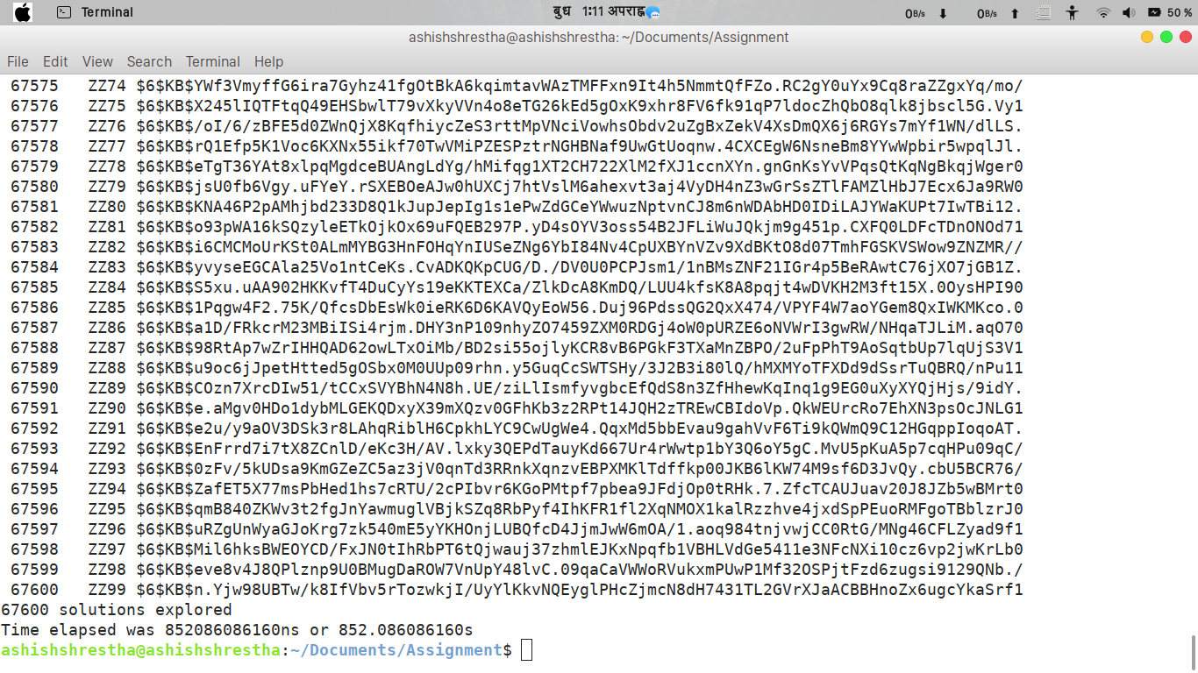
2.
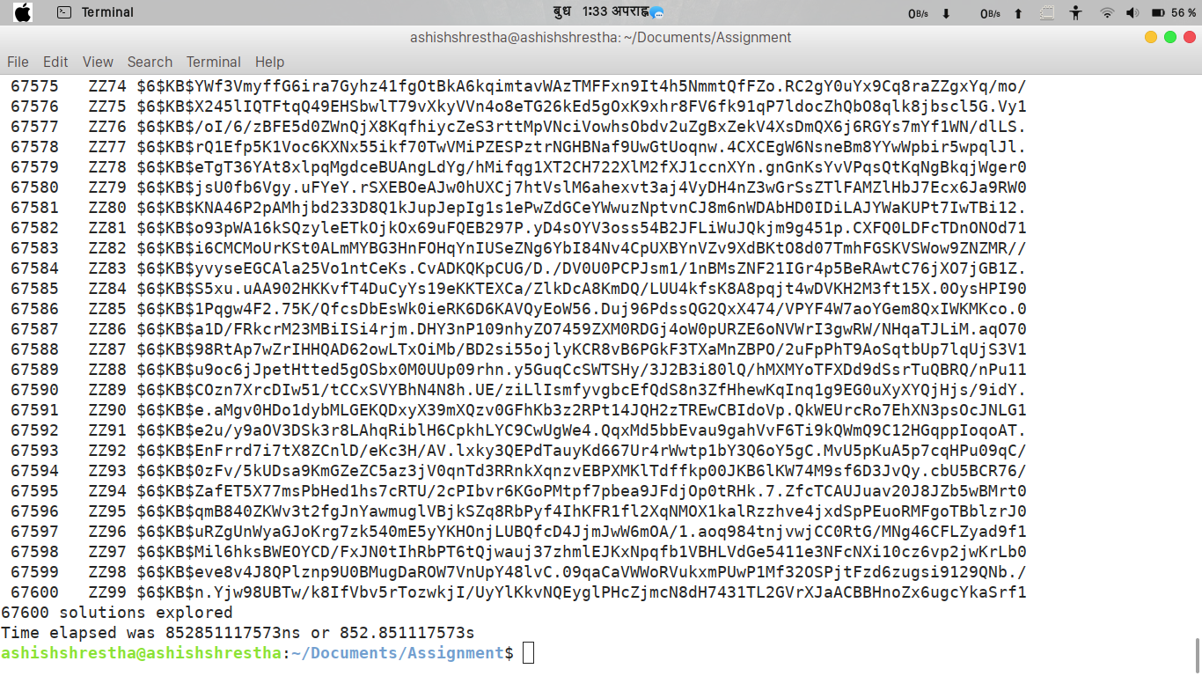

3.
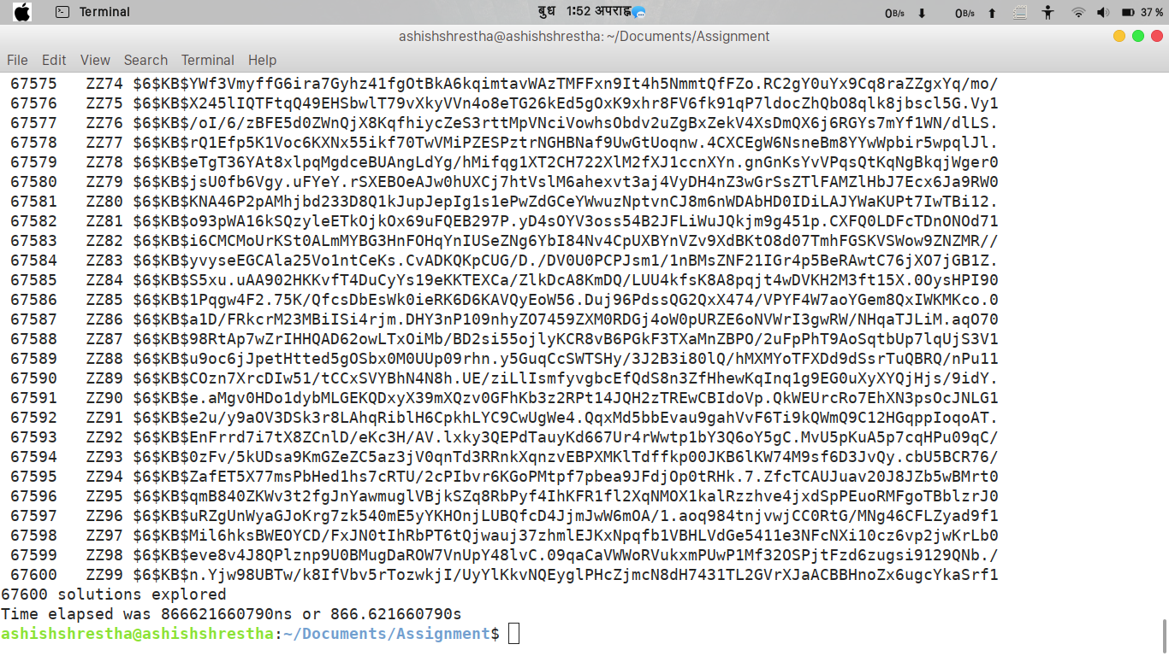
4.
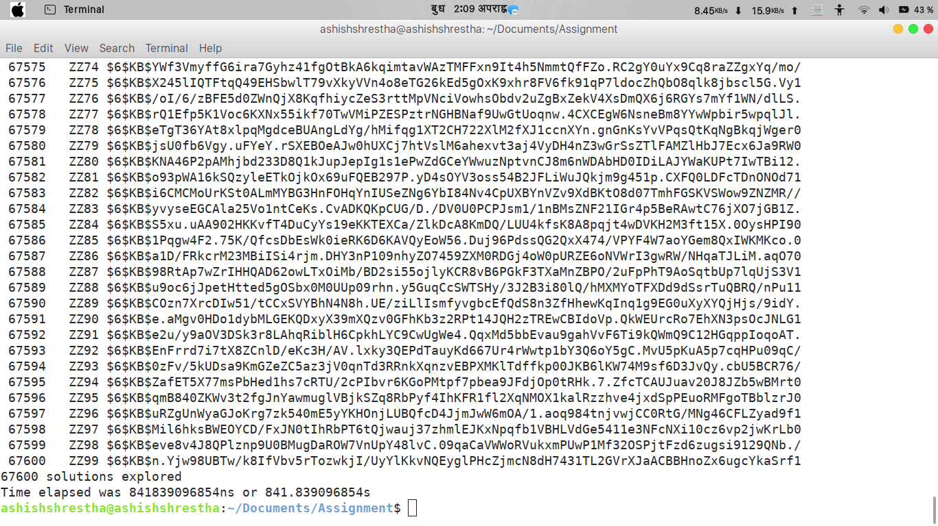

5.
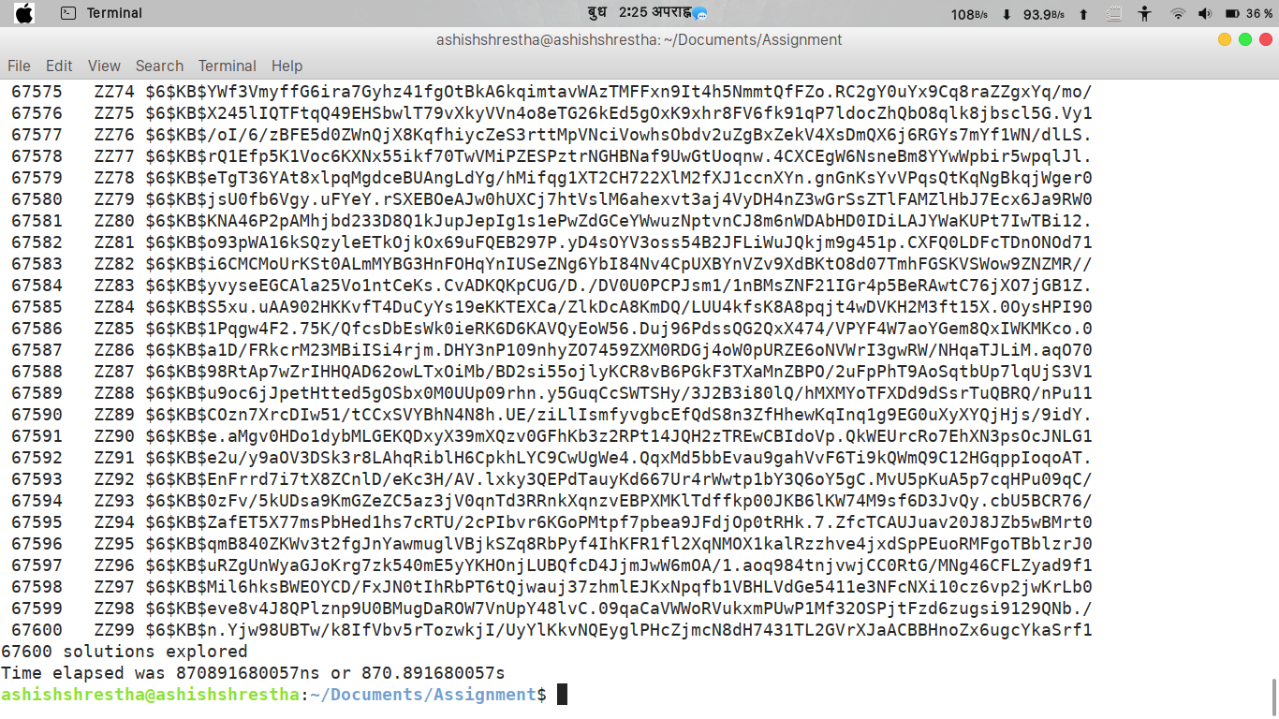
6.
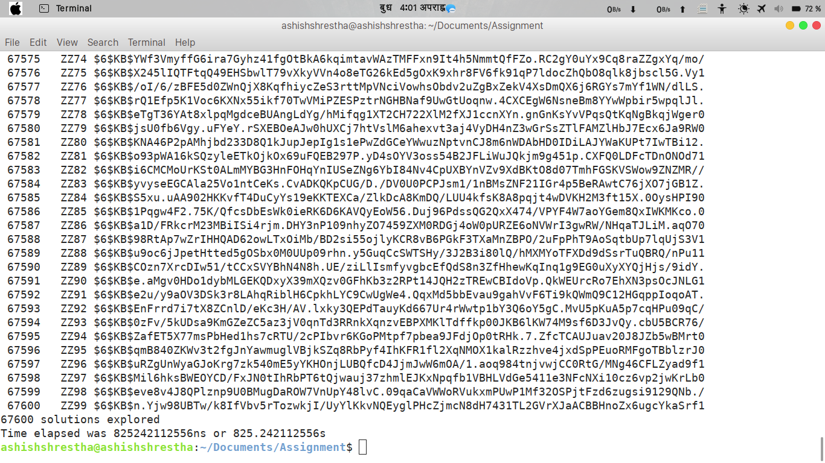

7.
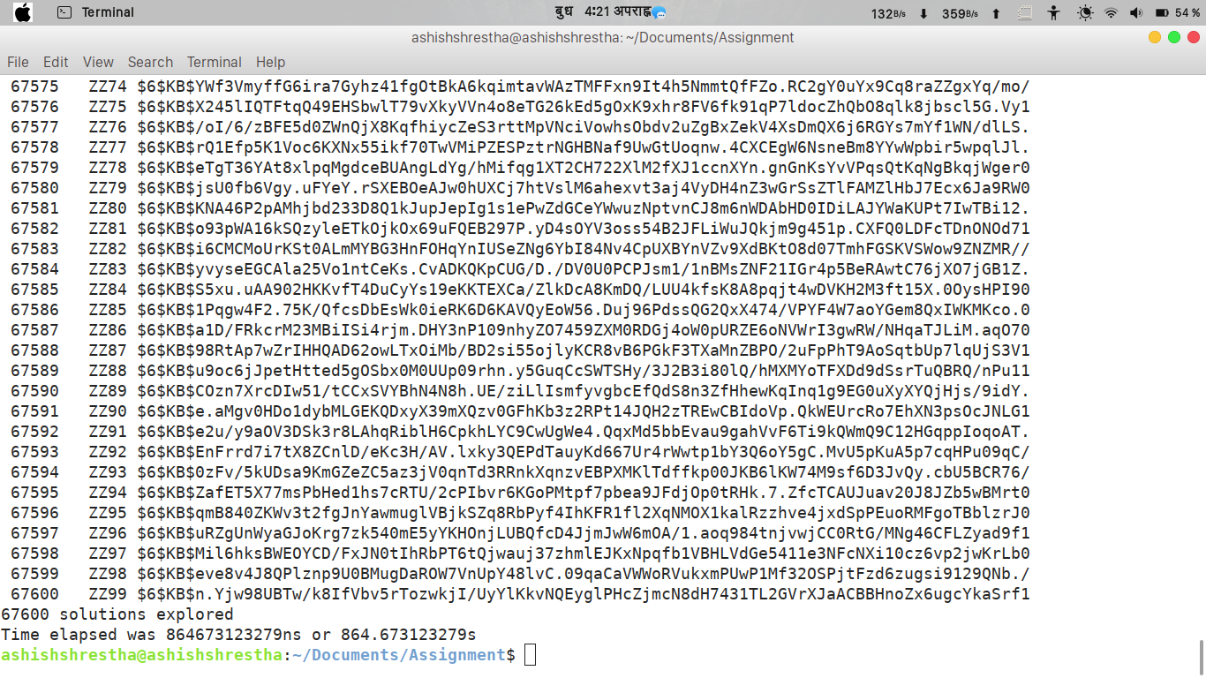
8.
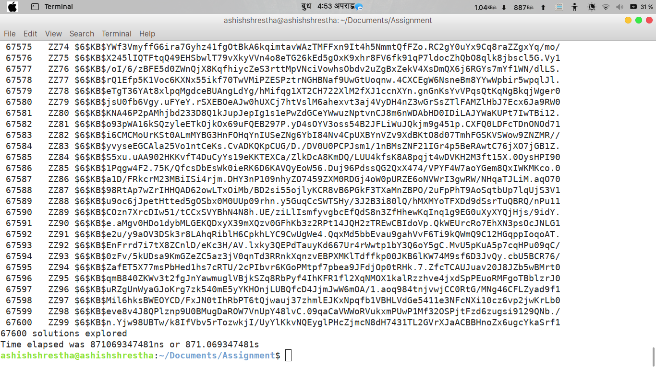

9.
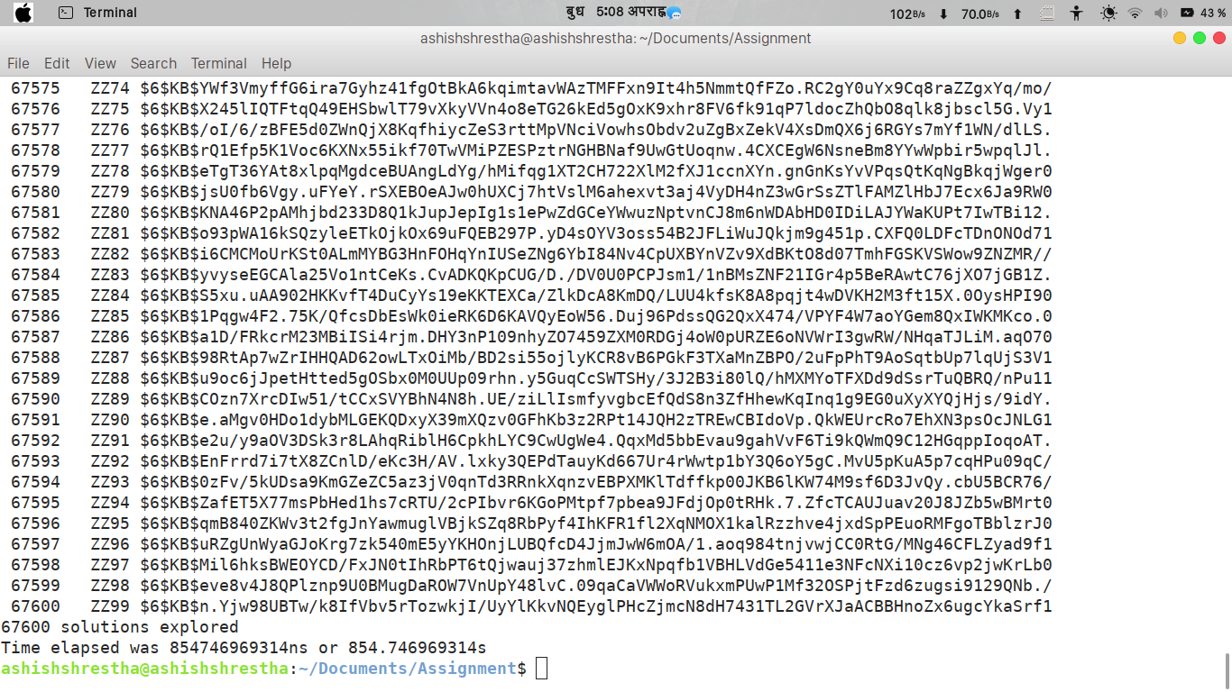
10.

Password Obtain from encrypted password.
Time taken by 3-initial-2digits password.​

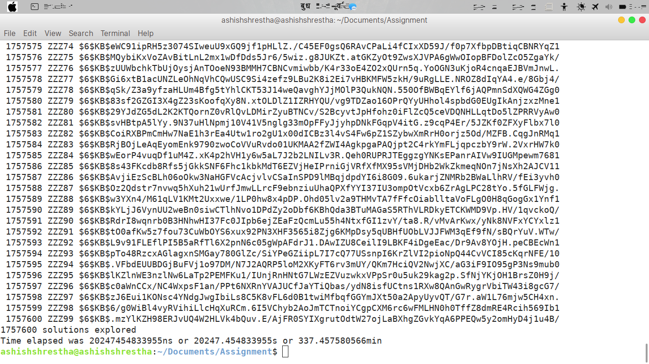

Time taken by multi-thread program.
1.
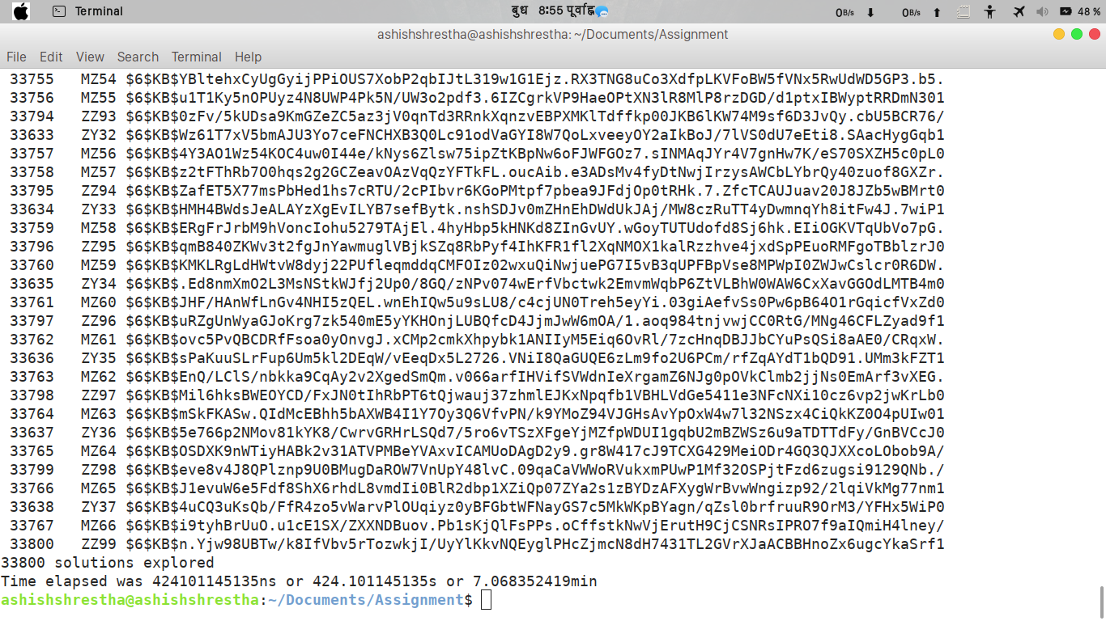
2.
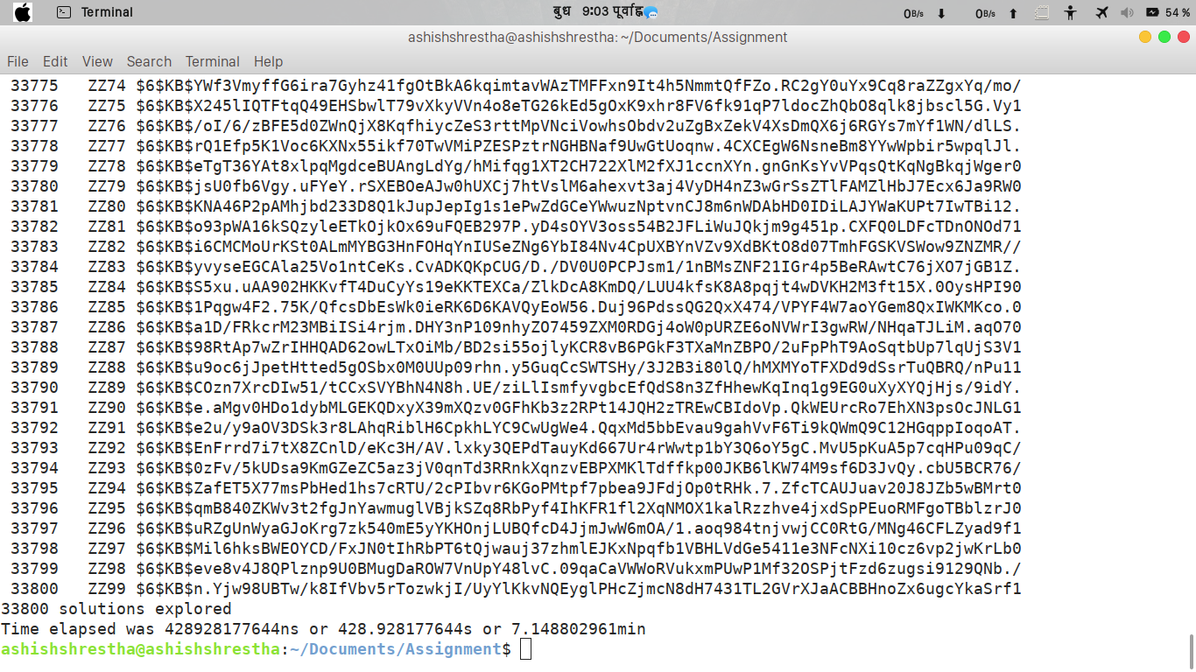

3.
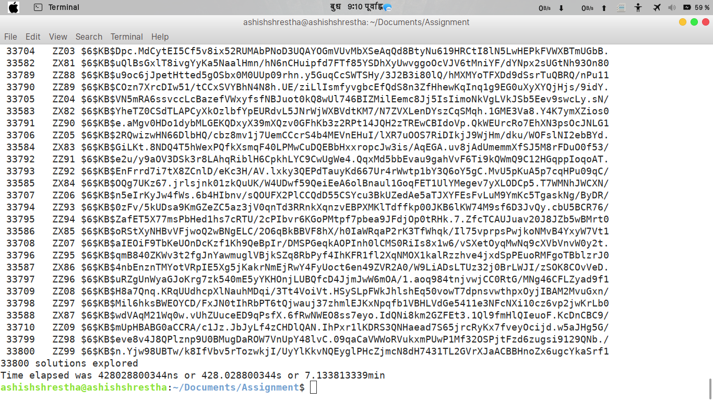

4.

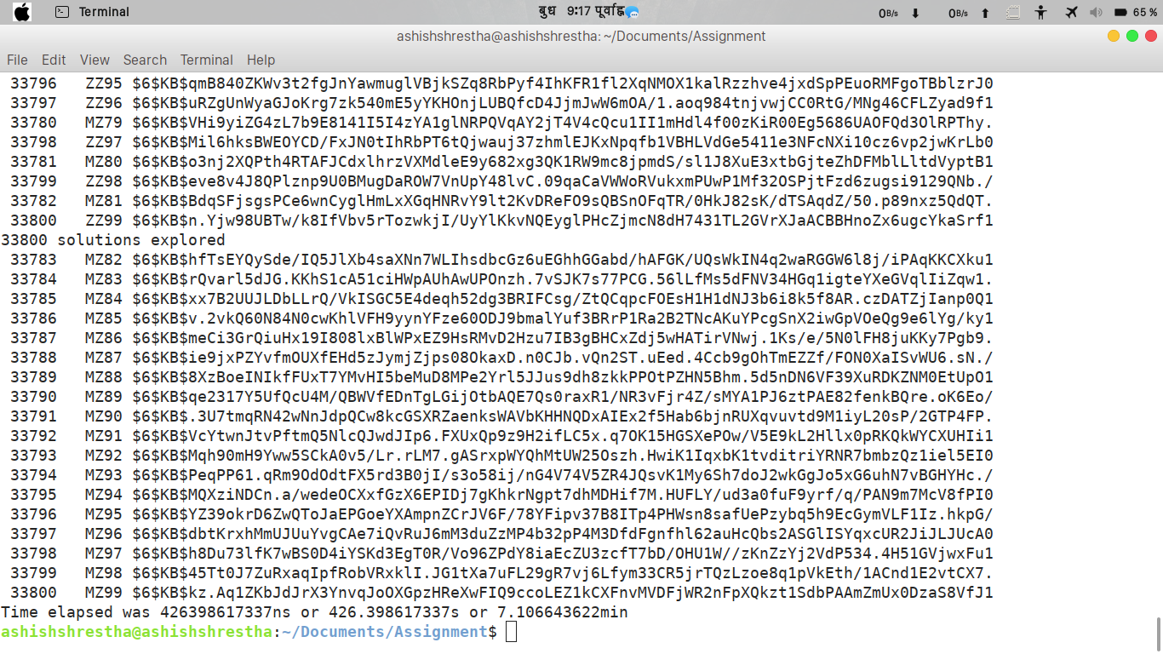

5.
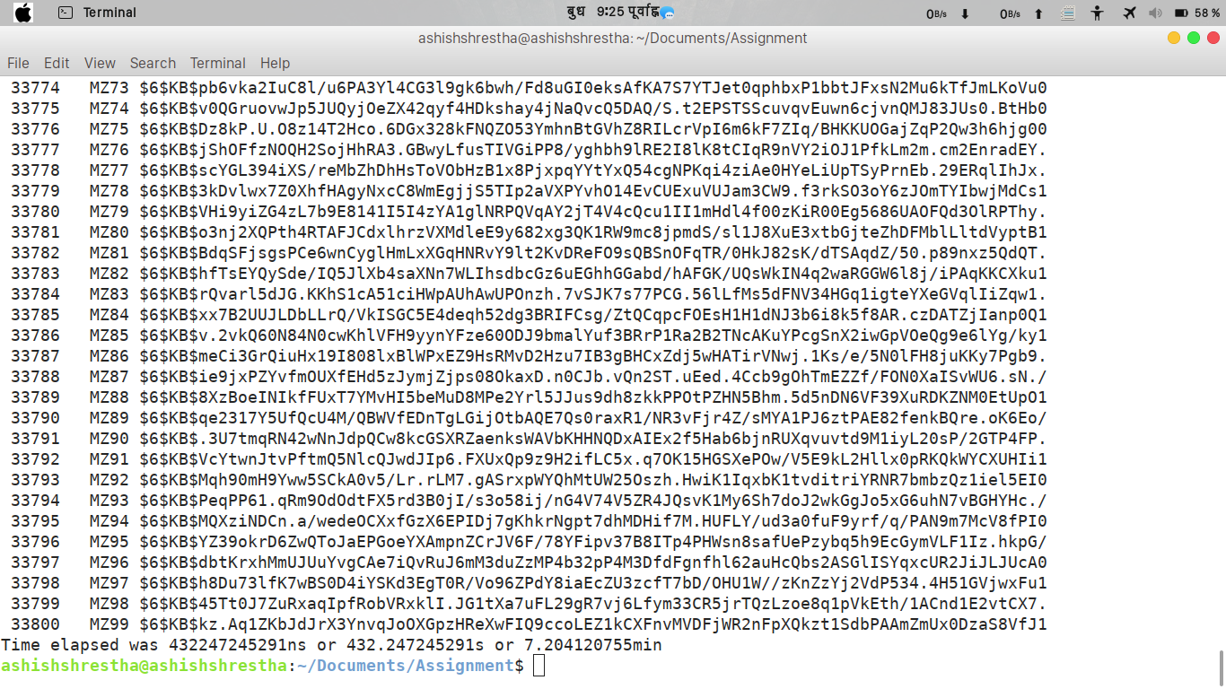

6.
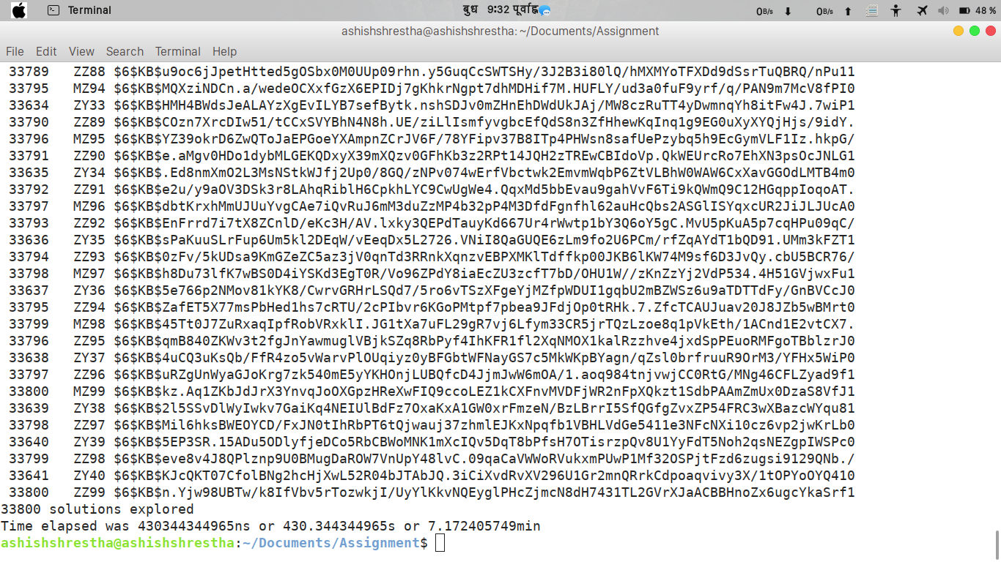

7.
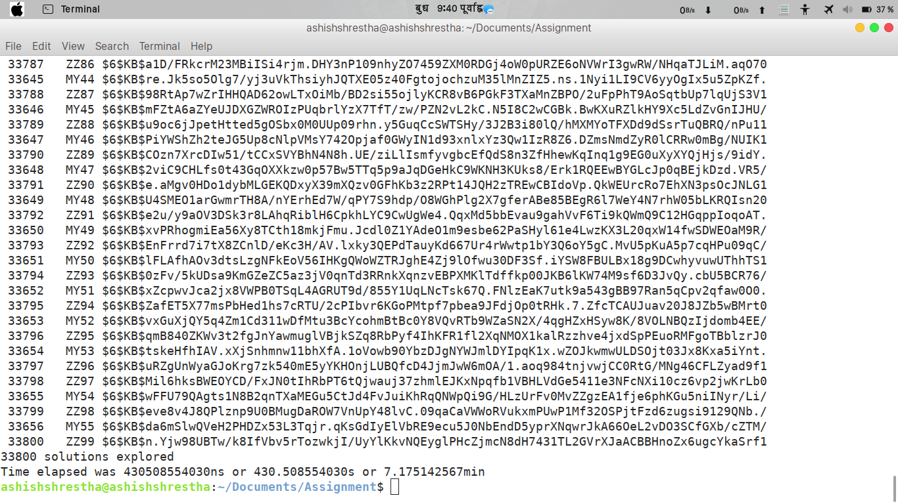
8.
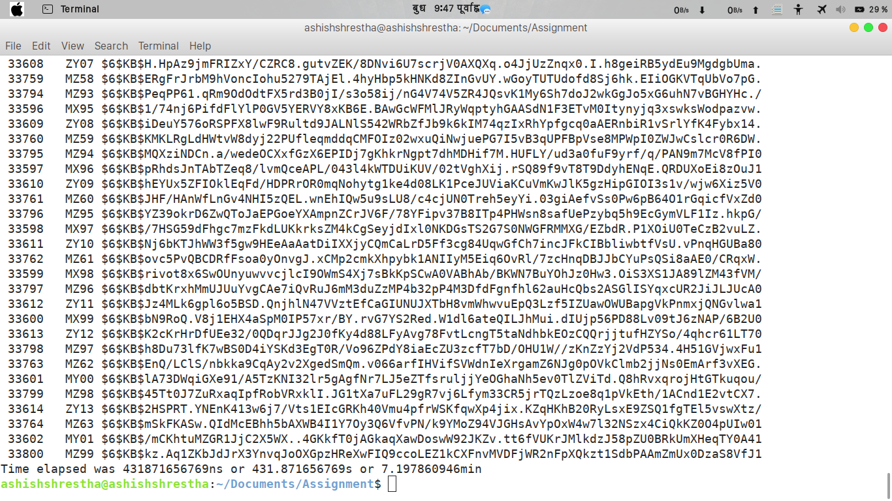

9.

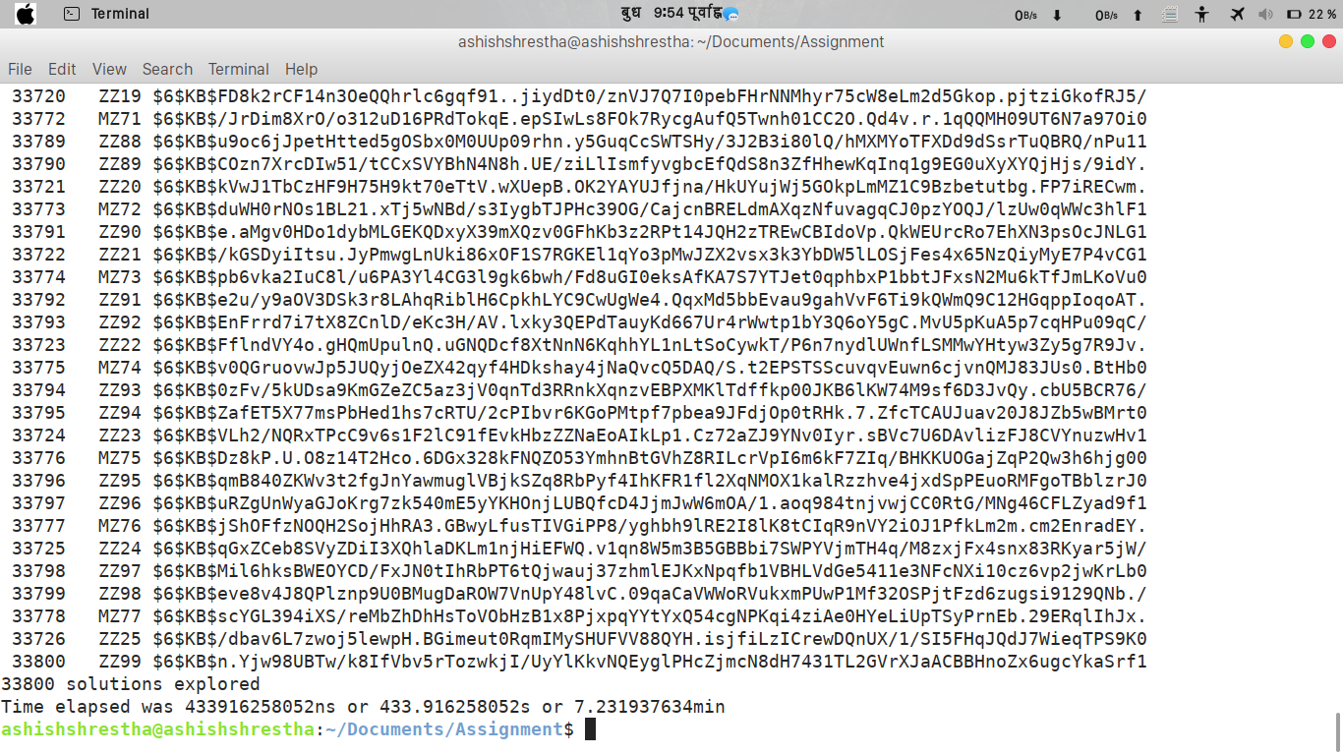

10.
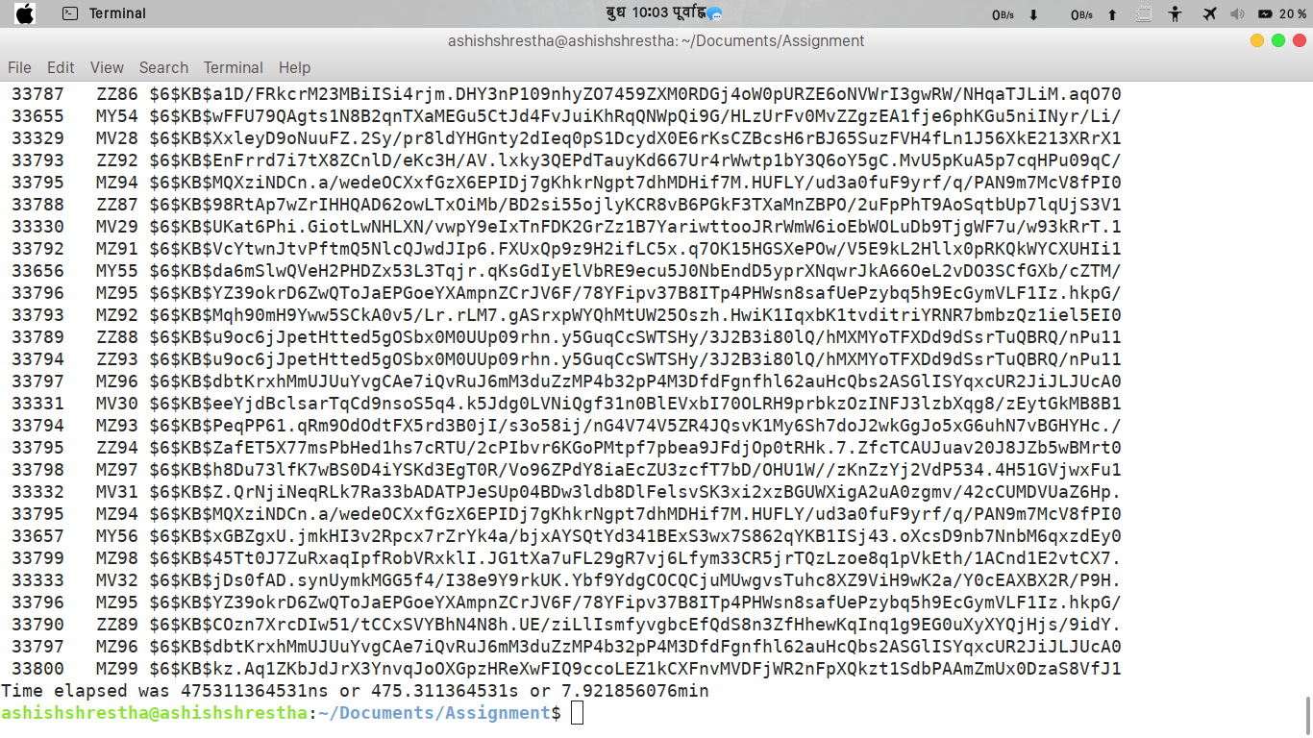

Time taken by Image Processing multi-thread program.

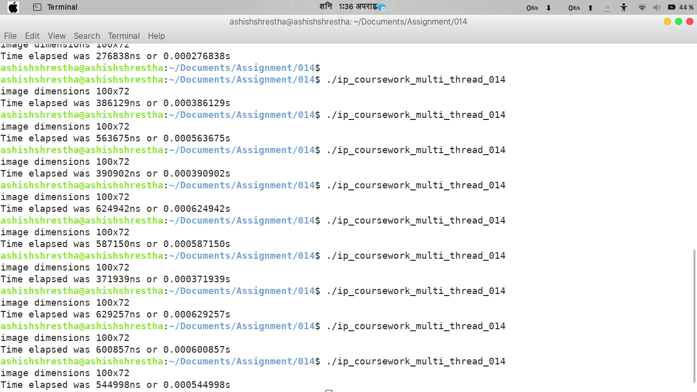

Scatter Plot of data-set given.

Three guesses at the optimum values for m and c plot diagram.

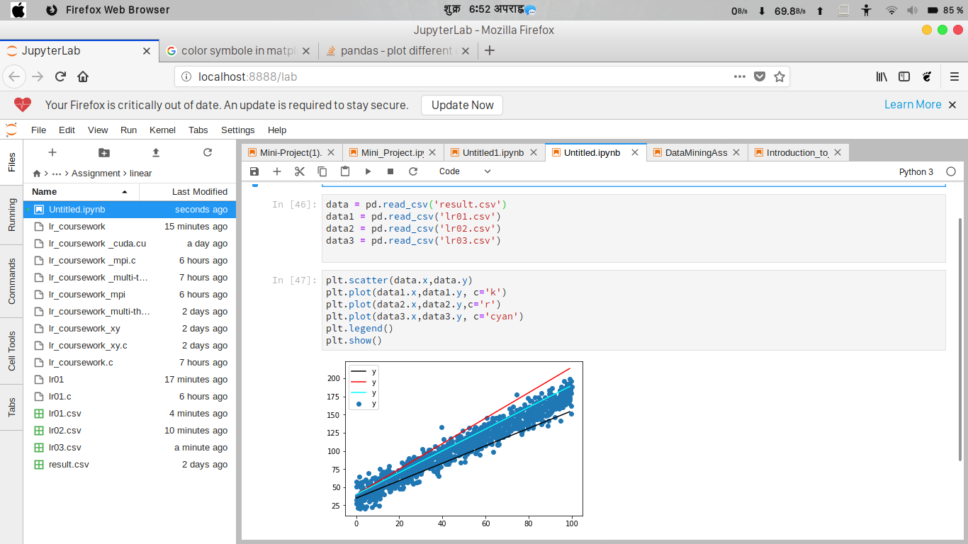

Overlaying the line that was found by the program on to a data-set scatter plot diagram.

Time taken by Linear Regression multi-thread program.

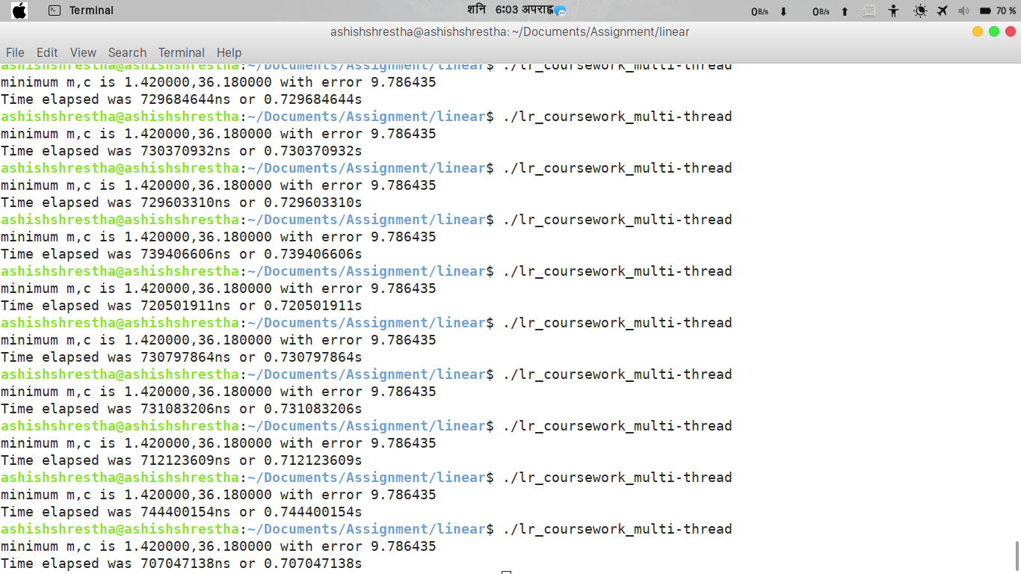

Time taken by 2-initials-4digits Password Cracking CUDA version program.
1.

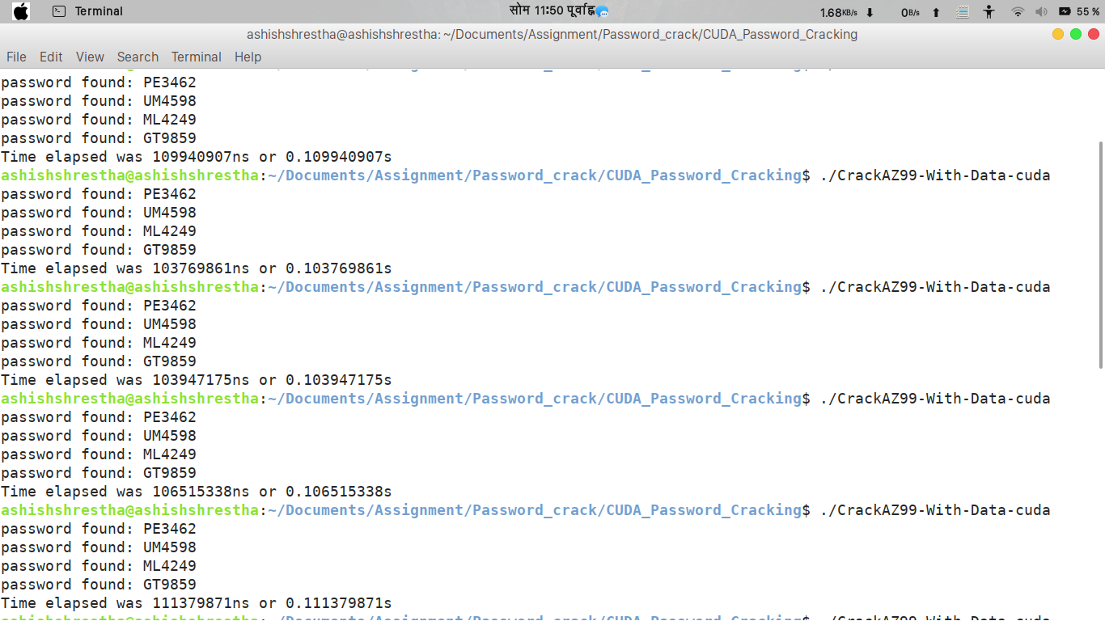

2.

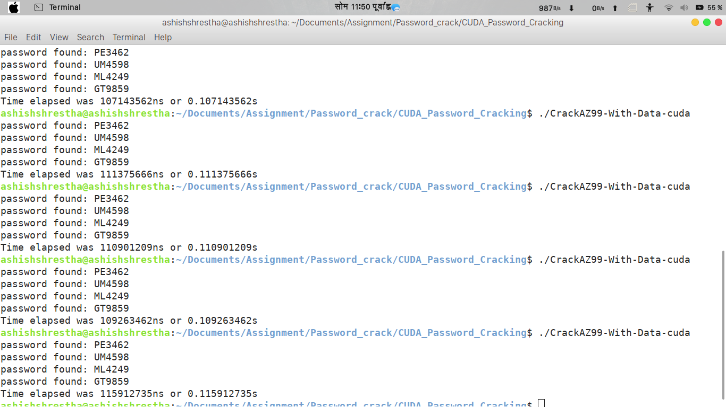

Time taken by Image Processing CUDA version program.

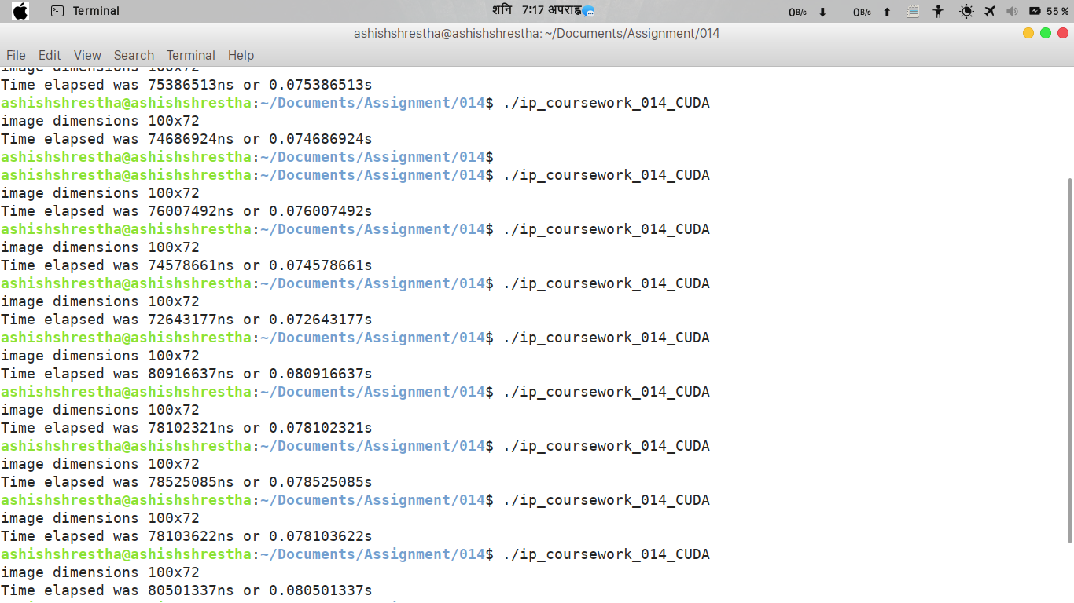

Time taken by Password Cracking MPI version program.

1.
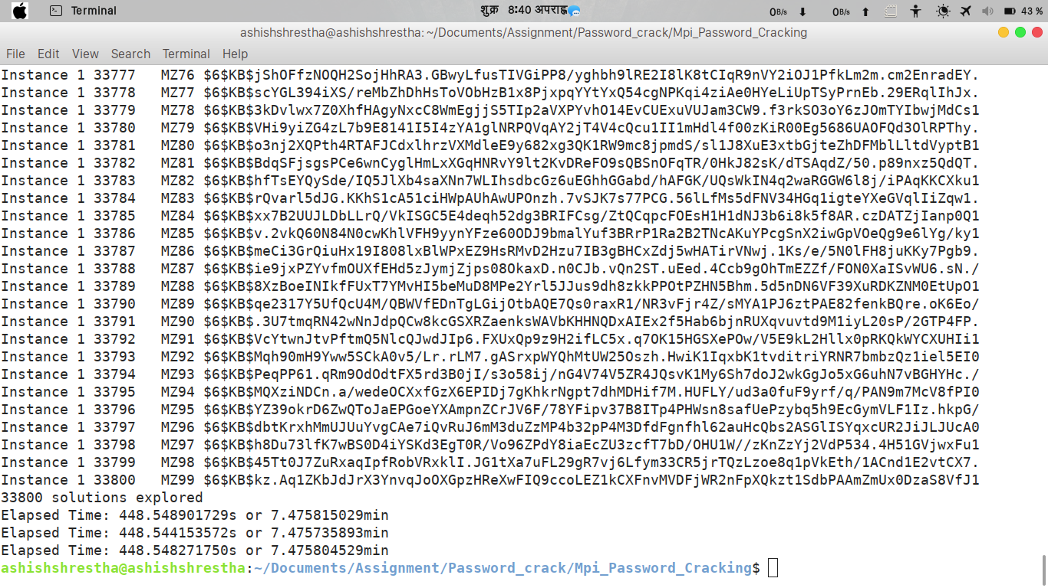

2.

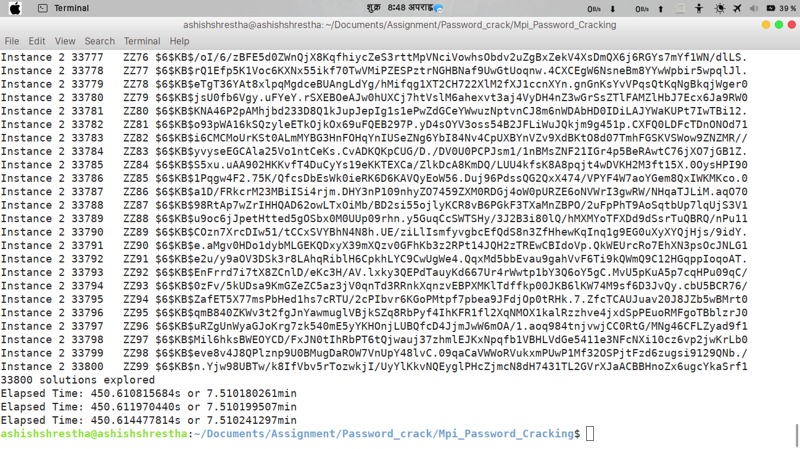

3.

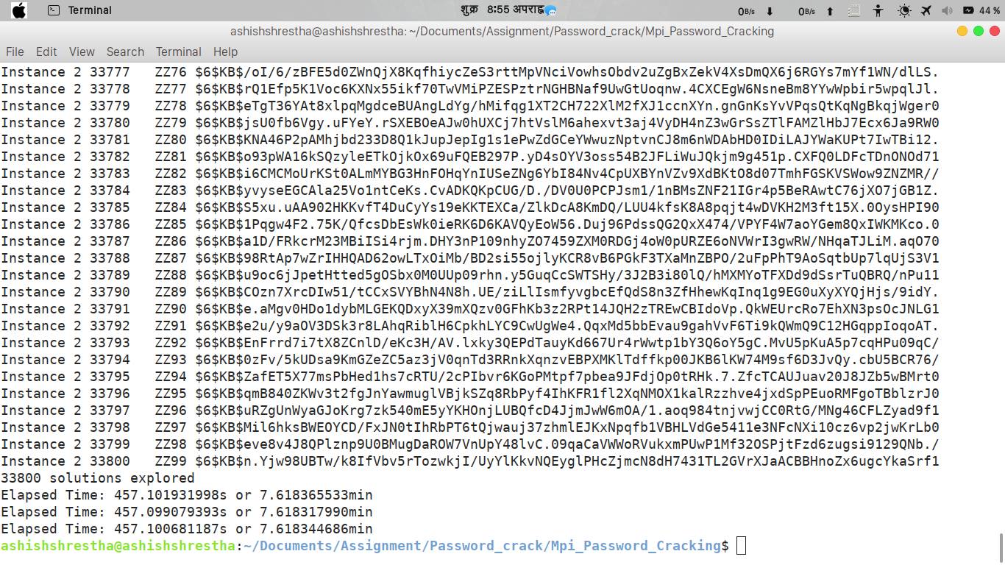

4.

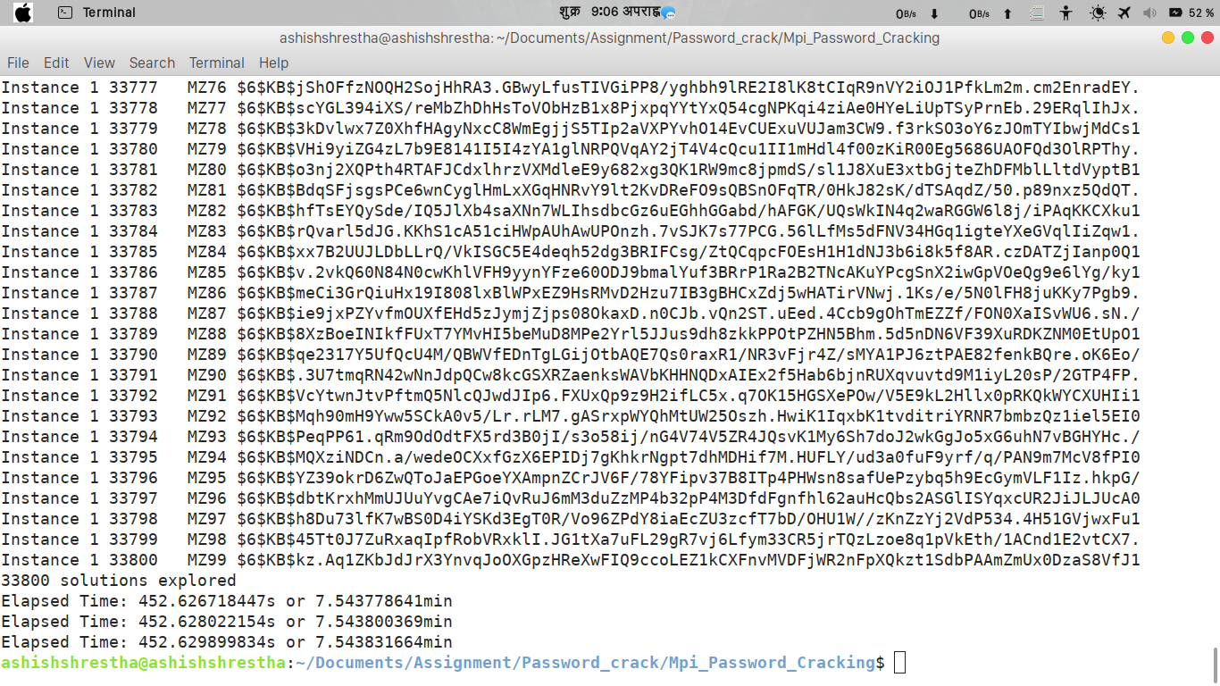

5.

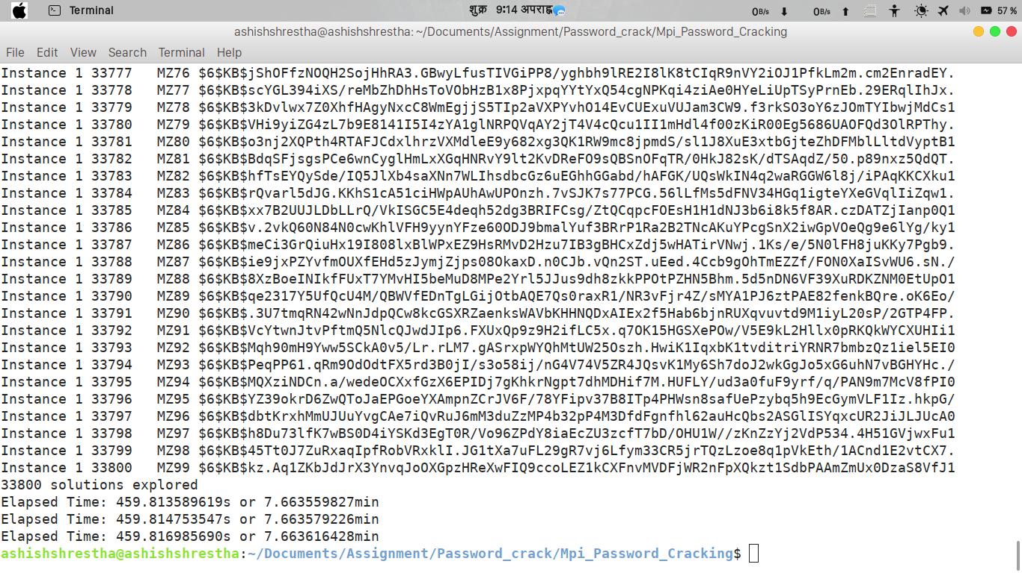

6.

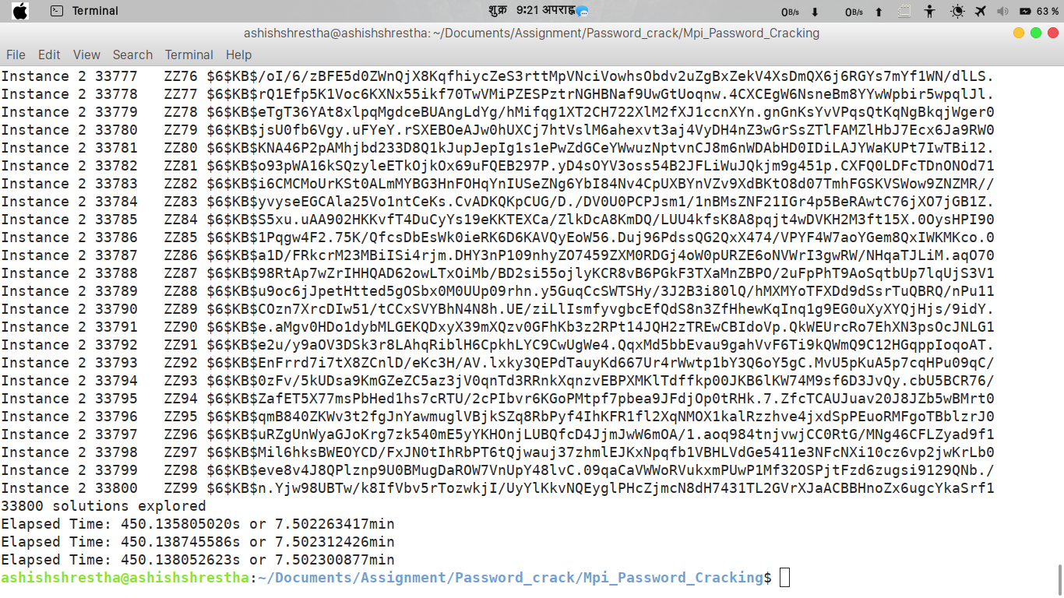

7.

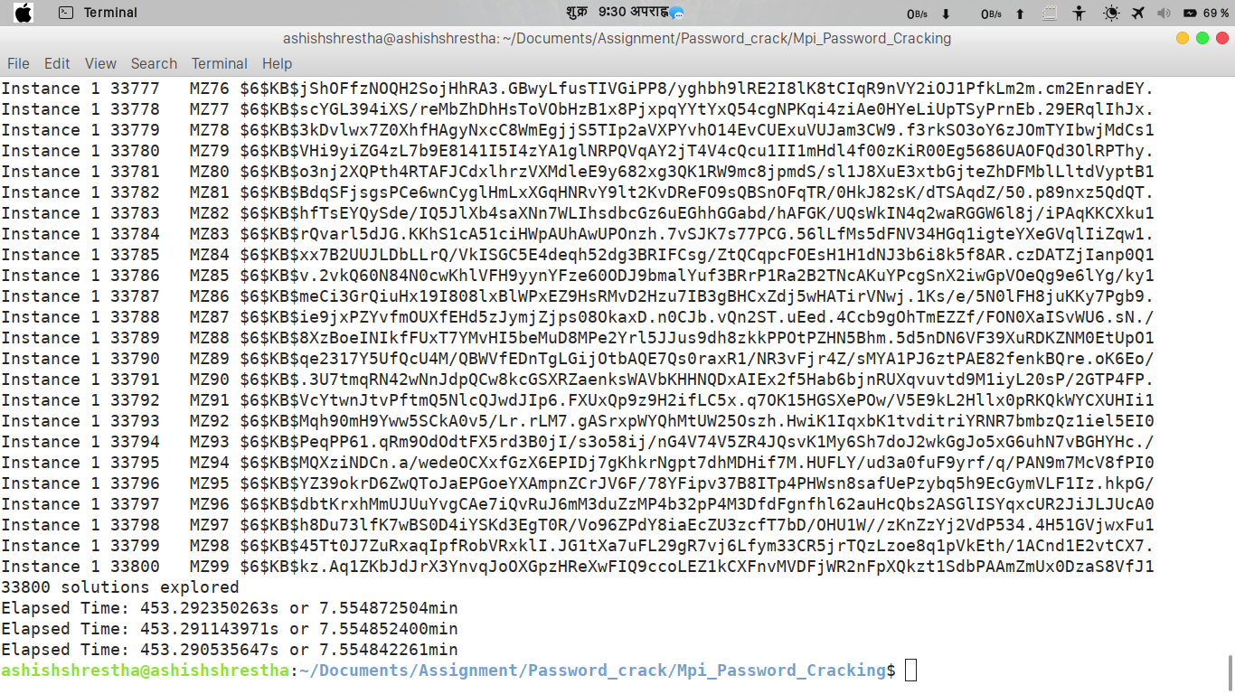

8.

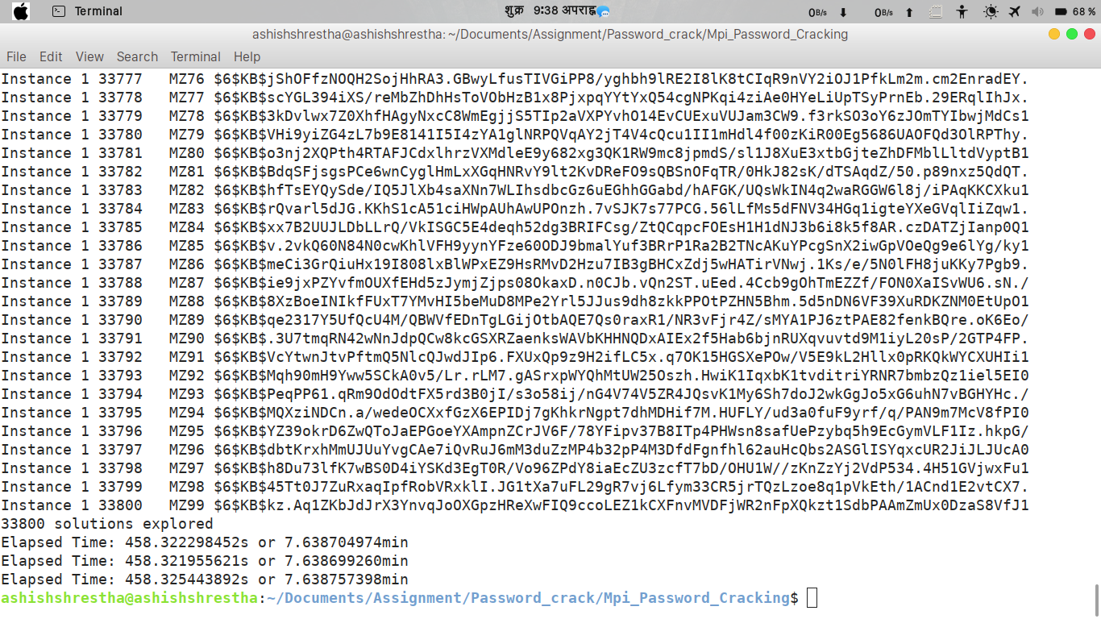
9.

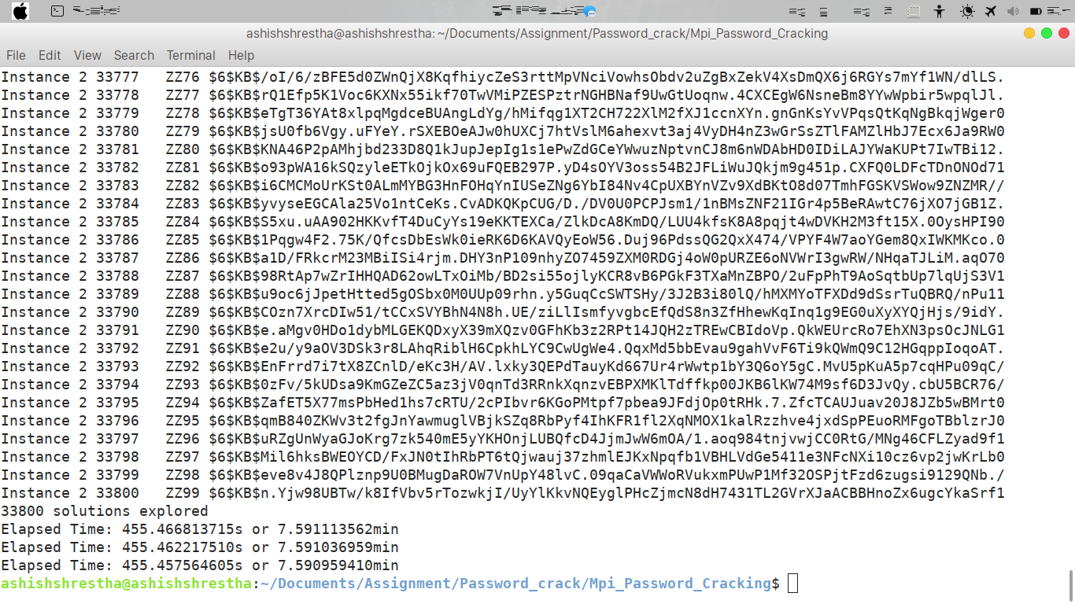

10.

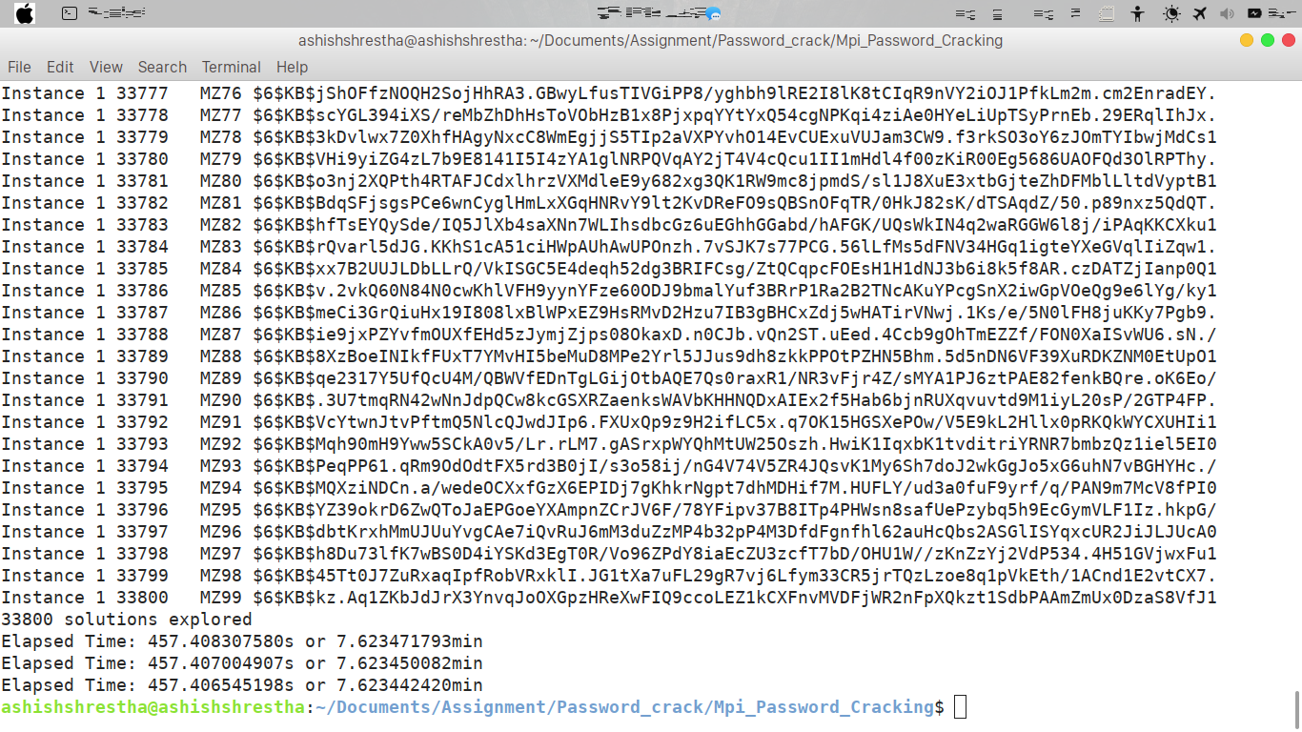
Time taken by Image Processing MPI version program.

1.

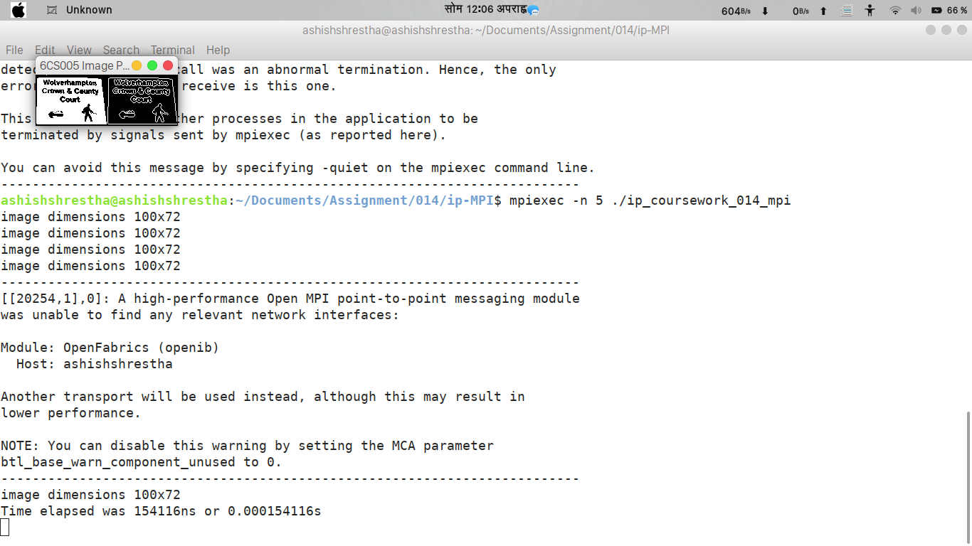

2.

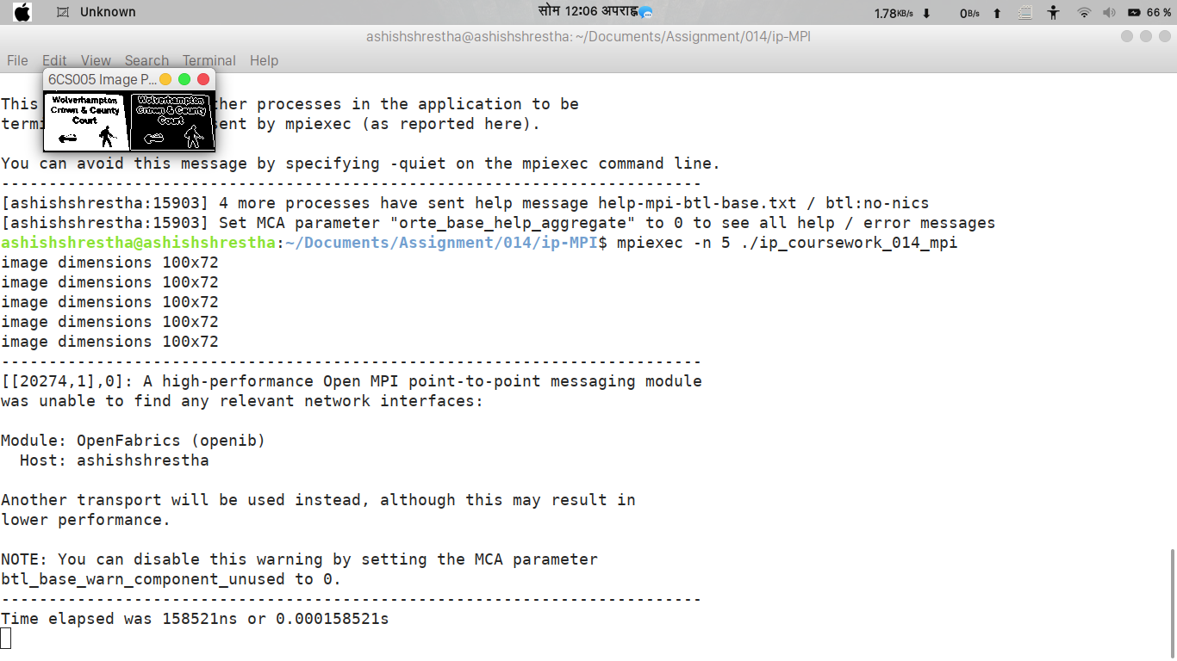

3.

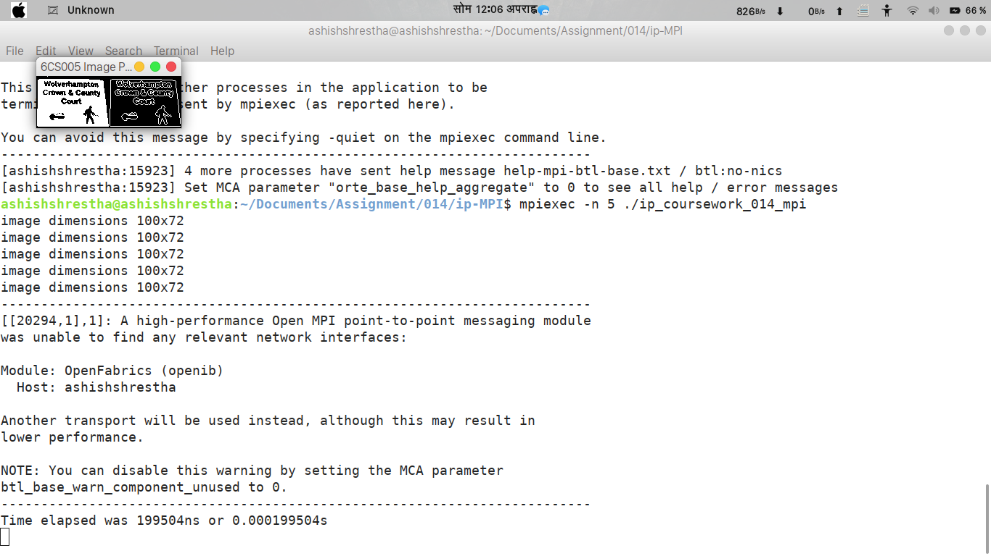

4.

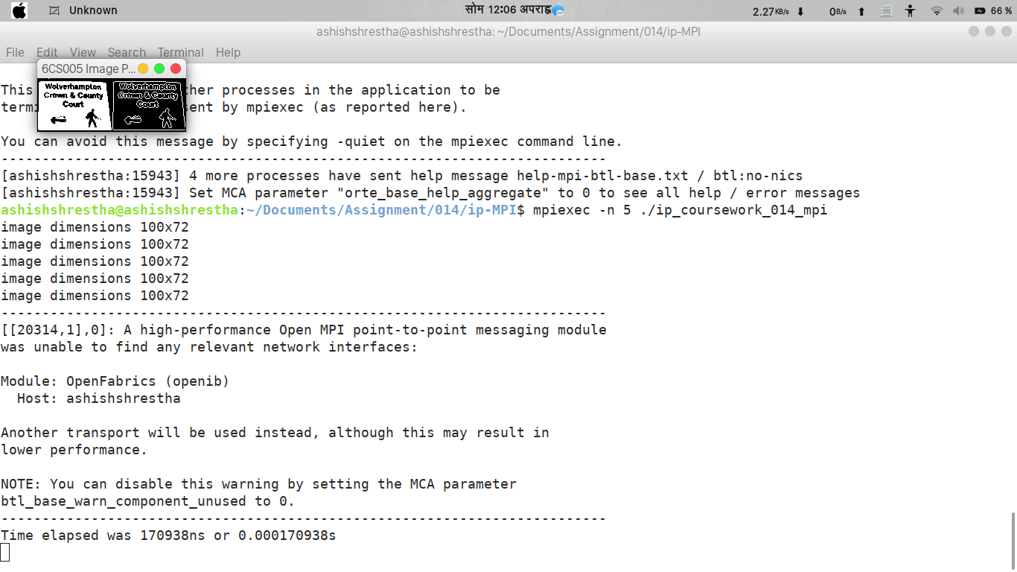
5.

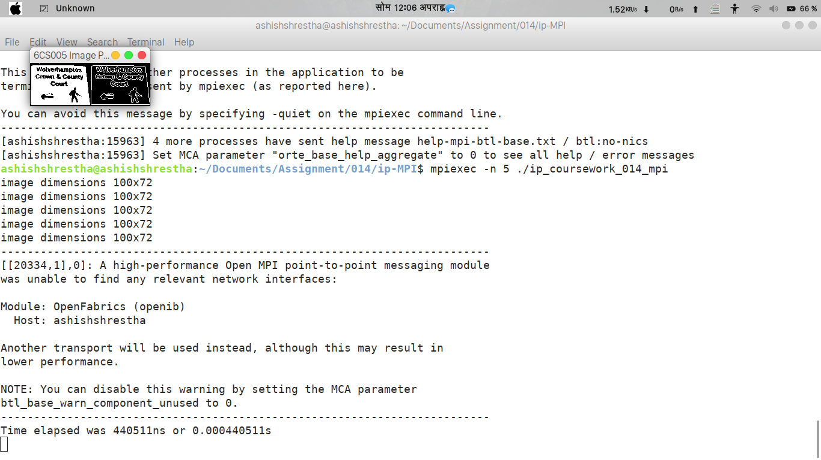

6.

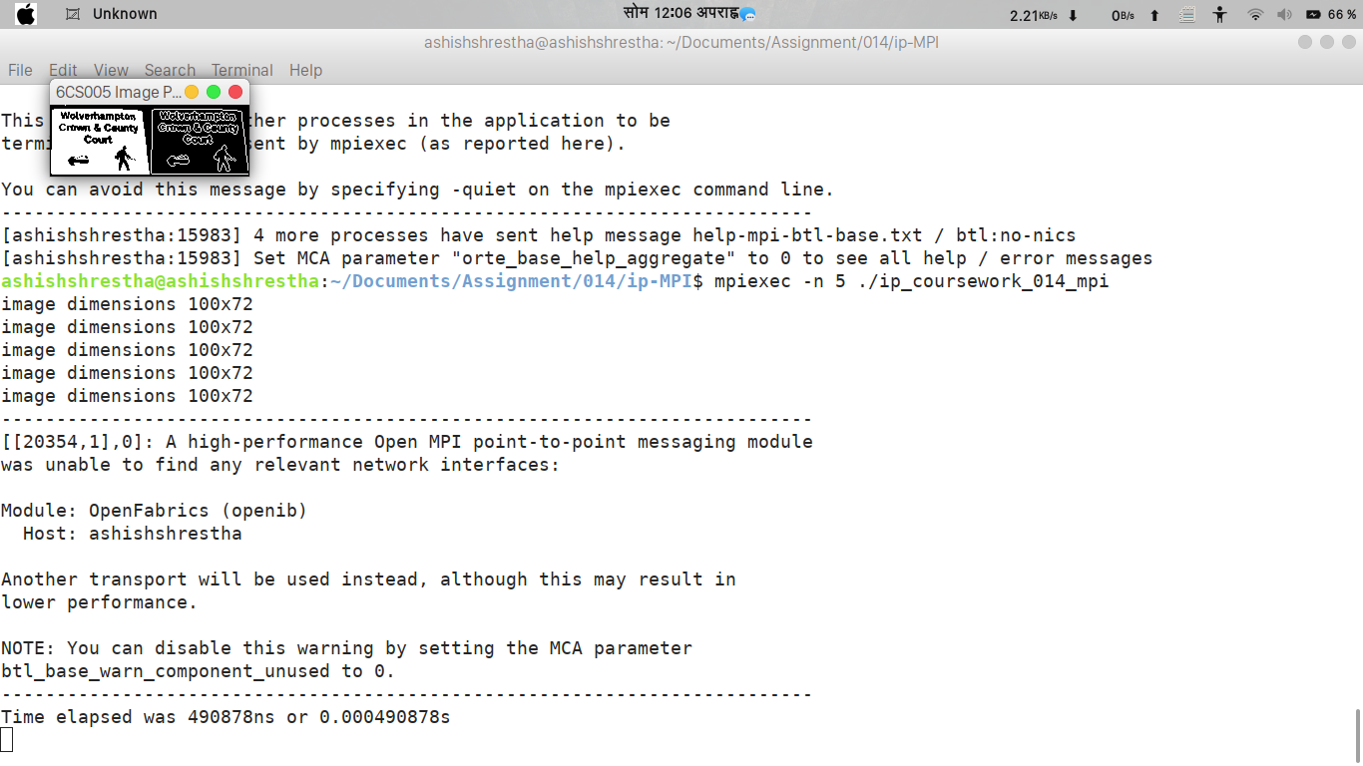

7.

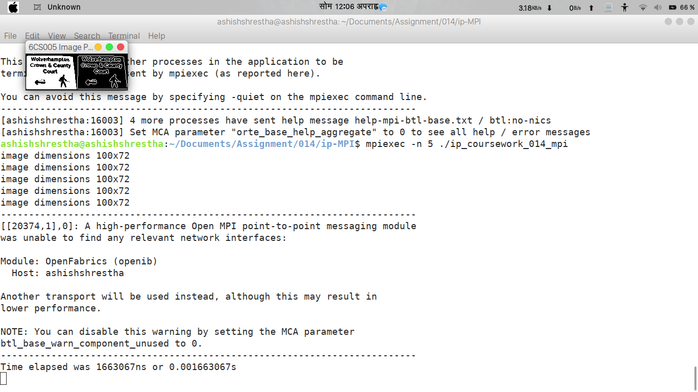

8.
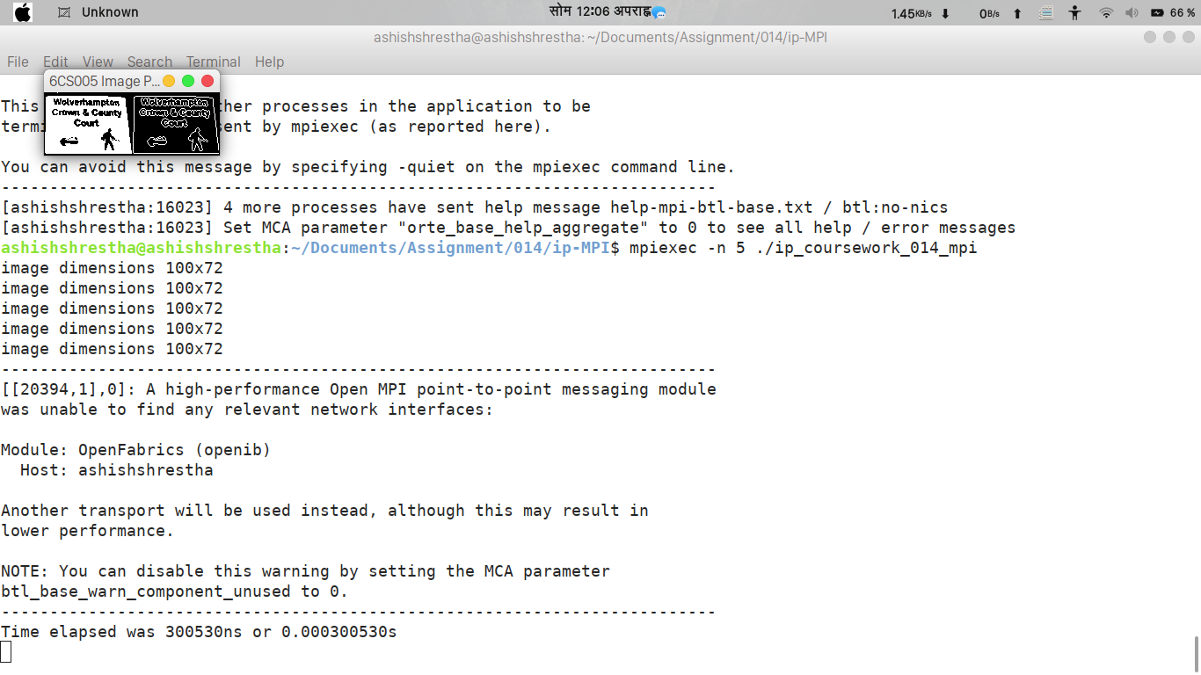

9.

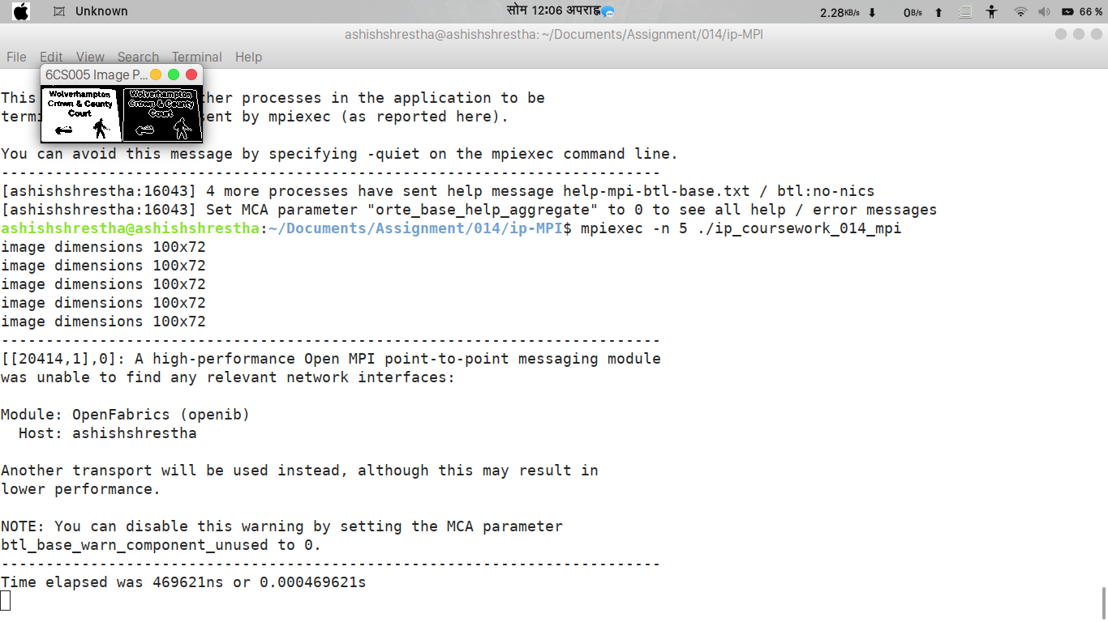

10.



